

**Consultation paper on proposed future of GP Out of Hours provision in Belfast Trust area**

**Consultation period from 3rd October 2024 to 2nd January 2025**

n.b This document is available in alternative formats on request. Please contact [equality.team@belfasttrust.hscni.net](NULL) or telephone 02895046060

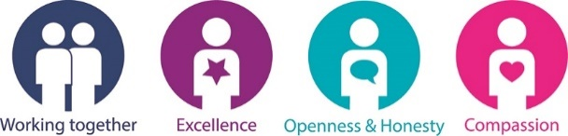

Table of Contents

**Executive Summary** 2

**Section 1:** **Introduction** 6

**Section 2: Current service profile** 10

**Section 3: The need for change** 20

**Section 4: Engagement and Consultation** 29

**Section 5: Consideration of the Options and the Preferred Option** 34

**Section 6: Conclusion and Recommendations** 39

**Section 7. Your Opportunity to Have Your Say** 40

**Appendix 1: Equality Screening Process** 41

**Appendix 2: Your Chance to have your say: Consultation questions** 79

# **Executive Summary**

Belfast Health and Social Care Trust is committed to ensuring our General Practice Out of Hours (GP OOH) services are of the highest possible quality and are effective and compassionate. As such, the Trust has produced this document to ensure that service users, and families, staff and the public at large have an opportunity to consider and comment on the proposed reorganisation of GP Out of Hours services.

Belfast Trust is responsible for the provision of GP Out of Hours services for the population of Belfast. Over recent years, there have been challenges in maintaining out of hours service provision at the two bases on the Crumlin Road and the Knockbreda Health and Wellbeing site. The location of these sites originated when there were two different Trusts – North and West Belfast Trust and South and East Belfast Trust and remained operational when Belfast Health and Social Care Trust was formed in 2007. Both sites provide: an Out of Hours primary urgent care (for an illness or injury that requires urgent attention but is not life threatening) service to the Belfast Population from 6pm – 8am weekdays and 6pm Friday – 8am Monday at weekends, including bank holidays.

The Trust has already engaged with and explained what changes it is proposing to modernise the service and address the challenges that it faces. This included the rationale for introducing a multi-disciplinary service with nurses, paramedics and pharmacists - so that the service is no longer reliant on one single profession and to free up GPs to attend to those who are more acutely unwell.

Furthermore, in the best use of public monies, the Trust considers that it would be more cost-effective and more efficient to provide the service from one base, alongside the relatively newly established Phone First service. Moving to one site with the newly introduced skill mix would make considerable economies of scale by consolidating resources and would address the significant, increasing overspend that the service is facing year on year. Evidence has shown that the current model is no longer sustainable and frequently, the Trust has had to close one site due to workforce issues.

The Trust has conducted an options appraisal and the options were assessed against the following objectives:

|  |  |  |
| --- | --- | --- |
| No. | Description of objective | Measured by |
| 1 | To match demand to capacity with the patient receiving a quality and responsive service in the right place at the right time by the right clinician (urgent/routine) (advice, base visit, home visit) | Key performance indicators  **Urgent – 100% within 20 minutes**  Current performance: 87%  Current performance – May 2024 : 91%  **Routine – 100% within 60 minutes**  Current performance : May 2024 : 43% |
| 2 | To develop the service to meet the strategic priorities of the Trust and the Urgent and Emergency Care pathways throughout the NI region. | Meet the Key Performance Indicators of the Out of Hours Service (as in objective one)  Meet the recommendations of the Urgent and Emergency Care review  Meet the demands of the service in ensuring that the patient requires the correct service in the right place at the right time by the right clinician  Patient satisfaction and involvement measures |
| 3 | To ensure workforce resilience of the service | Key performance indicator performance as per objective one  GP shift fill rate and GP performance in comparison to activity  Nurse hours performance in comparison to activity  Paramedic hours performance in comparison to activity  Pharmacist hours performance in comparison to activity |
| 4 | To deliver a value for money service which is responsive to the population of Belfast Health and Social Care Trust | Key performance indicator performance as per objective one  GP shift fill rate and performance in comparison to activity  Nurse hours performance in comparison to activity  Paramedic hours performance in comparison to activity  Pharmacist hours performance in comparison to activity  Cost of service compared to budget |

The options has been greatly informed by listening to the views of our stakeholders and taking into account strategic drivers such as [No More Silos](NULL), [the Review of Urgent and Emergency Care](NULL) and [recommendations from the Regulation Quality and Improvement Authority](NULL). As detailed in Section 5 of the paper, the following options were considered:

**Option 1** – the status quo – the option to do nothing and keep the two sites was not shortlisted as it has been difficult to keep both bases staffed and is not a long-term option for a viable and equitable GP OOH service for the population of the Belfast Trust area. The current model is not achieving the necessary performance indicators and projected to be overspent by £1 million.

**Option 2:** Consolidate both GP OOH Services into Knockbreda Wellbeing and Treatment Centre has been shortliste

**Option 3:** Consolidate both GP OOH Services onto the existing Crumlin Road site

**Option 4:** Move and consolidate both GP OOH services onto RVH site, alongside Urgent Care Centre and Emergency Department has not been shortlisted. There was overwhelming consensus that the Royal site is already extremely busy and is often congested with long queues for car parking.

**Option 5:** Develop an integrated urgent primary care service in a community setting. This option has been shortlisted and would be the ultimate preferred option for the long term but this is not feasible at present as it is not considered to be a sustainable model under current funding envelope available.

At our various engagement events with interested stakeholders, there was broad consensus about the rationale to move to a one site model. Based on the quantitative and qualitative information gathered, the preferred option is Option 3 to consolidate the two current sites on the Crumlin Road site. It is the preferred option as:

* It will deliver equity to all Belfast patients with the richness of a multi-disciplinary skill mix on one site.
* It offers dedicated physical capacity to accommodate both the newly established Primary Care Out of Hours (no longer just GP OOH) along with Phone First.
* It is located in close proximity to the Emergency Department at the Mater Hospital and
* It will improve safety and ensure sustainability of the services going forward.

It should be noted that no service is closing – the current service is being reconfigured onto one site from the two site model. Co-location of the service on the Crumlin Road will not have any impact on the other services provided at the Knockbreda Centre.

# **Section 1: Introduction**

The purpose of this consultation document is to outline the current service model of General Practice Out of Hours (GP OOH) provision for the population of the Belfast Trust, the challenges and the need for change. It highlights the strategic context and what the Trust has considered in terms of the future proposed model and how after conducting an options appraisal and equality screening, it is proposing the preferred model going forward.

Belfast Trust aims to be the safest, most effective and compassionate organisation and is committed to delivering the right care, at the right time at the right place.

In accordance with its statutory responsibilities in terms of Personal and Public Involvement and Equality under the Health and Social Care Reform Act 2009 and Section 75 of the Northern Ireland Act 1998, the Trust has engaged and is now issuing for formal consultation its proposed future service model for General Practice Out of Hours provision in Belfast Trust area.

**General Practitioner Out of Hours**

The GP Out of Hours service is for people who need urgent medical treatment but cannot wait until their doctor's practice opens. It is defined as “care provided between 18.30 and 08.00 on weekdays, all weekend and Bank Holidays. Unlike independent GP practices, Belfast Health and Social Care Trust is responsible for managing and delivering GP Out of Hours service through contractual arrangements with GPs, who have signed up to provide their services out of hours. Care provided in the OOH period is unscheduled, i.e. there has been no forward planning (either by patient or professional) or appointment made in advance. Both sites offer a telephone prioritisation service with either telephone assessment, treatment or advice from a GP, home or base visit or a referral into an Emergency Department or Urgent Care Centre or other multi-disciplinary services, or a mental health assessment, or confirmation of end of life or working with community district nurses and patients in nursing homes.

**Current model**

The current model of GP OOH over two sites has been adopted from legacy Trust arrangements, when Beldoc GP OOH on the Crumlin Road provided the service for the distinct population of north and west Belfast and Sebdoc provided the service out of hours for the distinct population of south and east Belfast. When Belfast Trust was established from the amalgamation of 6 legacy Trusts in 2007, the Trust maintained the existing arrangements for GP OOH for the whole population of Belfast Trust. Both sites provide an Out of Hours primary urgent care (an illness or injury that requires urgent attention but is not life threatening) service to the Belfast Population

* between 6pm and 8am weekdays
* weekends = 6pm Friday – 8am Monday
* includes all public holidays

The distance between the 2 sites is less than 5 miles, as depicted in the image below.

**Figure 1: Map showing distance between the 2 current sites**

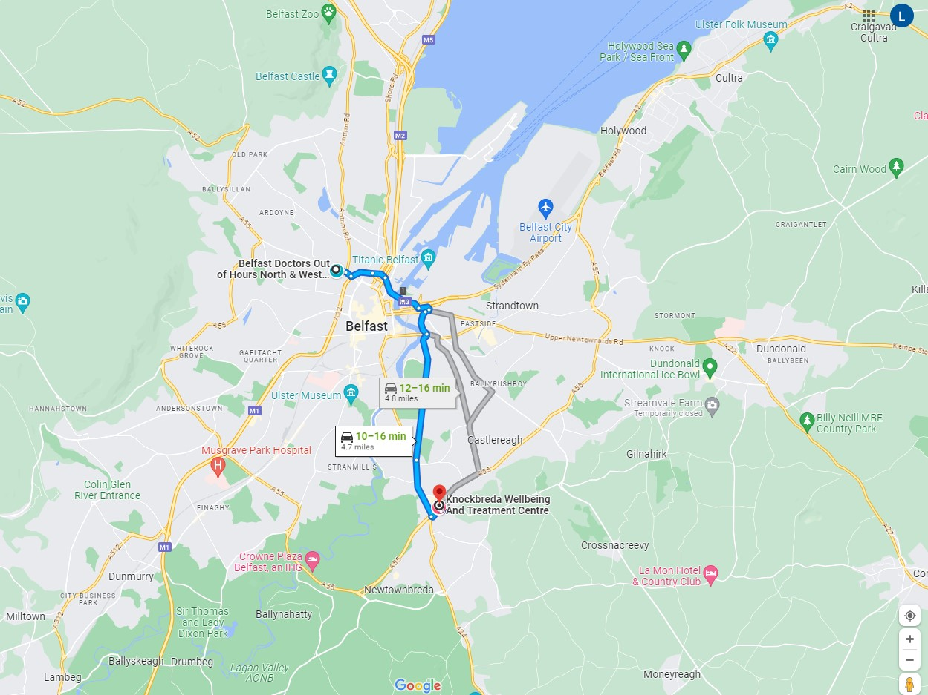

**Challenges**

Over recent years, sustained provision of the service across the two sites has proved to be challenging. This is due to several factors including increasing demand, recruitment and retention of GPs and financial pressures. Our GP colleagues have shared difficulties about the increasingly complex and time-consuming demands of daytime practice, which can then impact on the ability to leave to begin an OOH shift. That, coupled with changing financial remuneration, makes providing out-of-hours sessions more challenging.

The model of Out of Hours provision had been solely dependent on one discipline, with no potential for contingency or a tiered approach- whereby other professions could prioritise and provide consultations for patients and support GP colleagues to deal with the most urgent cases.

Out-of-hours (OOH) primary medical care in the UK has undergone substantial re-design and reorganisation, particularly since the implementation of the 2004 General Medical Services contract which allowed GPs to opt-out of providing OOH care. And evidence indicates that a more diverse staff and skill mix, in combination with positive contextual conditions, can result in improved quality of care, quality of life, and job satisfaction. [1]

A recently published document entitled [**A Workforce Fit for the Future**](NULL) issued by Royal College of General Practitioners in Northern Ireland further illustrates some of the issues that Primary Care faces. Regionally, there were 317 active GP practices as of 31 March 2023 and this constitutes a reduction of 33 (9%) since 2014, and a further two since 2022. As the number of practices has decreased, the average number of registered patients per practice has increased by around 17%, from 5,500 to 6,439 since 2014.

**Figure 2: Number of GP Practices and Registered Patients in NI 2014-2023**

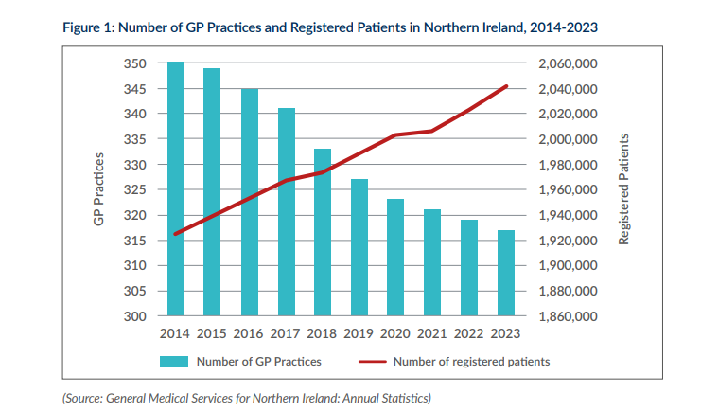

The Trust has recently looked to address some of the workforce constraints, by introducing a skill mix comprising paramedic, nursing and pharmacy staff to ensure that service users have timely access to the right care at the right time by the most appropriate professional. This is in keeping with the strategic direction set out in Health and Wellbeing 2016-2026 Delivering Together – this recognised that the primary care service in Northern Ireland was still largely based on GPs working independently with some input from other disciplines. And it committed that in the future, the focus of the system would be increasingly on keeping people healthy and well in the first place with collaboration between general Practitioners (GPs) and a multidisciplinary primary care team.

In addition to further address the challenges facing the service, Belfast Trust and GP colleagues within the existing Trust and Primary Care Forum have come together to consider and appraise various options in terms of the most sustainable model for a modern Primary Care service for Belfast. The options appraisal is detailed in Section 5.

In the longer term and in accordance with the strategic direction set out in the Urgent and Emergency Care and No More Silos, the optimal option would be an integrated urgent care service comprising of an urgent assessment and treatment centre out of hours incorporating a multi- disciplinary team, however, this would require further time and investment to facilitate development of a fully integrated out of hours urgent care service.

In the interim and based on the information available to date, the preferred option is to have a multi-disciplinary service on one site serving all of the population of Belfast. This option will comprise nurse, paramedic and pharmacy cover within the service and reduce the number of GP hours needed. Ultimately, it will also comprise Independent Prescribers and Advanced Nurse Practitioners. This will allow patients to access the right level of care depending on what they need. The proposal, which is now being issued for formal consultation, is to consolidate all resources on one base in the MIH/Crumlin Road as opposed to the two current bases.

# **Section 2: Current service profile**

GP Out of Hours (OOH) aims to provide, for urgent conditions, a comprehensive, safe and efficient out of hours service to the Northern Ireland population, as well as to the non-resident transient population, who are also entitled to General Medical Services (GMS) services until the patient’s own GP surgery is next open.

GP Out of Hours services are closely linked to other unscheduled care services across the health sector, including daytime GP services and Emergency Departments. There are currently 19 OOH centres across Northern Ireland; these are managed by 5 different provider organisations. Three of the OOH services are provided by HSC Trusts while two are provided by Mutual organisations.

The BHSCT GP OOH service provides an Out of Hour urgent care service to the Belfast Population (439,802), who are entitled to general medical services out of hours from 6pm – 8am weekdays and weekends over the 24-hour period, including bank holidays.

From Monday – Friday, the Belfast service provided from 6pm till midnight with up to 3 GPs at each base (Beldoc and Sebdoc) and 1 GP at each base from midnight till 8am at weekends, the service is provided between 8am and 6pm with a maximum of 11 GPs at Beldoc and a maximum of 11 GPs at Sebdoc. There are 9 x 6 hour shifts on each site which are staggered to meet peak periods of demand. From 6pm- midnight, with 8-9 GPs operating from each site and from midnight to 8am, the number of GPs reduced to one at each site.

The current service provision is mainly telephone consultation (>90%) with either: telephone assessment, treatment and advice from a GP which may lead to:  
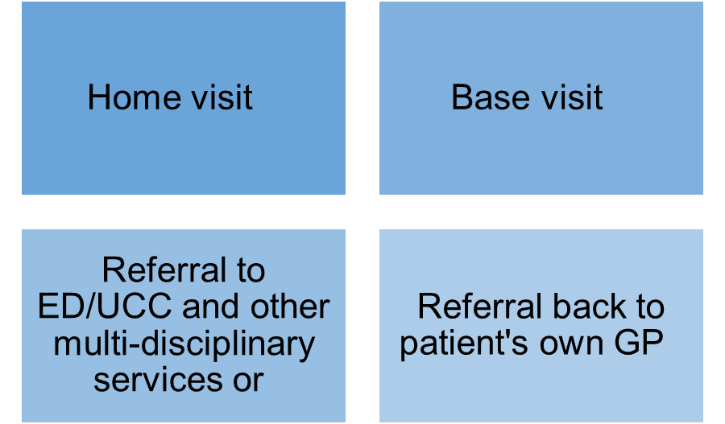

GP OOH service also provides:

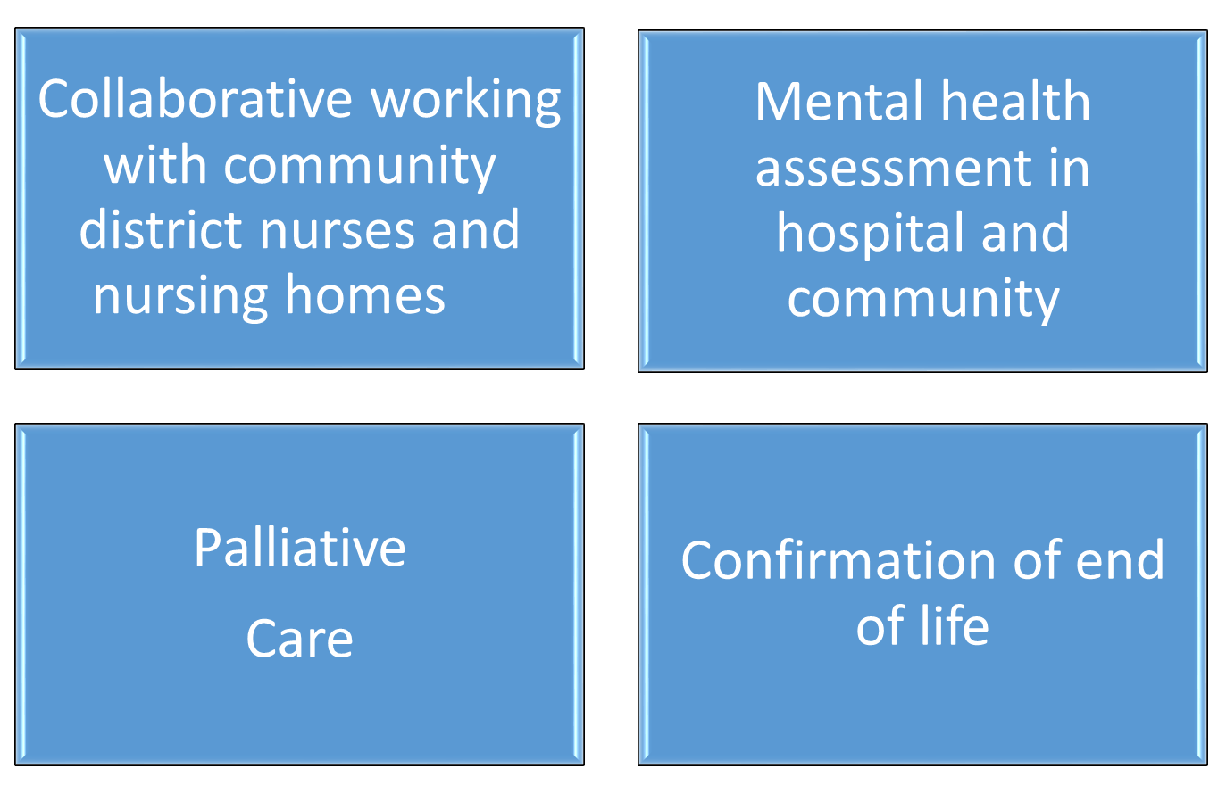

Over recent months, the Trust has made significant improvements to the delivery of the current 100% GP led service. The virtual one site GP OOH service means that all telephone calls are placed on one technology system and a single process for access. This means there is equity and efficiency in the service provision for service users, as the General Practitioners who are working in Out of Hours are able to work through the patient calls, whether they are in either N&W or S&E. Previously, each site would only do their own calls- meaning that either base would have a longer or shorter wait, depending on which area you are in. This has also proved more efficient as the service has historically had to work with reduced GPs and call handlers, therefore, the service is able to utilise the GPs more effectively to cover all areas.

Previously, when there were not sufficient GPs to cover two bases, one base would have to close. There is no longer a requirement for contingency arrangements, which resulted in a reduced service. The GP OOH works as one service, and this provides a timely service to all service users. The patient experience is therefore not negatively affected by this change, and as highlighted above ensures greater equity for people from any location in Belfast.

This improvement has worked well and has already shown that patients can and do travel to either site, if required to access the out of hours service. It is important to remember that this service is predominantly telephone prioritisation and consultation, and the number of base visits are relatively low and are usually to collect prescriptions.

**Introduction of Skill Mix**

Traditionally out-of-hours services have been provided by doctors but increasingly may be delivered by a range of healthcare professionals. The strategic direction of primary care out-of-hours emergency care is the development of a more responsive system, which is fully integrated and joined up with the wider health and social care network. At present in Northern Ireland, there are five GP out-of-hours providers. Three services are provided by Trusts (BHSCT, SEHSCT & SHSCT) and two services are mutual organisations (Western Urgent Care and Dalriada Urgent Care).

The Trust has now introduced a skill mix (with nursing, paramedic, and pharmacy staff) to the current out of hours service, which had been totally 100% GP led. This means less reliance on GPs to cover all aspects of the service and to make the best use of resources. It will also result in extra capacity in the system with nurses undertaking prioritisation and supervision and build resilience and sustainability in the multi-disciplinary team.

Paramedics will work within the service at weekends doing the home visits for GPs, which means the GPs are able to focus on prioritising and responding to urgent/routine calls with consultations, rather than spending time going to patients’ homes. The paramedic will assess the patient and contact the GP to plan care and treatment. In the future, it is hoped that this service can expand to paramedic prescribing. This service will provide a timely and more efficient service with the right health professional with appropriate patient for appropriate care.

The pharmacist will assist with prescriptions and giving out appropriate education to patients and providing some minor injury clinics for patients. This will again be supporting the GPs and reducing the need for them to do work which can be provided by other health professionals. This will free up the GPs to focus on the more urgent and routine calls which require their input within the service.

Skill mix will not be utilised during the period known as the “red eye” from 12 midnight to 8am 7 day a week. From a financial viewpoint, staff will be recruited via a bank mechanism and therefore the service will not be subjected to agency costs.

**Activity**

The current activity across the existing 2 bases is detailed below estimates an average level of demand for the 3 main areas of delivery which:

* Availability of a clinician to take calls and deliver advice to the patient (calls prioritised as emergency, urgent and routine). This area assumes that any patient classified as emergency is immediately directed to an Emergency Department if required
* The number of patients who need to attend the base for further assessment and treatment
* The need for a clinician to carry out visits to the patients’ homes in the evenings and weekends (nursing home calls, bloods and end of life verification).

**Demand for the BHSCT GP OOHs service**

Table 1 below shows the average monthly total of calls to BHSCT GP OOHs over the year and indicates a service, where similar to other services, demand was lower during the pandemic years but has now increased to close to pre pandemic levels.

However, the trend in category of demand is highlighted in the tables below.

**Table 1: Total calls – average monthly activity**

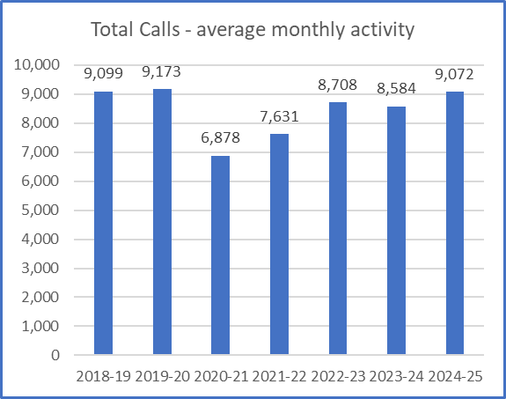

The trend, within overall activity for this year, is demonstrated in the graphs is compared to previous years:

**Figure 2: Advice calls**

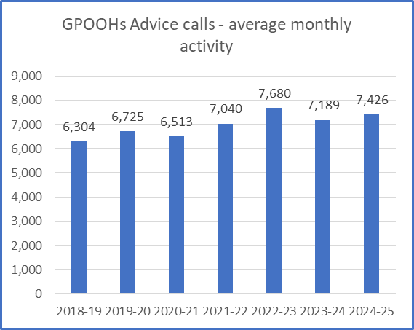

**Figure 3: Base visits**

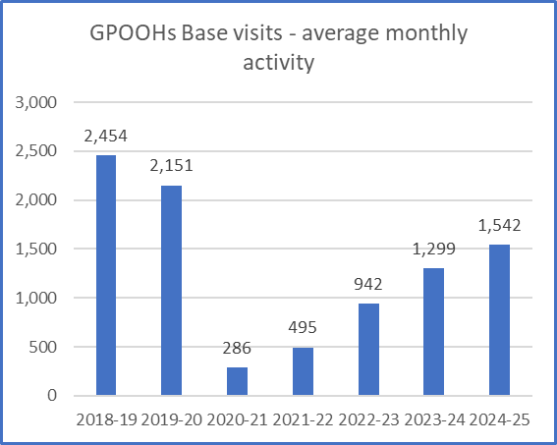

**Figure 4: Home visits**

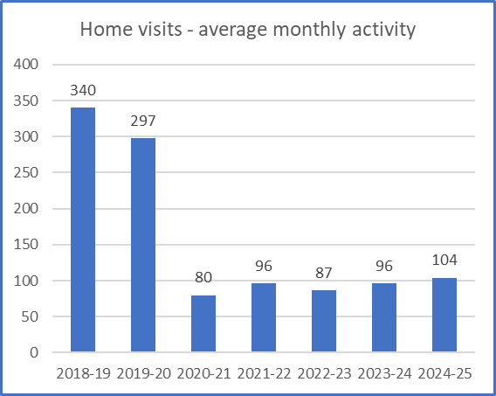

An analysis of demand for the service has been undertaken taking into account the pattern of presentation. This analysis is based on the following assumptions about overall annual demand. The demand assumptions have been based on actual activity during 2022/23 and 2023/24 figures have been added for completeness along with the annual variation.

|  |  |  |  |  |  |  |
| --- | --- | --- | --- | --- | --- | --- |
| Method | Annual demand 2022/23 | Monthly average | Variation since 2019 | Annual demand 2023/24 | Monthly average | Variation since 2022/23 |
| Advice calls | 92,160 | 7,680 | +955 | 86,262 | 7,189 | -5,898 |
| Base visit | 11,304 | 942 | +1209 | 15,591 | 1,299 | +4287 |
| Home visit | 1,044 | 87 | -210 | 1150 | 96 | +106 |

It is accepted, that in exceptional circumstances, the pattern of activity may change but the assumption of this paper is that it will return to the levels indicated in the figure graphs above. A surge in activity took place in December 2022 (due to an outbreak of Strep throat) and is reflected in the graph below but this also shows activity levels stabilising.

**Figure 5 - Base visits for both N&W and S&E site**

Virtual merger of GPOOH

The increase in base visits is in line with post covid recovery. The virual merger of the OOH computer system commenced with a pilot in March 2022. Patients from either N&W or S&E may have visited either base for a consultation.

**Children’s services within GPOOH**

**Figure 6**

GPOOH service provides an urgent care service for children, who may also require a base or home visit, after telephone triage and assessment. The data above shows the no. of children between the ages of 1-15 years using the GPOOH service. Figure 7 shows that the 0-5 year olds are the most frequent to require a base visit.

Please note the virtual merger (combined telephone triage screen of N&W and S&E telephone triage system) commenced in 2022 and will have affected the results as service users from within N&W or S&E can use either base to ensure an equitable service.

**Figure 7- Base visit Demand for Childrens services within GPOOH**

Virtual merger

**Figure 8 – Weekly Call volumes** 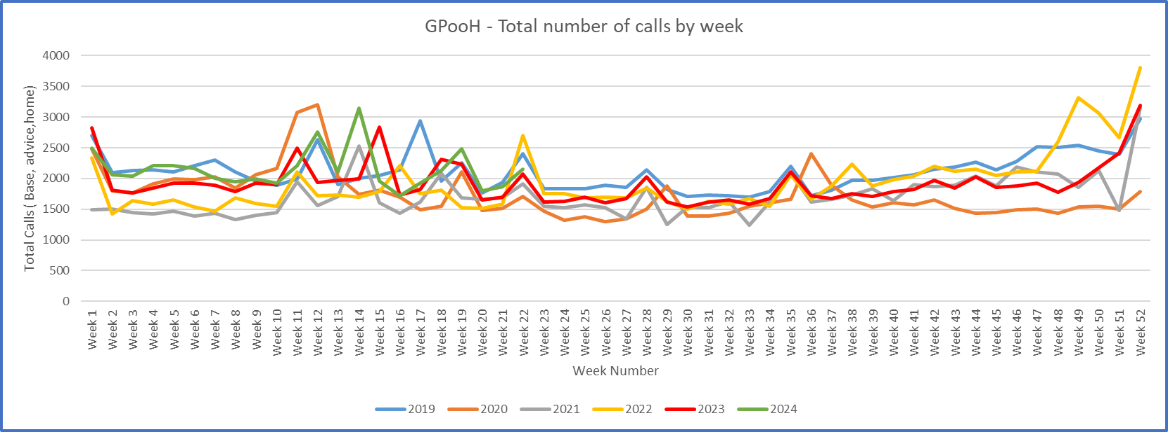

**Management dashboard**

A GP OOHs management dashboard is now in place and activity levels in each of the 3 areas (advice, base and home) are reviewed regularly and seasonal demands are always factored into planning assumptions.

**Pattern of demand**

The levels of demand above have been analysed further to determine when the busiest times are to match capacity with demand. The table below shows the outcome of this. These have been identified as shifts and are described as follows:

* Red eye – 12 midnight to 8am – 7 days per week – the assumption is that this is GP led only and, in the interim, does not change weekday evenings Monday to Friday 6pm to 12 midnight

Weekends and bank holidays are broken down into the following shifts to reflect the demand and the number of staff required:

* Mornings 8am to 1pm
* Afternoons 1pm to 6pm
* Evenings 6pm to 12 midnight

The graph below shows the trend of typical call activity across an average weekend day which reflects the figures above.

**Figure 9 – Weekend trend calls**

The Trust has considered all of this quantitative data and notes that the number of home visits has greatly decreased from 340 in 2018/19 to 104 in this current period. Similarly, visits to the base by patients have seen a decrease of 912 during this time period. Whereas there has been an increase of 1122 calls for advice.

# **Section 3: The need for change**

**Strategic Context**

The review carried out by Professor Bengoa in 2016 [Systems, not Structures](NULL) emphasised the need for change and described the current health and social care system as a burning platformfaced with numerous challenges including increasing demand, workforce issues, increasing expectations and an ageing population. It emphasised:

*“The need to move from predominantly GP led model of care to more blended approach that accommodates rich range of professionals working in partnership to meet the needs of the practice population”*

Delivering Together: Health and Wellbeing 2016-2026 was the strategy in response to the Bengoa Review acknowledged that for too long HSC services were planned and managed around structures and buildings. It recommended that the Health and Social Care system in Northern Ireland needed to organise itself to deliver by ensuring that the administrative and management structures make it easier for staff to look after the public, patients and clients.

Over recent years, it has become normal for those attending Emergency Departments to experience overcrowded waiting rooms and long waits to be seen and treated. The Belfast trust figures from last year showed that the number of patients who waited more than 12 hours in emergency departments (EDs) in Belfast trust EDs increased by 3% between March 2023 and March 2024 (increase June 2022 – June 2023 9%) . The current model of unscheduled care in Northern Ireland is heavily focused on accidents and emergency even though most patients attending Emergency Departments do not fulfil the criteria for that category of care. (See below for definitions agreed by DOH review group)

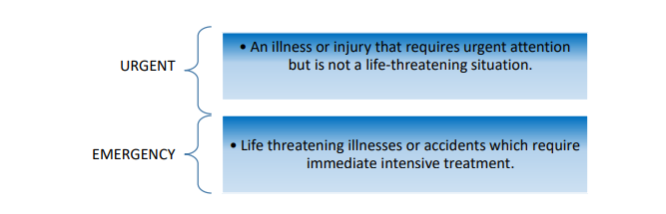

To seek to address these issues, [the Review of Urgent and Emergency Care](NULL) was launched on 26 November 2018, with the aim of establishing a new regional care model for Northern Ireland. The review did recognise that there had been an over-reliance on the Emergency Departments. During the consultation on the review, the following elements were highlighted as enablers in reviewing how urgent and emergency care serves the population of Northern Ireland:

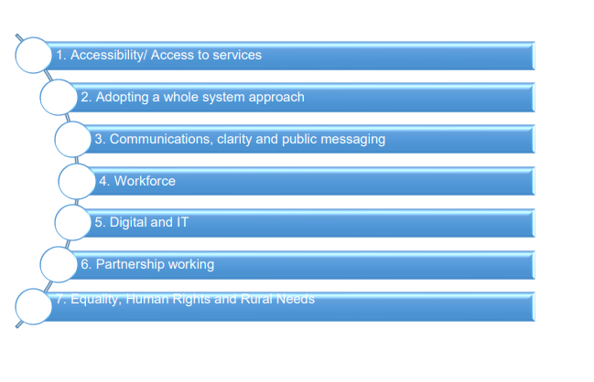

A number of priorities were identified to transform and improve services so patients can receive the right care, from the right person, as quickly as possible and improve the service user experience, by ensuring greater accessibility to services.

From the review and consultation, three priorities were identified:

1. **Creating an Integrated Urgent and Emergency Care Service**
2. **Capacity, Co-ordination, and Performance**
3. **Intermediate Care**

The review committed that there would be an Integrated Urgent and Emergency Care Service, which would include:

* An **Urgent Care Centre** model across Northern Ireland by winter 2023 where patients with illnesses and injuries which are not life threatening but require urgent attention can be assessed and treated. Patients can attend an urgent care centre via **Phone First**, GP referral or by walking in.
* A range of **Rapid Access Clinics** so patients can be seen by the right clinical specialist for assessments, tests, and diagnosis; without having to go through an Emergency Department. Appointments can be booked by GP practices and Phone First providers.
* A regional **Phone First** service, accessed through the telephone number HSC 111 for help and advice in 2024. Patients will still call 999 for emergencies, serious illnesses, or injuries.
* The review concluded that these proposed reforms would help to ensure all citizens in NI (Northern Ireland) have access to equal access safe urgent and emergency care services by providing the right care at right time in the right place.

**Phone First**

Phone first is a clinical triage advice and guidance service designed to make it easier and quicker for service users with an urgent need to get the right advice or treatment they need. It provides advice, guidance and navigation for people who are unwell and considering attending an Emergency Department. It will operate all day every day. At evenings and weekends, it will also provide access for people who wish to contact the GP Out of Hours services. The ‘Phone First’ model needs to be accompanied by establishment of Urgent Care Centres and rapid access assessment and treatment services in all Trusts.

**Reform of GP OOH**

As part of the new model, the review stated that the current GP Out of Hours service will be reshaped to form part of the wider integrated urgent and emergency care service.

Although completion of the Urgent and Emergency Care Review was delayed due to the COVID-19 pandemic, the Department launched the [No More Silos Action Plan](NULL) in October 2020 to set out the direction of travel for Urgent and Emergency Care. ‘No More Silos’ (NMS) was developed by officials and clinicians from both primary and secondary care who form a regional NMS Network

The NMS Action Plan set out 10 key actions to be taken forward to ensure that urgent & emergency care services across primary and secondary care could be maintained and improved in an environment that is safe for patients and for staff. This was in terms of the pressures that arose out of COVID 19, existing winter pressures, and the systemic issues faced by emergency care generally.

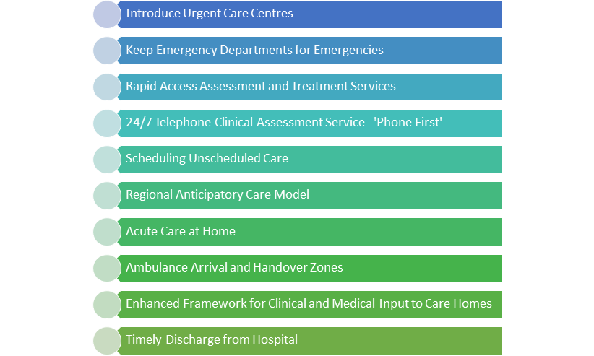

**Challenges**

Urgent and emergency care services including GP OOH have been under significant, and increasing, pressure for many years, with additional pressures arising from the COVID-19 pandemic

As previously referenced, the BHSCT GP OOH service has had ongoing issues for a number of years trying to provide a full GP OOH service for both bases BELDOC and SEBDOC. This included having to close bases due to no GP cover for mainly the BELDOC site for Saturday and Sunday OOH services and on occasion, 1 episode of closure during a weekday. This, in turn, meant that patients were redirected to the already over-stretched services at the Urgent Care Centre at the Royal Victoria Hospital. When the GP OOH service had to move to the contingency arrangements of closing one base due to shortage in GP cover, the Trust undertook an equality screening of the temporary arrangements but made a clear commitment that if the Trust were to make the move to one site on a permanent basis, that a full public consultation would be undertaken.

**Workforce**

Challenges in the workforce are due to a smaller number of Whole Time Equivalent (Full time) pool of GPs in Belfast and all Northern Ireland. The workforce composition is changing with some doctors choosing to work on a part-time basis and the workforce gender balance has changed from a predominantly male one to a 60% female/40% male ratio as of 2023. 21% of the NI GP workforce are aged over 55.

Due to a myriad of complex factors, the Trust has struggled to populate GP OOH rota over recent years and securing adequate GPOOH cover becomes particularly challenging during holiday periods.

Almost 20% of Northern Ireland's GP training places were yet to be filled, only days before the new academic year was due to begin in 2023, However this situation has much improved in 2024 with an increase in the competition level. There has also been an increase in General Practice training places in NI by 35% owing to the increased demand for primary care physicians

It is reported that whilst some new GPs have qualified, the number has not been in keeping up with the number of older GPs that are either retiring or leaving the profession. As recently referenced by Professor Kamila Hawthorne, Chair of the Royal College of GPs across the UK:[2]

*“Many GPs are experiencing burnout, low morale and a sense of moral distress at not being able to offer patients access to much-needed care. We know that when GPs do leave the profession earlier than planned, it is often due to the pressures of the role which results in a vicious cycle effect, whereby the workloads of those who remain in practice intensify.”*

According to the most recent national survey of Royal College of GPs in June 2024, those who declared that they would no longer be working in General Practice in one, two or five years gave the following reasons:  
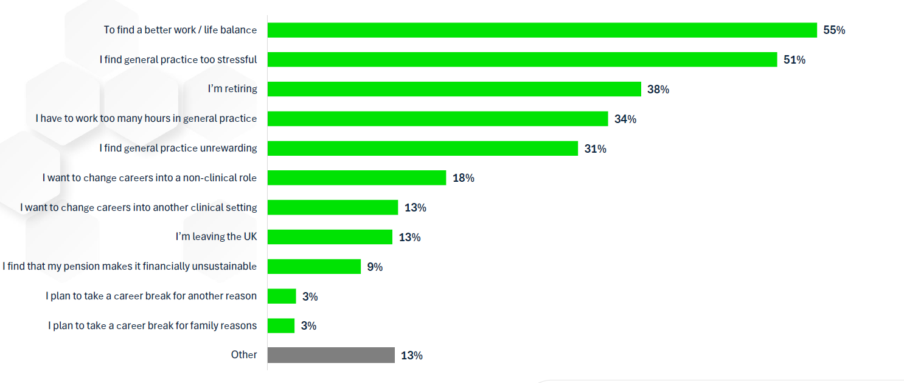

*n.b. it should be noted that this applies to all General Practice, not just GP OOH.*

An [RQIA review](NULL) in April 2021 had already highlighted a number of challenges with the present GP Out-of-Hours Service model and considered that

***“This model may not be sustainable into the future. …they found that increasingly fewer GPs were contributing to the GP Out-of-Hours Service, a consequence of: increasing pressures facing daytime GP Services; increasing pressures in the out-of-hours service; limited flexible working arrangements; and financial implications associated with working in the out-of-hours service such as static pay and changes to pension arrangements. If no action is taken, the result is likely to be fewer locations able to provide GP Out-of-Hours Services, as well as increasing gaps in rotas and services in those locations that remain, with consequent delays and longer waiting times for patients”.***

Interestingly, The Expert Review Team was concerned in undertaking the review found that many patients perceived the GP Out-of-Hours Service as a continuation of daytime GP services rather than an urgent care service. As noted in the Urgent and Emergency Care Review, care delivered through GP Out-of-Hours Services is intended to differ from the type of care delivered within a GP practice during normal working hours. This public perception is important in relation to the service’s ability to respond to demand. The care provided is not intended to be a continuation of the normal GP service, but rather, is intended to assess and treat only the most urgent problems which cannot wait until the normal GP service is available. Anecdotally, the Trust would find that this perception has heightened since Covid, in the event when people could not get through to their GP during the day.

The introduction of a Multi-Disciplinary Team would help to alleviate some of the workforce challenges and remove the sole dependency on GP colleagues by moving from a GP OOH to a Primary Care Out of Hours service. It would ensure that the patient would access the right care at the right time from the right professional.

**Performance**

The service has been failing to meet its key performance indicators – the following table shows the volume of calls which are serviced within the target timeframe and those that do not.

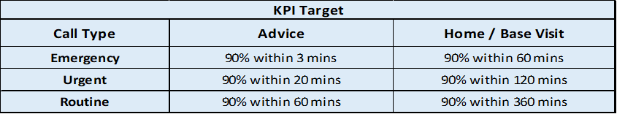

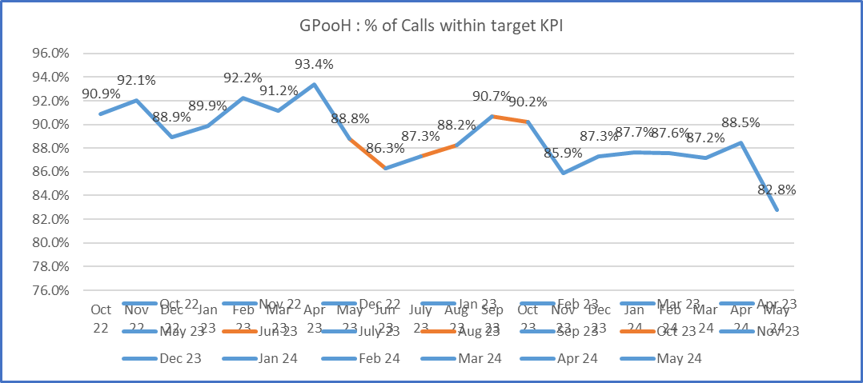

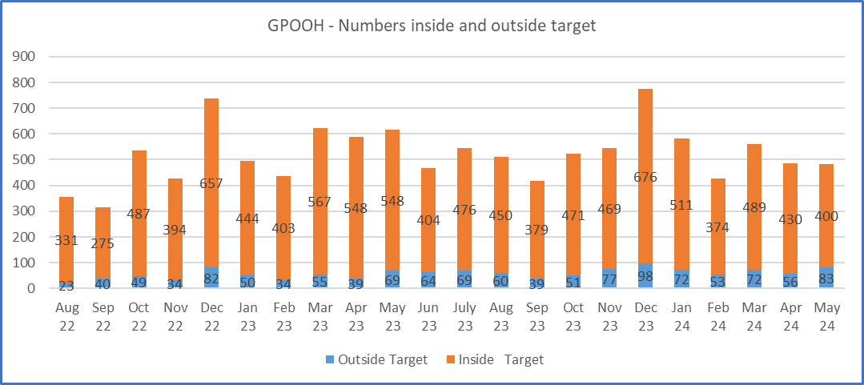

The Trust needs to match demand to capacity with the patient receiving a quality and responsive service in the right place at the right time by the right clinician (urgent/routine) (advice, base visit, home visit).

**Value for money**

It is important to highlight that the Trust has a statutory duty to make the best use of public resources. With the huge challenges in delivering the current 100% GP led service for a number of years, the Trust has needed to offer enhanced rates in order to fill the shifts.

Moving to one site with the newly introduced skill mix would make considerable economies of scale by consolidating resources and would address the significant, increasing overspend that the service is facing year on year, projected overspend for current model for 2024/2025 is £1million.

The current system of a two-site model has been inherited from the two legacy Trusts in 2007 which served two distinct populations in North and West Belfast and South and East Belfast, after the Review of Public Administration. The introduction of the virtual screen has already confirmed that patients can and do travel to either site, if required to access the out of hours service. The activity detailed in the previous section demonstrates that this service is predominantly telephone prioritisation and consultation, and the number of base visits are minimal and are usually to collect prescriptions.

**Rationale**

These challenges are not unique to Belfast and can be attributed to several factors including demographic change with an ageing population with more chronic conditions, daytime service pressure in primary care, and increasing demand for services.

In essence, it is within this context, that the Trust needs to establish a sustainable, resilient primary care workforce for the future to provide an equitable and efficient out of hours of service, and to ensure that the patient has access to the right person at the right time in the right place.

The Trust is committed to providing a safe, effective and compassionate service for the greater Belfast area and is therefore proposing that it will amalgamate provision for Primary Care OOH for Belfast onto one site. This will help to consolidate and optimise utilisation of the available resources and to deliver a value for money service which is responsive and equitable to the population of Belfast Health and Social Care Trust

# **Section 4: Engagement and Consultation**

The Trust has engaged with a range of stakeholders to discuss and inform work to change how we provide the GP OOH service for all the population of Belfast. The Trust has a statutory duty in accordance with the Health and Social Care Reform Act (NI) 2009 to involve service users, carers and the public in the commissioning, planning and delivery of all Health and Social Care (HSC) services. (Commonly known as Personal and Public Involvement or PPI). The Trust also has a statutory duty to subject its proposals to an equality screening to determine if there is potential adverse impact on any of the people protected by the 9 Section 75 (equality) groups and if there is potential, the Trust must address this by taking measures to lessen the impact or choose an alternative plan. The 9 Section 75 groups include:

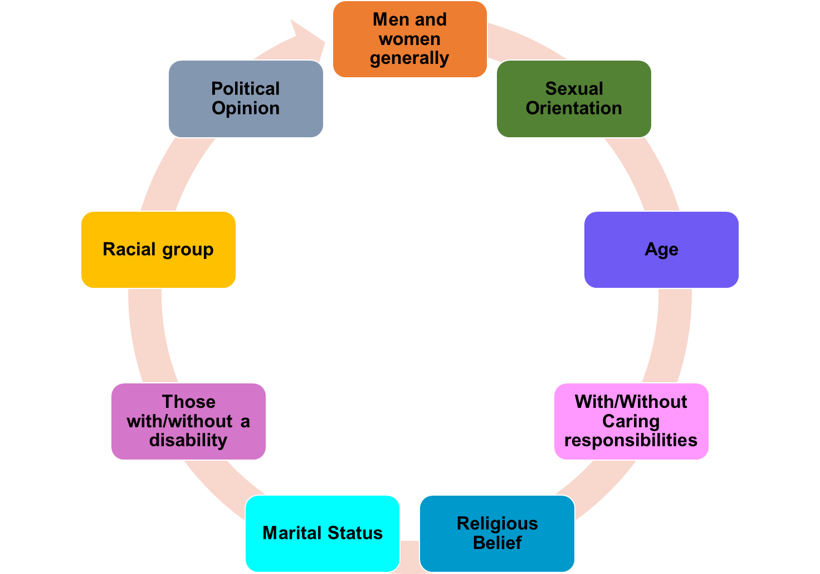

The Trust recognises not only their legislative responsibilities to involve, consult and assess the equality implications of their proposals, but also is committed to working in partnership with key groups including patients, carers, families, staff and trade unions and primary care and other interested stakeholders. This collaborative approach aids decision making and ensures that all perspectives are considered.

In January 2022, the Trust embarked on work to transform unscheduled care and through the No More Silo (NMS) work hosted a focus group with representatives from the NMS service user and carer reference group regarding GP OOH. This session focused on the service in place at that time and explored potential areas for improvement including the introduction of a nurse prioritisation and consultation system and the integration of GP OOH into a more co-ordinated unscheduled care 24/7 service. At this stage, a range of issues were identified to support transformation including GP recruitment, understanding of the implications of a nurse prioritisation and consultation system and more effective public messaging to increase awareness about how and when to access GP OOH i.e. understanding ‘urgent’ care service and options available.

Further engagement was undertaken in 2023. This focused on the proposed one-site model. A range of stakeholders were identified who would potentially be impacted by service change proposals both in relation to staff who deliver the service and the users of the service. A series of engagement sessions were held to engage stakeholders to explore the proposed service changes.

**Overview of engagement events**

* Disability Steering Committee, 18th September 2023 – comprises Trust representatives, disabled people and a range of representative organisations.
* GP’s (Online meeting), 1st September 2023
* Belfast Trust Primary Care Forum (Online meeting), 20th October 2023 - including Trust Directors and Co Directors and GPs, representing the LMC and GP Federations.
* GP OOH staff (Online meeting), 16th November 2023 - staff employed by the Trust (GP’s, drivers, administration staff),
* Service users, carers, community/ voluntary sector, politicians, Care Home staff and Trust staff (Online meeting), 21st November 2023
* Service users, carers, community/ voluntary sector, politicians, Care Home staff and Trust staff (Face to face meeting), 22nd November 2023 at Girdwood Community Hub, Belfast
* Surestart, (parents of children under 4), 15th April 2024 at Donegal Pass Community Centre, Belfast
* Individual stakeholder meetings – held at the request of individuals:
  + Alliance Party of Northern Ireland – 5th January 2024

At each of these events, the Trust presented on the aforementioned strategic context and the challenges the Trust had faced over recent years in maintaining an effective, efficient and equitable GP OOH service across the two original sites. Urgent and Emergency Care representatives were transparent and explicit that the two-model site was not viable due to the issues of finance, workforce, performance and sustainability. Each engagement session provided the opportunity for stakeholders to discuss the proposals presented and consider the benefits and barriers.

Key themes emerged from the engagement sessions which are summarised below:

*One-site model:* There was broad agreement for a one-site model from all stakeholders including GP OOH staff and service users. The benefits of this were in relation to making the service more efficient for the delivery of a GP OOH MDT service based at one-site. It was recognised that GP OOH, as part of wider emergency care, needs to be effective to potentially reduce pressures on other parts of the system. Consideration needs to be given to accessibility requirements in relation to physical access and different communication needs such as access to interpreter services. There was a concern raised that a move to a one-site model could be seen as an opportunity to reduce staff levels and it was recommended that a workforce planning exercise be undertaken.

*Physical location:* Overall it was recognised that the infrastructure for the location of a GP OOH service was important i.e. parking, transport, safety, accessibility and transport links need to be mapped and tested. Access to other services was raised with close proximity to an ED being cited frequently as a core element of GP OOH services.

Feedback was provided about the current sites located at Knockbreda and Crumlin Road and it was acknowledged that there is a need to recognise the different cultures accessing services, but that this should not be the main driver for determining the location of a future service. Concerns were raised in relation to the specific site location and whilst it was acknowledged that it was handier to have two sites, there was clear recognition that the majority of patients are not seen face to face and therefore actual location should not be a major issue in relation to progressing the one-side model.

Home visits were referred to which may be covered by the most appropriate member of the MDT, however it was identified that with a change in base, when home visits are required that that these could take longer to travel to and from.

Concerns were also raised about the potential impact and unintended consequences for increased attendances at other Trusts ED services due to a move in service site. The Trust will communicate with South Eastern and Northern Trusts in relation to any change in service.

*Multi-disciplinary Team:* There was agreement that a strengthened skill mix approach for the delivery of GP OOH service was a positive move. The prioritisation and consultation system was welcomed but some responses highlighted concerns about availability of telephone cover and timings of call backs. The important roles within a MDT approach was recognised with reference given to nursing and pharmacy. It was suggested that a move to one-site may present the opportunity to review pathways in place for certain conditions to utilise MDT skills rather than direct referral to a Doctor e.g. mental health which may also support reduction in direct referrals to ED. The end-of-life pathway and involvement of Advanced Nurse Practitioners was also raised.

It was highlighted that access to pharmacy advice is important but physical access to a pharmacy re collection of prescriptions, was also important from a patient perspective in relation to accessing a late night /overnight service and potential travel costs and time associated with this. Suggestions were provided to support a standardisation of practice to improve access to prescriptions and medication in OOH situations.

*Communication*

The need for enhanced communication was a common thread throughout all engagement sessions with a clear need to enhance public messaging about how to access GP OOH and importantly its role within an ‘urgent’ care model. The Trust is committed to developing a communication strategy to ensure that public messaging is strong, consistent and comprehensive. It is important that all people in Belfast know what services are available and when it is appropriate and how to access them.

# **Section 5: Consideration of the Options and the Preferred Option**

The Trust laid out a number of different options, which had been largely influenced by the findings of the Department of Health - No More Silos (NMS) Group and the Review of Unscheduled and Emergency care. They were also informed by conversations with Health and Social Care Board (SPPG), discussions at the Trust and GP partnership meetings, engagement with service users and carers, community services and urgent and emergency care /GP OOH colleagues.

It is important to highlight that Out of hours services are designed and resourced to focus on those patients who have care needs that are urgent, but not an emergency. It is clinically preferable to have an out of hours service co-located or close to an emergency department, Urgent Care Centre, or Minor Injury Unit.

The sub-group leading on this proposal have also engaged with the Capital Redevelopment Team, who are responsible for the whole Trust Estate and deal respond to requests for accommodation across the Trust.

The options are illustrated below:

**Options**

|  |
| --- |
| **Option 1:** Status Quo – do nothing |
| **Option 2:** Consolidate both GP OOH Services into Knockbreda H&W Treatment Centre or other Health &Wellbeing centre in Belfast |
| **Option 3:** Consolidate both GP OOH Services onto Crumlin Road site |
| **Option 4:** Move and consolidate both GP OOH services onto RVH site, alongside Urgent Care Centre and Emergency Department |
| **Option 5:** Integrate to Mater hospital site using current infrastructure |
| **Option 6:** Develop an integrated urgent primary care service in a community setting |
| **Option 7:** Regional Out of Hours service |

**The options were assessed against the following objectives:**

|  |  |  |
| --- | --- | --- |
| No. | Description of objective | Measured by |
| 1 | To match demand to capacity with the patient receiving a quality and responsive service in the right place at the right time by the right clinician (urgent/routine) (advice, base visit, home visit) | Key performance indicators  **Urgent – 100% within 20 minutes**  Current performance: 87%  Current performance – May 2024 : 91%  **Routine – 100% within 60 minutes**  Current performance : May 2024 : 43% |
| 2 | To develop the service to meet the strategic priorities of the Trust and the Urgent and Emergency Care pathways throughout the NI region. | Meet the Key Performance Indicators of the Out of Hours Service (as in objective one)  Meet the recommendations of the Urgent and Emergency Care review  Meet the demands of the service in ensuring that the patient requires the correct service in the right place at the right time by the right clinician  Patient satisfaction and involvement measures |
| 3 | To ensure workforce resilience of the service | Key performance indicator performance as per objective one  GP shift fill rate and performance in comparison to activity  Nurse hours performance in comparison to activity  Paramedic hours performance in comparison to activity  Pharmacist hours performance in comparison to activity |
| 4 | To deliver a value for money service which is responsive to the population of Belfast Health and Social Care Trust | Key performance indicator performance as per objective one  GP shift fill rate and performance in comparison to activity  Nurse hours performance in comparison to activity  Paramedic hours performance in comparison to activity  Pharmacist hours performance in comparison to activity  Cost of service compared to budget |

**Option 1** – the status quo – the option to do nothing and keep the two sites was not shortlisted as it has been difficult to keep both bases staffed and is not a long-term option for a viable and equitable GP OOH service for the population of the Belfast Trust area. The current model is not achieving the necessary performance indicators and projected to be overspent by £1 million.

**Option 2:** Consolidate both GP OOH Services into Knockbreda Wellbeing and Treatment Centre has been shortlisted.

**Option 3:** Consolidate both GP OOH Services onto the existing Crumlin Road site

**Option 4:** Move and consolidate both GP OOH services onto RVH site, alongside Urgent Care Centre and Emergency Department has not been shortlisted. **:** There was overwhelming consensus that the Royal site is already extremely busy and the RVH site is the centre for regional trauma which does not fit the profile for urgent primary GPOOH service.

**Option 5:** Develop an integrated urgent primary care service in a community setting. This option has been shortlisted and would be the ultimate preferred option for the long term but this is not feasible at present as it is not considered to be a sustainable model under current funding envelope available.

**Benefits and Disadvantages of each shortlisted option**

|  |  |  |
| --- | --- | --- |
|  | Benefits | Disadvantages |
| Option 2: Consolidate both GP OOH Services into Knockbreda Wellbeing and Treatment Centre has been shortlisted. | Modern building  Car parking for service users | Not in line with NMS to be co- located to urgent care centre /ED Dept.  Shared facilities with in - hours services.  Not enough capacity for multi- disciplinary team. |
| Option 3:Consolidate both GP OOH Services onto the existing Crumlin Road site | Co- located to ED dept. Mater hospital as per NMS DOH  Encompass Phone First service  Can facilitate increased multi- disciplinary (MDT) service in GP OOH  Capable to expand or improve upon current structure with space available at current site. | Building requires considerable refurbishment /upgrade  Service users can park OOH on the Crumlin road |
| Option 5: Develop an integrated urgent primary care service in a community setting. | Urgent primary care service consisting of Phone Frist with urgent assessment and treatment service encompassing MDT to assess and treat patients in the community. | This option has been shortlisted and would be the ultimate preferred option for the long term but this is not feasible at present as it is not considered to be a sustainable model under current funding envelope available. |

**Preferred Option**

The preferred option is to consolidate the service on the Crumlin Road site – this will provide accommodation to the Phone First staff and the Primary Care out of hours staff.

**What would this mean for patients, carers and staff?**

**What does this mean for patients and carers?**

Patients will have access to a more equitable service, whereby regardless of where someone lives in Belfast. The one site model will offer timely access to the population of Belfast and will ensure a more efficient way of working. Patients will get to see the appropriate practitioner according to their need.

**What does this mean for GP and staff?**

In dealing with any proposal the Trust is committed to ensuring that the process is characterised by openness, transparency, involvement, recognition and engagement with its staff and Trades Unions.

The Trust will put in place a range of support mechanisms which can be tailored to the specific needs of the individual. These may include, as appropriate, individual staff support, induction, skills analysis to identify staff needs and support the transition to the agreed change in service, advice and guidance on Human Resource Policies and Procedures.

**Partnerships**

The Trust will work in partnership with Trades Unions and in accordance with the agreed Frameworks.

These proposals are subject to this consultation process and an equality screening which will inform the decision to be made. The equality screening document (Appendix 1) provides more detail on the potential impact on patients, carers and staff.

# **Section 6: Conclusion and Recommendations**

The preferred option is to reconfigure GP Out of Hours provision to the current site on the Crumlin Road. The Trust will move from a service solely dependent on GPs to the introduction of a multi-disciplinary primary care Out of Hours service. In the context of the proposal to reconfigure GP Out of Hours Services and the consideration of the available options this document was approved for formal consultation by Belfast Health and Social Care Trust at the Trust Board meeting on 3rd October 2024.

The Trust will consult on this proposal for 13 weeks from 3rd October 2024 to 2nd January 2025 and will take time to diligently consider all the responses, before developing a consultation feedback report.

We are now seeking views from patients, carers, the public, and other key stakeholders on the proposed way forward. Please refer to Appendix 2 for the consultation questions.

# **Section 7. Your Opportunity to Have Your Say**

This document represents a formal consultation between the Belfast Trust and the people we serve on how our Primary Care out of hours services should be delivered. The consultation period will open on 3rd October and closes on 2nd January 2025.

We are sending this paper to staff, key groups and stakeholders and Trades Unions. We will also respond to requests for further clarification and discussion as best we can. The documents will be available on both the Trust’s intranet and internet pages.

**Appendix 1: Equality screening**

**Equality, Good Relations and Human Rights SCREENING TEMPLATE**

# **Appendix 1: Equality Screening Process**

**Section 1: Policy Scoping:** This notes the background & context of the policy/proposal/decision being screened.

**Section 2: Screening Classification:** The purpose of this section is to consider the policy/proposal/decision in terms of its relevance and likely impact (actual/potential) on equality of opportunity, disability/good relations duties and human rights. Policies may be screened out at this stage provided they are clinical and/or technical and have no relevance whatsoever to equality, disability/good relations and human rights and have no bearing in terms of its likely impact on equality of opportunity or good relations for people within the equality and good relations categories.

**Section 3: Evidence Used to Assess Impact:** This section records the quantitative and qualitative data gathered and considered across the 9 protected groups (plus multiple identities) to assess the impact of the policy/proposal/decision on staff and service users.

**Section 4: Consideration of Impact & Identification of Mitigation and/or Alternative Policies** given the evidence.

**Section 5: Good Relations Duties:** Based on the evidence gathered the Good Relations duties are considered**.**

**Section 6: Disability Duties:** Based on the evidence gathered the Disability Duties are considered.

**Section 7: Human Rights:** Based on the evidence gathered Human Rights obligations are considered.

**Section 8: Screening Decision:** In this section, a decision is taken as to whether or not there is a need to carry out an equality impact assessment (EQIA), or to introduce (a) measures to mitigate the likely impact (b) an alternative policy to better promote the duties.

**Section 9: Monitoring: identify the steps that will be taken to monitor the policy**

**Section 10: Approval and Authorisation**: The screening decision is verified and approved by a senior manager responsible for the policy. Equality screenings are completed by a senior manager subject to advice/assistance from Trust Equality Managers.

**Section 11**: **Statutory Rural Impact Assessments**: Signposting

**\*\*Completed Screening Templates are public documents posted on the** [**Trust Website**](NULL)**\*\***

**Ref No: ES Apr 24 01** 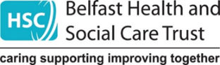

|  |  |  |  |  |  |  |  |  |  |  |  |  |  |  |  |  |  |
| --- | --- | --- | --- | --- | --- | --- | --- | --- | --- | --- | --- | --- | --- | --- | --- | --- | --- |
| **Section 1: Policy Scoping: Information about the Policy / Proposal / Decision** | | | | | | | | | | | | | | | | | |
| * 1. **Name of the policy/proposal/decision** | | | | **Proposed future model of GP Out of Hours provision in Belfast Trust** | | | | | | | | | | | | | |
| * 1. **Status of policy/proposal/decision**   *(please underline)* | | | | **New** | | | | Existing | | | | | Revised | | | | |
| * 1. **Trust Directorate / Division**     *(please underline)* | | | | Corporate Services Group *(Please specify)*   * Performance, Planning & Informatics * Finance, Estates & Capital Development * HR & Org Development * Corporate Comms | | Nursing and User Experience  Medical Directorate | | | | **Unscheduled Care and Older People's Acute Services** | | ACCTSS and Surgery  Anaesthetics, Critical Care, Theatres and Sterile Services (ACCTSS) | | | Trauma, Orthopaedics, Rehab Services, Maternity, ENT, Dental and Sexual Health | | |
| Mental Health and Intellectual Disability | | Cancer and Specialist Services | | | | Children's Community Services and Social Work | | Child Health & NISTAR, Imaging, Medical Physics and Outpatients and Medical Illustration | | | Adult Community, Older Peoples' Services and Allied Health Professionals | | |
| * 1. **Description of the policy/ proposal/decision?** | | | | This equality screening is being completed with regard tothe consultation paper that has been developed detailing the proposed future of GP Out of Hours (GP OOH) provision in Belfast Trust area. Belfast Trust has taken the decision to **consolidate both GP OOH Services onto the Crumlin Road site.** On this one site there will be a multi-disciplinary service serving all of the population of Belfast. The team will comprise of nursing, paramedic and pharmacy cover within the service and reduce the number of GP hours needed. The proposal, which is now being issued for formal consultation, is to consolidate all resources on one base in the MIH/Crumlin Road as opposed to the two current bases.  The decision has been based on balancing the needs of the Belfast people and the current challenges to GP OOH. An options appraisal was conducted and engagement with a range of key stakeholders took place.  **Context**  When Belfast Health and Social Care Trust was created from 6 Legacy Health and Social Services Trusts in 2007, it retained GP OOH provision at the existing at Beldoc on the Crumlin Road and Sebdoc on the Saintfield Road. Beldoc continued to support north and west Belfast whilst Sebdoc provided GP OOH service to south and east Belfast. GP OOH serves a population of 354,706 people.  The GP OOH service is for people who need urgent medical treatment but cannot wait until their doctor's practice opens. It is defined as “care provided between 18.30 and 08.00 on weekdays, all weekend and Bank Holidays. Unlike independent GP practices, Belfast Health and Social Care Trust is responsible for managing and delivering GP OOH service through contractual arrangements with GPs, who have signed up to provide their services out of hours. Care provided in the GP OOH time period is unscheduled, i.e. there has been no forward planning (either by patient or professional) or appointment made in advance. Both sites offer a telephone prioritisation and consultation service with either telephone assessment, treatment or advice from a GP, home or base visit or a referral into an Emergency Department or Urgent Care Centre or other multi-disciplinary services, or a mental health assessment, or confirmation of end of life or working with community district nurses and patients in nursing homes.  GP OOH aims to provide, for urgent conditions, a comprehensive, safe and efficient out of hours service to the Northern Ireland population, as well as to the non-resident transient population, who are also entitled to General Medical Services (GMS) services until the patient’s own GP surgery is next open.  **Current model**  The current model of GP OOH over two sites has been adopted from legacy Trust arrangements, when Beldoc GP OOH on the Crumlin Road provided the service for the distinct population of north and west Belfast and Sebdoc provided the service out of hours for the distinct population of south and east Belfast. When Belfast Trust was established from the amalgamation of 6 legacy Trusts in 2007, the Trust maintained the existing arrangements for GP OOH for the whole population of Belfast Trust. Both sites provide an Out of Hours primary urgent care (an illness or injury that requires urgent attention but is not life threatening) service to the Belfast Population (439,802 population):   * Between 6pm and 8am weekdays * Weekends - 6pm Friday to 8am Monday * Includes all public holidays   The distance between the 2 sites is less than 5 miles, as depicted in the image below.  **Figure 1: Map to show distance and time taken to travel between Beldoc and Sebdoc**    **Challenges**  Over recent years, sustained provision of the service across the two sites has proved to be challenging. This is due to a number of factors including rising demand, recruitment and retention of GPs and financial pressures. In July and August 2021 a temporary amalgamation of GP OOH had to take place, as a contingency measure, due to the issues with filling GP slots.  Our GP colleagues have shared difficulties about the increasingly complex and time-consuming demands of daytime practice, which can then impact on the ability to leave to begin an OOH shift. That, coupled with changing financial remuneration, makes providing out-of-hours sessions more challenging.  The model of GP OOH provision had been solely dependent on one discipline, with no potential for contingency or a tiered approach- whereby other professions could prioritise patients and provide support through consultation so that GP colleagues can deal with the most urgent cases.  GP OOH primary medical care in the UK has undergone substantial re-design and reorganisation, particularly since the implementation of the 2004 General Medical Services contract which allowed GPs to opt-out of providing OOH care. And evidence indicates that a more diverse staff and skill mix, in combination with positive contextual conditions, can result in improved quality of care, quality of life, and job satisfaction.[3]  The Trust has recently looked to address some of the workforce constraints, by introducing a skill mix comprising paramedic, nursing and pharmacy staff to ensure that service users have timely access to the right care at the right time by the most appropriate professional.  A recently published document entitled [**A Workforce Fit for the Future**](NULL) issued by Royal College of General Practitioners in Northern Ireland further compounds some of the issues that Primary Care faces. Regionally, there were 317 active GP practices as of 31 March 2023 and this constitutes a reduction of 33 (9%) since 2014, and a further two since 2022. As the number of practices has decreased, the average number of registered patients per practice has increased by around 17%, from 5,500 to 6,439 since 2014.  **Rationale**  In addition to further address the challenges facing the service, Belfast Trust and GP colleagues within the existing Trust and Primary Care Forum have come together to consider and appraise various options in terms of the most sustainable model for a modern Primary Care service for Belfast. In the long term and in accordance with the strategic direction set out in the Urgent and Emergency Care and No More Silos, the optimal option would be an integrated urgent care service however, this would require further time and investment to facilitate development of a fully integrated out of hours urgent care service.  In the interim and on the basis of the information available to date, the preferred option is to have a Multi-disciplinary service on one site serving all of the population of Belfast. This option will comprise nursing, paramedic and pharmacy cover within the service and reduce the number of GP hours needed. The proposal, which is now being issued for formal consultation, is to consolidate all resources on one base in the Beldoc urgent care centre/Crumlin Road as opposed to the two current bases.  An RQIA review in April 2021 had already highlighted a number of challenges with the present GP Out-of-Hours Service model and *“considered that this model may not be sustainable into the future. …they found that increasingly fewer GPs were contributing to the GP Out-of-Hours Service, a consequence of: increasing pressures facing daytime GP Services; increasing pressures in the out-of-hours service; limited flexible working arrangements; and financial implications associated with working in the out-of-hours service such as static pay and changes to pension arrangements. If no action is taken, the result is likely to be fewer locations able to provide GP Out-of-Hours Services, as well as increasing gaps in rotas and services in those locations that remain, with consequent delays and longer waiting times for patients”.*  **Introduction of Skill Mix**  The Trust is now introducing a skill mix (with nursing, paramedic and pharmacy staff) to the current out of hours service, which was totally 100% GP led. This means less reliance on GPs to cover all aspects of the service and to make the best use of resources. It will also result in extra capacity in the system with nurses undertaking prioritisation, consultation and supervision and build resilience and sustainability in the multi-disciplinary team.  Paramedics will work within the service at weekends doing some home visits for GPs, which means the GPs are able to focus on triaging and responding to urgent/routine calls, rather than spending time going to patients’ homes. The paramedic will assess the patient and contact the GP to plan care and treatment. In the future it is hoped that this service can expand to paramedic prescribing. This service will provide a timely and more efficient service with right health professional with appropriate patient for appropriate care.  The pharmacist will be assist with prescriptions and giving out appropriate education to patients and also doing some minor injury clinics with patients, again supporting the GPs and reducing their time doing work which can be provided by other health professionals and releasing the GPs to focus on the more urgent and routine calls which require their input within the service.  Skill mix will not be utilised during the period known as the “red eye” from 12 midnight to 8am 7 day a week. From a financial viewpoint, staff will be recruited via a bank mechanism and therefore the service will not be subjected to agency costs.  **Activity**  There are a number of charts in the consultation paper that detail an average level of demand across the existing 2 bases for the 3 main areas of delivery:   * Availability of a clinician to take calls and deliver advice to the patient (calls prioritised as emergency, urgent and routine). This area assumes that any patient classified as emergency is immediately directed to an Emergency department if required * The number of patients who need to attend the base for further assessment and treatment * The need for a clinician to carry out visits to the patients’ homes in the evenings and weekends (nursing home calls, bloods and end of life verification).   **Demand for the BHSCT GPOOH service**  A range of qualitative and quantitative data has been collected to review the current service in place. In the current financial year, the average monthly total of calls to BHSCT GPOOHs is on average 9,072 monthly calls. With regard to category of demand, this is 7,426 advice telephone calls, 1,542 base visits and 104 home visits.  For the majority of patients approximately **(83%)**, this proposal will have **no impact** at all given that most of the advice is provided by telephone and only a very minor percentage of people need to come to the base.  Belfast Trust recognises that some patients will find it difficult to make their way to the Crumlin Road and therefore is offering a taxi service for anyone who cannot make it to the base or who cannot collect their prescription.  A GPOOHs management dashboard is now in place and activity levels in each of the 3 areas (advice, base and home) are reviewed regularly and seasonal demands are always factored into planning assumptions.  **Pattern of demand**  The levels of demand have been analysed further to determine when the busiest times are to match capacity with demand. These have been identified as shifts and are described as follows:   * Red eye – 12 midnight to 8am – 7 days per week – the assumption is that this is GP led only and, in the interim, does not change weekday evenings Monday to Friday 6pm to 12 midnight   Weekends and bank holidays are broken down into the following shifts to reflect the demand and the number of staff required:   * Mornings 8am to 1pm * Afternoons 1pm to 6pm * Evenings 6pm to 12 midnight   The Trust has considered all of this quantitative data and notes that the number of home visits has greatly decreased from 340 in 2018/19 to 104 in this current period. Similarly, visits to the base by patients have seen a decrease of 912 during this time period. Whereas there has been an increase of 1122 calls for advice.  **The need for change**  The consultation paper details the strategic context behind the need for change, acknowledging the 2016 Bengoa [Systems, not Structures](NULL) review, the Delivering Together: Health and Wellbeing 2016-2026 strategy and the 2018 [the Review of Urgent and Emergency Care](NULL).  A number of priorities were identified, as part of the Review of Urgent and Emergency Care, to transform and improve services so patients can receive the right care, from the right person, as quickly as possible and improve the service user experience, by ensuring greater accessibility to services.  From the review and consultation, three priorities were identified:   1. **Creating an Integrated Urgent and Emergency Care Service** 2. **Capacity, Co-ordination, and Performance** 3. **Intermediate Care**   The review committed that there would be an Integrated Urgent and Emergency Care Service, which would include:   * An **Urgent Care Centre** model across Northern Ireland by winter 2023 where patients with illnesses and injuries which are not life threatening but require urgent attention can be assessed and treated. Patients can attend an urgent care centre via **Phone First**, GP referral or by walking in. * A range of **Rapid Access Clinics** so patients can be seen by the right clinical specialist for assessments, tests, and diagnosis; without having to go through an Emergency Department. Appointments can be booked by GP practices and Phone First providers. * A regional **Phone First** service, accessed through the telephone number HSC 111 for help and advice in 2024. Patients will still call 999 for emergencies, serious illnesses, or injuries.   The review concluded that these proposed reforms would help to ensure all citizens in Northern Ireland have access to equal access safe urgent and emergency care services…by providing the right care at right time in the right place.  **Reform of GP OOH**  As part of the new model, the review stated that the current GP OOH service will be reshaped to form part of the wider integrated urgent and emergency care service.  The Trust is committed to providing a safe, effective and compassionate service for the greater Belfast area and is therefore proposing that it will amalgamate provision for GP OOH for Belfast onto one site.  This will help to consolidate and optimise utilisation of the available resources and to deliver a value for money service which is responsive and equitable to the population of Belfast Health and Social Care Trust.  **Engagement and Consultation**  The Trust has engaged with a range of stakeholders to discuss and inform work to change how we provide the GP OOH service for all the population of Belfast. The Trust has a statutory duty in accordance with the Health and Social Care Reform Act (NI) 2009 to involve service users, carers and the public in the commissioning, planning and delivery of all Health and Social Care (HSC) services (Commonly known as Personal and Public Involvement or PPI). A number of engagement events took place, online and face to face. Each engagement session provided the opportunity for stakeholders to discuss the proposals presented and consider the benefits and barriers. Key themes emerged from the engagement sessions:  **One-site model:** There was broad agreement for a one-site model from all stakeholders including GP OOH staff and service users.  **Physical location:** Overall it was recognised that the infrastructure for the location of a GP OOH service was important i.e. parking, transport, safety, accessibility and transport links need to be mapped and tested.  Access to other services was raised with close proximity to an ED being cited frequently as a core element of GP OOH services.  **Multi-disciplinary Team:** There was agreement that a strengthened skill mix approach for the delivery of GP OOH service was a positive move.  **Communication:**  The need for enhanced communication was a common thread throughout all engagement sessions with a clear need to enhance public messaging about how to access GP OOH and importantly its role within an ‘urgent’ care model.  **What does this mean for patients and carers?**  Patients will have access to a more equitable service, whereby regardless of where someone lives in Belfast. The one site model will offer timely access to the population of Belfast and will ensure a more efficient way of working. Patients will get to see the appropriate practitioner according to their need.    **What does this mean for GP and staff?**  In dealing with any proposal the Trust is committed to ensuring that the process is characterised by openness, transparency, involvement, recognition and engagement with its staff and Trades Unions.  The Trust will put in place a range of support mechanisms which can be tailored to the specific needs of the individual. These may include, as appropriate, individual staff support, induction, skills analysis to identify staff needs and support the transition to the agreed change in service, advice and guidance on Human Resource Policies and Procedures.  **Partnerships**  The Trust will work in partnership with Trades Unions and in accordance with the agreed Frameworks.  These proposals are subject to a consultation process and this equality screening which will inform the decision to be made.    **Health Inequalities and Social Deprivation**  Belfast Trust recognises that it provides services to the whole population of Belfast – some of whom experience high levels of deprivation and health inequalities. Some wards in North and West Belfast have the highest levels of deprivation in Northern Ireland and their communities experience some of the highest levels of chronic illnesses, poor mental health and those suffering from an addiction. The Annual Inequalities Report for 2023 found that large inequality gaps continue to exist for mental health indicators, with the death rate from intentional self-harm in the most deprived areas was double that in the least deprived areas. Life expectancy values for Northern Ireland as a whole are 78.4 years for males and 82.3 for females. Life expectancy is lowest in three Belfast constituencies (West, North and East). In Belfast West, the life expectancy of males (70.8 years) is eight years less than the Northern Ireland average (78.4), while the life expectancy of females (76.9) is five years lower than the regional average (82.3).  On the basis of the higher levels of uptake of GPOOH at Beldoc and some of the most deprived wards in Northern Ireland are within north and west Belfast, the Trust is proposing the location for the consolidated GP OOH service is the Crumlin Road site.  The Trust remains committed to the principle that "The purpose of GP Out-of-Hours Services in primary care should meet those urgent patient needs that cannot safely be deferred until the patient's own GP practice is next open”. The decision to consolidate both GP OOH Services onto the Crumlin Road site with a multi-disciplinary service has been informed by this principle and we believe this decision will enable Belfast Trust to appropriately meet those urgent patient’s needs. Given this will be a permanent reconfiguration wide engagement has taken place with key stakeholders and this consultation paper and equality screening has been completed. This is in line with our statutory duties in terms of Personal and Public Involvement and Section 75: Equality duties of the Northern Ireland Act 1998. | | | | | | | | | | | | | |
| * 1. **Who owns the policy/proposal?** | | | | Belfast Trust and Primary Care Partners in conjunction with HSCB and DOH | | | | | | | | | | | | | |
| * 1. Who are the **main stakeholders affected**? | | | | * Population of Belfast * General Practitioners * Belfast Trust Management * GP OOH Administrative Staff * Nursing, Drivers * Paramedics * Trade Unions | | | | | | | | | | | | | |
| * 1. Provide details of **how you involved stakeholders,** views of colleagues, service users, staff side or other stakeholders when screening this policy/proposal. | | | | The Trust has engaged with a range of stakeholders to discuss and inform work to change how we provide the GP OOH service for all the population of Belfast. A number of engagement events took place.   * January 2022 - focus group with representatives from the NMS service user and carer reference group regarding GP OOH * Disability Steering Committee, 18th September 2023 – comprises Trust representatives, disabled people and a range of representative organisations. * GP’s (Online meeting), 1st September 2023 * Belfast Trust Primary Care Forum (Online meeting), 20th October 2023 - including Trust Directors and Co Directors and GPs, representing the LMC and GP Federations. * GP OOH staff (Online meeting), 16th November 2023 - staff employed by the Trust (GP’s, drivers, administration staff), * Service users, carers, community/ voluntary sector, politicians, Care Home staff and Trust staff (Online meeting), 21st November 2023 * Service users, carers, community/ voluntary sector, politicians, Care Home staff and Trust staff (Face to face meeting), 22nd November 2023 at Girdwood Community Hub, Belfast * Surestart, (parents of children under 4), 15th April 2024 at Donegal Pass Community Centre, Belfast * Individual stakeholder meetings – held at the request of individuals: Alliance Party of Northern Ireland – 5th January 2024   **A 13-week public consultation will now take place, commencing 3rd October 2024.** | | | | | | | | | | | | | |
| * 1. **Other policies/strategies** with a bearing on this policy/proposal | | | | * RQIA Review of GPOOH Services in Northern Ireland April 2021 * GP–Led Care Working Group report, DoH, March 2016 *‘Building Sustainable Out of Hours Services.’* * Strategic framework of GP OOH, HSCB, Jan 2014 * Analysis of Survey Returns from General Practices reported by the then Department for Health, Social Services and Public Safety, in January 2015 * Estimating the Volume and Growth Strategic Framework for GP Out-of-Hours, HSC Board (June 2012). * The case for change reported by the BMA in Northern Ireland in February 2015; and Understanding Pressures in General Practice reported by the King’s Fund in May 2016 * No More Silos - Urgent care review and implementation * [Retaining our GP workforce in Scotland, April 2024 (rcgp.org.uk)](NULL) * [Systems, not Structures](NULL) * Delivering Together: Health and Wellbeing 2016-2026 * [The Review of Urgent and Emergency Care](NULL). | | | | | | | | | | | | | |
| * 1. Are there any **factors that could contribute to/detract** from the intended aim/outcome of the policy/proposal/decision? | | | | Belfast Trust is committed to the full implementation of this policy and through regular monitoring it is anticipated that the aims and objectives of the policy will be fully realised and any factors that could detract from those aims and objectives will be minimised/avoided. However, influencing factors regarding the full implementation of the policy include: GP availability and general public awareness in terms of appropriately accessing the right level of care e.g. Emergency Department, GP regular hours and GP Out of Hours. | | | | | | | | | | | | | |
| **Section 2: Screening Classification of the Policy / Proposal /Decision**   * The purpose of this Section is to consider the policy/proposal in terms of its **relevance** and likely **impact (actual/potential)** on **equality of opportunity, disability duties, good relations and human rights.** * To **determine** the **impact (actual and potential)** of a policy/proposal on **equality of opportunity, disability duties, good relations duties and human rights** please **complete the screening questions at 2.1 – 2.6.** | | | | | | | | | | | | | | | | | |
| **Screening Questions** | | | | | | | | | | | | | | **Yes** | | **No** | |
| **(2.1)** Is there an **impact** on **Equality of Opportunity** for those affected by this policy, for each of the S75*  equality categories? I.e. is there a differential impact for one S75 group rather than the others? | | | | | | | | | | | | | | **✓** | |  | |
| **(2.2)** Are there better **opportunities** to promote equality of opportunity for people within the S75* categories? | | | | | | | | | | | | | | **✓** | |  | |
| **(2.3)** Does the policy **impact** upon **Good Relations** between people of a different religious belief, political opinion or racial group? (Good Relations Duties) | | | | | | | | | | | | | |  | | **✓** | |
| **(2.4)** Are there **opportunities** to better promote good relations between people of a different religious belief, political opinion or racial group? (Good Relations Duties) | | | | | | | | | | | | | |  | | **✓** | |
| **(2.5)** Are there **opportunities** to encourage **disabled people** to **participate** in public life and promote **positive attitudes** toward disabled people? (Disability Duties) | | | | | | | | | | | | | |  | | **✓** | |
| **(2.6)** Does the policy/proposal **impact** on **human rights**? | | | | | | | | | | | | | |  | | **✓** | |
| *S75 protected equality categories include: Age, Dependent Status, Disability, Men and Women generally, Marital Status Ethnicity, Religion, Political Opinion and Sexual Orientation. | | | | | | | | | | | | | | | | | |
| **Screening Statement**   * If you have answered **Yes** to **any** of the above questions (2.1 – 2.6) please **complete Sections 3 – 10** * If you have answered **No** to **all** of the above questions (2.1 – 2.6) please **complete only 2.7, 2.8 and 2.9** | | | | | | | | | | | | | | | | | |
| **(2.7) Screening Statement:**  This policy is **‘screened out’** on the basis that - **please tick all statements** that are appropriate to the policy: | | | | | | | | | | | | | | | | | |
| 1. It is purely clinical policy and/or is technical in nature and has **no relevance** or **bearing in terms of its likely impact** (actual / potential)on equality of opportunity, good relations and for people within these categories and in relation to disability duties, good relations and human rights. | | | | | | | | | | | | | | | | |  |
| 1. It is a purely clinical policy and/or is technical in nature and aims to **standardise practice** to achieve best practice based on current evidence. | | | | | | | | | | | | | | | | |  |
| 1. **Other** reason: Please provide details. | | | | | | | | | | | | | | | | |  |
| (2.8): **Statutory Duties – Making Reasonable Adjustments and Accessible Information**    **To complete the equality screening please tick this box** to indicate that you have **considered** andhave made **explicit reference** in the policy to the need to make reasonable adjustments and information accessible.   1. The Trust has a **statutory duty to make reasonable adjustments** in respect of disabled patients/service users/carers/visitors.   This includes making all communication (in person, by phone, via email) *and* any information provided (in writing, verbally) accessible using alternative formats as required. Accessible/ Alternative formats can include, for example, information translated into Easy Read format or into Audio format - when a patient/service user/carer/visitor has a learning disability or is visually impaired. For advice on making information accessible for a person with a disability please refer to the staff guidance  [Making-Communication-Accessible-for-All-A-guide-for-HSC-Staff](NULL)   1. In addition, if a patient/service user/carer/visitor does not speak English as their first language or has poor English, the Trust has a **statutory duty** to **provide an interpreter** and to **translate written information**. This facilitates informed consent, better understanding and greater independence. | | | | | | | | | | | | | | | | |  |
| **(2.9)** **Approval**  Please sign / date and forward to the Equality and Planning Team for consideration equalityscreenings@belfasttrust.hscni.net | | | | | | | | | | | | | | | | | |
| **Lead Responsible Manager:**  Name:  Position:  Date: | | | | | | | | | **Countersigned by Equality Manager:**  Name:  Date: | | | | | | | | |
| **Section 3: Evidence used to Assess Impact on Service Users and Staff**  This section records the quantitative and qualitative data you have used to consider equality and good relations issues to assess the impact on staff and service users across the 9 protected categories plus multiple identities.  Evidence to help inform the screening process may be quantitative and qualitative. Consideration needs to be given to the different needs, experiences and priorities of each of the categories in relation to the policy / proposal. For example: previous consultations and equality impact assessments (EQIAs), statistics, research, complaints, feedback, referrals, grievances, inspection reports, focus groups, user groups etc. Please also refer to the Equality Commissions’ publication: [Section 75 - Using Evidence in Policy Making (A Signposting Guide) (equalityni.org)](NULL) | | | | | | | | | | | | | | | | | |
| (3.1) | **Quantitative and Qualitative Data: Service Users** | | | | | | | | | | | | | | | | |
| **Equality Category** | | **Service Users** | **Quantitative Data**  (Using 2022 census data unless otherwise stated) | | | | | | | | **Qualitative Data**  (Needs, Experiences, Priorities) | | | | | | |
| **Belfast**  **Population only** | | **NI**  **Population** | | **Service Users affected %** | | | |
| **1.**  **Age** | | 0-14 15-24 25-34 35-44 45-54 55-64 65-74  75+ | 18.04%  14.57%  15.47%  13.35%  11.85%  12%  7.8%  6.92% | | 19.19%  11.8%  12.74  13.11%  13.27  12.73  9.3%  7.86% | | GP OOH Provision is available for all people of all ages in Belfast and Castlereagh | | | | The RQIA Review in 2021 found that calls to GP OOH in relation to children (under 10 years of age) and older people (over 60 years of age) were the most frequent to the service; accounting for 53% of all contacts (this was in regard to all of NI GP Out of Hours Provision). Anecdotally GP OOH providers recounted that they were receiving an increased volume of calls from residential and nursing homes. There will be a differential equality impact on older people and those under 10.  For those requiring to visit the GP OOH base, there is a travel distance of less than 5 miles between the two current bases Beldoc and Sebdoc (18 minutes by car or 43 minutes by public transport). It is important to note that due to the public transport infrastructure, it may require people in certain areas of Belfast who do not have their own private transport to either take one bus into the city centre and a further bus to either base in the north of Belfast or take a taxi.  We know from the Census that in 2021 over 80% of households had a car or van available, one in five households (19.5%) did not have access to a car or van. Urban areas, which included Belfast (33.9%) and had the highest percentage of households without a car or van available.  The majority of patients (approx. 93%), who use GP OOH receive advice by telephone - only a very minor percentage of people need to go to a GP OOH. Given this information, the proposals for GP OOH provision will impact on very few people. | | | | | | |
| **2. Dependent Status** | | Caring for a child dependant, older person or a person with a disability | | | 12.42 %  are carers | |  | | | | Parents of children and carers for older people account for more than half the contacts made to GP OOH. Therefore on this basis there will be a differential impact on those with caring responsibilities.  For those requiring to visit the GP OOH base, there is a travel distance of less than 5 miles between the two current bases Beldoc and Sebdoc. It is important to note that due to the public transport infrastructure, it may require people in certain areas of Belfast who do not have their own private transport to either take one bus into the city centre and a further bus to either base in the north of Belfast or take a taxi. (16-18 minutes by car or 38 minutes by public transport).  We know from the census that in 2021 over 80% of households had a car or van available, one in five households (19.5%) did not have access to a car or van. Urban areas, which included Belfast (33.9%) and had the highest percentage of households without a car or van available.  The majority of patients (approx. 93%), who use GP OOH receive advice by telephone - only a very minor percentage of people need to go to a GP OOH. Given this information, the proposals for GP OOH provision will impact on very few people. | | | | | | |
| **3.**  **Disability** | | Yes*  No  *Type of disability:   * Deafness or partial hearing loss * Blindness or partial sight loss * Mobility or dexterity difficulty that requires the use of a wheelchair * Intellectual or learning disability * Learning difficulty * Autism or Asperger Syndrome * Emotional, psychological or mental health condition * Frequent periods of confusion or memory loss * Long term pain or discomfort * Shortness of breath or difficulty breathing * Other condition | | | 24.33%*  75.67%    5.75%    1.78%    1.48%    0.89%    3.15%  1.86%  8.68%  1.99%  11.58%  10.29%  8.81% | |  | | | | The Trust recognises people with disabilities are likely to access primary care services more – in and out of hours. Given that the prevalence of disability increases with age it is likely disabled people will be differentially impacted.  For those requiring to visit the GP OOH base, there is a travel distance of less than 5 miles between the two current bases Beldoc and Sebdoc. It is important to note that due to the public transport infrastructure, it may require people in certain areas of Belfast who do not have their own private transport to either take one bus into the city centre and a further bus to either base in the north of Belfast or take a taxi. (16-18 minutes by car or 38 minutes by public transport).  We know from the census that in 2021 over 80% of households had a car or van available, one in five households (19.5%) did not have access to a car or van. Urban areas, which included Belfast (33.9%) and had the highest percentage of households without a car or van available.  The majority of patients (approx. 93%), who use GP OOH receive advice by telephone - only a very minor percentage of people need to go to a GP OOH. Given this information, the proposals for GP OOH provision will impact on very few people. | | | | | | |
| **4.**  **Men and Women generally** | | Female  Male |  | | 50.81%  49.19% | |  | | | | According to the RQIA report in 2016/17, 42% (234,900) of contacts made with the GP Out-of-Hours Service across Northern Ireland (expressed as gender of patient) were male, and 58% (329,191) were female. Therefore proportionally there are more females accessing the service than males.  For those requiring to visit the GP OOH base, there is a travel distance of less than 5 miles between the two current bases Beldoc and Sebdoc. It is important to note that due to the public transport infrastructure, it may require people in certain areas of Belfast who do not have their own private transport to either take one bus into the city centre and a further bus to either base in the north of Belfast or take a taxi. (16-18 minutes by car or 38 minutes by public transport). We know from the census that in 2021 over 80% of households had a car or van available, one in five households (19.5%) did not have access to a car or van. Urban areas, which included Belfast (33.9%) and had the highest percentage of households without a car or van available.  The majority of patients (approx. 93%), who use GP OOH receive advice by telephone - only a very minor percentage of people need to go to a GP OOH. Given this information, the proposals for GP OOH provision will impact on very few people. | | | | | | |
| **5.**  **Marital Status** | | Single  Married  Civil P’ship Separated  Divorced  Widowed | 49.82%  32.94%  0.26%  4.73%  6.15%  6.1% | | 38.07%  45.59%  0.18%  3.78%  6.02%  6.36% | |  | | | | On the basis of the information available, there is nothing to suggest that this will impact on the basis of a person’s marital status. | | | | | | |
| **6.**  **Race**  **Ethnicity** | | White BME | 92.95%  7.05% | | 96.55%  3.45% | |  | | | | On the basis of the information available, there is nothing to suggest that this will impact on the basis of a person’s race or ethnicity. | | | | | | |
| **7.**  **Religion** | | Roman Catholic  Presbyterian C.of Ireland  Methodist Other Christian  Other Religions  No Religion  Religion not stated | 43.46%  12.44%  8.49%  2.86%  5.95%  2.96%  21.67%  2.17% | | 42.31%  16.61%  11.55%  2.35%  6.85%  1.34%  17.39%  1.6% | |  | | | | On the basis of the information available, there is nothing to suggest that this will impact on the basis of a person’s religious belief. | | | | | | |
| **8.**  **Political Opinion**  Based on total elected candidates in the local government elections 2023  *\*Figures extracted from Lisburn and Castlereagh Council 2023.* | | DUP  SF  SDLP  UUP  APNI  Green  PBP  IND  Trad UP | Belfast  Council  14  22  5  2  11  3  1  1  2 | | C’reagh*  3  2  1  1  5  0  0  0  0 | |  | | | | On the basis of the information available, there is nothing to suggest that this proposal will impact on the basis of a person’s political opinion. | | | | | | |
| **9.**  **Sexual Orientation** | | Straight or heterosexual  Gay or lesbian  Bisexual  Other  Prefer not to say  Not stated | 87.1%  2.27%  1.48%  0.32%  5.2%  3.64% | | 90.04%  1.17%  0.75%  0.17%  4.58%  3.30% | |  | | | | On the basis of the information available, there is nothing to suggest that this proposal will impact on the basis of a person’s sexual orientation. | | | | | | |
| **Multiple Identities** | |  |  | |  | |  | | | | Overall it can be seen that Belfast Health and Social Care Trust area still experiences significant deprivation, in comparison with NI.  **Belfast Trust Population Health Outcomes**   |  |  | | --- | --- | | **32** | Health outcomes were **worse than** the NI average, most notably Drug Misuse/Related Mortality, Alcohol Specific Mortality and Alcohol Related Admissions | | **8** | Health outcomes were **similar** to the NI average | | **3** | Health outcomes were **better than** the NI average – most notably circulatory admissions |   The Trust is mindful that it provides services for users from some of the most deprived areas in Northern Ireland:   * Belfast is the most deprived out of the 26 Local Government Districts (LGDs). * Belfast has the highest concentration of disadvantage with 7 out of the worst 10 wards (3 North, 3 West, 1 Shankill) and 12 out of the worst 20 wards on the NI Multiple Deprivation Measure 2 (NIMDM) 2010 (also known as Noble Measure). * Belfast has 9 of the 10 worst wards in the region in relation to health deprivation. * The most widespread disadvantage and deprivation exists in north and west Belfast.   The Trust and Primary Care are aware of the direct correlation between levels of deprivation and poor health outcomes. Research shows that population health is affected to a greater extent by the economic, social and environmental conditions in which people are born, live, work and age, with overall health tending to improve with each step up the socioeconomic ladder. This is commonly known as the ‘social gradient of health’ and exists across the whole population with the greatest differences, or inequalities in health seen between the most and least disadvantaged in our society.  This in turn will mean that people from more deprived areas will rely more heavily on health and social care services including GP OOH, resulting in a differential impact on people from deprived communities.  For those requiring to visit the GP OOH base, there is a travel distance of less than 5 miles between the two current bases Beldoc and Sebdoc. It is important to note that due to the public transport infrastructure, it may require people in certain areas of Belfast who do not have their own private transport to either take one bus into the city centre and a further bus to either base in the north of Belfast or take a taxi. (16-18 minutes by car or 38 minutes by public transport). We know from the census that in 2021 over 80% of households had a car or van available, one in five households (19.5%) did not have access to a car or van. Urban areas, which included Belfast (33.9%) and had the highest percentage of households without a car or van available.  The majority of patients (approx. 93%), who use GP OOH receive advice by telephone - only a very minor percentage of people need to go to a GP OOH. Given this information, the proposals for GP OOH provision will impact on very few people. | | | | | | |

|  |  |  |  |  |
| --- | --- | --- | --- | --- |
| (3.2) **Quantitative and Qualitative Data: Staff** | | | | |
| When organisational / policy change is necessary, regardless of whether it is a permanent or temporary change, the Trust is committed to treating staff fairly and equitably. Staff can be assured that the change process will be managed. This includes consultation with staff and the opportunity for staff to discuss in one to one meetings, any adverse equality impacts resulting in changes to their employment.  Information will be provided together with analysis and advice by the Employment Equality Team in the Human Resources department.  **Quantitative Data:** Please contact: **Samantha Whann / Tel: 028 96159615 Email : samantha.whann@belfasttrust.hscni.net**  **Qualitative Data:** Consider thedifferent needs, experiences and priorities of each of the categories in relation to the policy / proposal / decision.  Should any equality / modernisation related issues arise they will be managed through the Organisational Change Framework.  [Click here for Framework](NULL)  This framework also works alongside other Human Resources policies including for example the Disability and Reasonable Adjustment Framework, the Work Life Balance Policy and Procedure, the Recruitment and Selection Policy and Procedure and Agenda for Change Terms and Conditions Handbook. | | | | |
| **Equality Category** | **Groups** | **Quantitative Data** | | **Qualitative Data** |
| Belfast Trust workforce  (@January 2021) | Staff affected by the Policy/Proposal % |
|  |  |  |  |  |
| **1.**  **Age** | 16-24 25-34 35-44 45-54 55-64 65+ | |  | | --- | | 6% | | 24% | | 24% | | 24% | | 19% | | 3% | | |  | | --- | |  | | 17% | | 34% | | 20% | | 17% | | 12% | | The workforce profile is broadly in line with that of the Trust overall workforce profile with (51%) aged <45 compared to that of the Trust data (49%) aged >45+ |
| **2.**  **Dependant Status** | Dependants  No Dependants Not known | |  | | --- | | 18% | | 20% | | 62% | | |  | | --- | | 33% | | 25% | | 43% | | A higher proportion of staff have declared dependant status +15% (33%) compared to that of the workplace profile (18%). However, it should be noted that 43% of staff have not declared.  A higher proportion of staff have declared no dependant status +5% (25%) compared to that of the workplace profile (20%). |
| **3. Disability** | Yes  No  Not known | |  | | --- | | 2% | | 63% | | 35% | | |  | | --- | | 3% | | 62% | | 35% | | Broadly in line with overall workforce profile |
| **4. Gender** | Female  Male | |  | | --- | | 76% | | 24% | | |  | | --- | | 53% | | 47% | | There is a higher proportion of male staff + 23% 473%) compared to that of the workplace profile (24%). |
| **5. Marital Status** | Married/ Civil P’ship  Single  Other/Not known | |  | | --- | | 48% | | 31% | | 4% | | 17% | | |  | | --- | | 33% | | 13% | | 2% | | 52% | | A lower proportion of staff have declared marital status as married -15% (33%) compared to that of the workplace profile (48%).  A lower rate of Single Status is also evident -18% (13%) compared to that of the workplace profile (31%). |
| **6. Race**  **a) Ethnicity** | BME White  Not Known | |  | | --- | | 4% | | 71% | | 26% | | |  | | --- | | 5% | | 62% | | 32% | | A lower proportion of staff Ethnicity status is ‘White’ -9% (62%) compared to that of the workplace profile (71%). However, it should be noted that 32% of staff have not declared. |
| **b) Nationality** | GB  Irish  Northern Irish  Other  Not known | |  | | --- | | 21% | | 15% | | 1% | | 63% | | |  | | --- | | 29% | | 16% | | 7% | | 48% | | A higher proportion of staff Nationality status is ‘GB’ +8% (29%) compared to that of the workplace profile (18%).  A higher proportion of staff Nationality status is ‘NI’ +6% (7%) compared to that of the workplace profile (1%). |
| **7. Religion**  **a) Community Background** | Protestant  Roman Catholic  Neither | |  | | --- | | 35% | | 45% | | 20% | | |  | | --- | | 33% | | 31% | | 36% | | There is a lower proportion of staff from the Roman Catholic community background -14% (31%) compared to that of the overall workforce profile (45%). However, it should be noted that 36% of staff have not declared. |
| **b) Religious Belief** | Christian  Other  No religious belief  Not known | |  | | --- | | 31% | | 10% | | 1% | | 58% | | |  | | --- | | 41% | | 9% | | 5% | | 44% | | A higher proportion of staff Religious Belief status is ‘Christian’ +10% (41%) compared to that of the workplace profile (31%). However, there is limited data available as 44% of staff have not declared. |
| **8. Political Opinion**  ***\* 2011 Assembly election*** | Broadly Nationalist Broadly Unionist Other Do not wish to answer/Unknown  Not known | |  | | --- | | 7% | | 7% | | 23% | | 55% | | 8% | | |  | | --- | | 11% | | 8% | | 27% | | 41% | | 14% | | A lower proportion of staff Political Opinion status is ‘Not Known’ -14% (41%) compared to that of the workplace profile (55%).  However, there is limited data available, as 41% of staff have not declared. |
| **9. Sexual Orientation** | Opposite sex  Same sex or both sexes  Do not wish to answer | |  | | --- | | 44% | | 1% | | 6% | | 48% | | |  | | --- | | 53% | | 2% | | 6% | | 39% | | Limited data available.  A higher proportion of staff Political Opinion status is ‘Opposite Sex’ +7% (53%) compared to that of the workplace profile (44%). |

|  |  |  |  |  |
| --- | --- | --- | --- | --- |
| **Section 4: Consideration of Impacts and Identification of Mitigations and/or Alternative Policies**  Given the **evidence** gathered in Section 3, please identify for each of the **nine equality categories** the level **of impact, mitigation measures** and **alternative** policies / proposals that better **promote equality of opportunity**. | | | | |
| (4.1) **SERVICE USERS** | | | | |
| **Equality Category** | **Level of Impact** | | | **Mitigation Measures and Alternative Policies or Actions that might lessen the severity of the equality impact**  (where Major or Minor Impact identified) |
| **Major** | **Minor** | **None** |
| **Age** |  | ✓ |  | This equality screening is being completed with regard tothe consultation paper that has been developed detailing the proposed future of GP Out of Hours provision in Belfast Trust area. Belfast Trust has taken the decision to **consolidate both GP OOH Services onto the Crumlin Road site.** On this one site there will be a multi-disciplinary service serving all of the population of Belfast. The team will comprise of nursing, paramedic and pharmacy cover within the service and reduce the number of GP hours needed. The proposal, which is now being issued for formal consultation, is to consolidate all resources on one base in the MIH/Crumlin Road as opposed to the two current bases.  The current and potential service users of GP OOH fall within the protected Section 75 Groups of age, dependant status, disability, men and women generally and in turn multiple identities. It is therefore likely they will be differentially impacted by the decision to consolidate both GP OOH Services onto the Crumlin Road site with a multi-disciplinary service.  The challenges of the current GP OOH model have been detailed in the consultation paper. In summary over recent years, sustained provision of the service across the two sites has proved to be challenging. This is due to a number of factors including rising demand, recruitment and retention of GPs and financial pressures. Our GP colleagues have shared difficulties about the increasingly complex and time-consuming demands of daytime practice, which can then impact on the ability to leave to begin an OOH shift. That, coupled with changing financial remuneration, makes providing out-of-hours sessions more challenging.  The proposed changes to provision will help overcome these challenges and in turn should create a more effective and efficient GP OOH service for the population of Belfast.  **Rationale**  In addition to further address the challenges facing the service, Belfast Trust and GP colleagues within the existing Trust and Primary Care Forum have come together to consider and appraise various options in terms of the most sustainable model for a modern Primary Care service for Belfast. In the long term and in accordance with the strategic direction set out in the Urgent and Emergency Care and No More Silos, the optimal option would be an integrated urgent care service however, this would require further time and investment to facilitate development of a fully integrated out of hours urgent care service.  In the interim and on the basis of the information available to date, the preferred option is to have a Multi-disciplinary service on one site serving all of the population of Belfast. This option will comprise nursing, paramedic and pharmacy cover within the service and reduce the number of GP hours needed. The proposal, which is now being issued for formal consultation, is to consolidate all resources on one base in the Mater Infirmorum Hospital /Crumlin Road as opposed to the two current bases.  **Mitigation Measures:**   * The decision has been based on balancing the needs of the Belfast people and the current challenges to GP OOH. * Belfast Trust recognises that some patients will find it difficult to make their way to the Crumlin Road and therefore is offering a taxi service for anyone who cannot make it to the base or who cannot collect their prescription. * A thorough options appraisal was conducted. * Extensive engagement has been undertaken with a wide range of stakeholders both internally and externally to identify the potential options and to review and inform the identified preferred option. This has included engaging with GP’s, GP OOH staff, service users and carers, representatives of third sector organisations and Health and Social Care provider including independent health and care providers. * In July and August 2021 a temporary amalgamation of GP OOH had to take place at the Beldoc site, as a contingency measure, due to the issues with filling GP slots. This model was effective in creating equity in access times and clinical intervention. * For the majority of patients approx. **(83%)**, this proposal will have **no impact** at all given that most of the advice is provided by telephone and only a very minor percentage of people need to come to the base. * The distance between the two bases is less than five miles. * The Trust is proposing to use the Crumlin Road site in light of the increased demand from communities in both north and west Belfast and because of the increased levels of health inequalities and social deprivation in some wards. * Moving to one site with the newly introduced skill mix would make considerable economies of scale by consolidating resources and would address the significant, increasing overspend that the service is facing year on year. * Patients will have access to a more equitable service, whereby regardless of where someone lives in Belfast. The one site model will offer timely access to the population of Belfast and will ensure a more efficient way of working. Patients will get to see the appropriate practitioner according to their need. * With regard to staff - in dealing with any proposal the Trust is committed to ensuring that the process is characterised by openness, transparency, involvement, recognition and engagement with its staff and Trades Unions.  The Trust will put in place a range of support mechanisms which can be tailored to the specific needs of the individual. * The Trust will work in partnership with Trades Unions and in accordance with the agreed Frameworks. * The proposed model is in line with the 2016 Bengoa [Systems, not Structures](NULL) review, the Delivering Together: Health and Wellbeing 2016-2026 strategy and the 2018 [the Review of Urgent and Emergency Care](NULL). * A 13-week public consultation will now take place – this will give people another opportunity to share their views on the proposed model. * Once the one site model is operational, feedback will be sought from patients in the form of questionnaires. * There will be ongoing monitoring and review of the new model when it becomes operational. This will include patient feedback and cognisant to any compliments and/or complaints, as well as monitoring of any adverse impacts with regard to equality and the nine protected groups. |
| **Dependant Status** |  | ✓ |  |
| **Disability** |  | ✓ |  |
| **Men and Women generally** |  | ✓ |  |
| **Marital Status** |  |  | ✓ |
| **Race (Ethnicity)** |  |  | ✓ |
| **Religion** |  |  | ✓ |
| **Political Opinion** |  |  | ✓ |
| **Sexual Orientation** |  |  | ✓ |
| **Multiple Identities** e*.g. disabled ethnic minorities or young Protestant men.* |  | ✓ |  |

|  |  |  |  |  |  |
| --- | --- | --- | --- | --- | --- |
| (4.2) **STAFF** | | | | | |
| **Equality Category** | | **Level of Impact** | | | **Mitigation Measures and consideration of alternative policies or actions that might lessen the severity of the equality impact**  (where Major or Minor Impact identified) |
| **Major** | **Minor** | **None** |
| **Age** | |  |  |  | Compared to the overall Trust profile there is a higher proportion of male staff (53%) and with dependant status (33%). A higher proportion of staff have also declared has having a religious belief (50%) 41% of which are Christian.  Where limited data is available in Sexual Orientation, Political Opinion and Religious Belief, Community Background and Ethnicity it would be remiss to decide a firm level of impact.  The service will constructively engage with those affected and ensure that it adheres to the Organisations Management of Change Framework.  In line with this process, staff will be offered the opportunity to discuss in one to one meetings any adverse equality impacts resulting in changes to work location and/or working patterns. |
| **Dependant Status** | |  |  |  |
| **Disability** | |  |  |  |
| **Men and Women generally** | |  |  |  |
| **Marital Status** | |  |  |  |
| **Race** | **Ethnicity** |  |  |  |
| **Nationality** |  |  |  |
| **Religion** | **Community Background** |  |  |  |
| **Religious Belief** |  |  |  |
| **Political Opinion** | |  |  |  |
| **Sexual Orientation** | |  |  |  |
| Multiple Identity | |  |  |  |

|  |  |  |  |  |
| --- | --- | --- | --- | --- |
| **Section 5: Good Relations** | | | | |
| Based on the **evidence** collected in Sections 3 & 4:   * To what extent is the policy/proposal likely to **impact Good Relations** i.e. between people of different religious belief, political opinion or racial group? * Are there any **additional measures** that could be suggested to ensure the policy or proposal **promotes Good Relations?** | | | | |
| **Good Relations category** | **Level of impact** | | | **Mitigation Measures and Alternative Policies or Actions that might lessen the severity of the equality impact**  (where Major or Minor Impact identified) |
| **Major** | **Minor** | **None** |
| **Religious belief** |  |  | **✓** | All Trust staff attend mandatory Equality, Human Rights and Good Relations training which includes reference to the Good Relations duty.  The Trust has a clear and well defined Good Relations strategy [‘Healthy Relations for A Healthy Future 3’](NULL) whereby the corporate commitment to Good Relations is underlined.  The Trust will ensure that all services and all facilities are welcoming to all patients their carers and advocates regardless of their religious affiliation, political opinion and racial group.  Appropriate and inclusive means of communication will be used to contact and communicate with patients, their families and carers who do not speak English as their first language. An interpreter will be booked and/or letters translated using established protocols within the Trust as appropriate. |
| **Political opinion** |  |  | **✓** |
| **Racial group** |  |  | **✓** |

|  |  |
| --- | --- |
| **Section 6: Disability Duties** | |
| How does the policy / proposal:     * **encourage disabled people to participate in public life** *and* * **promote positive attitudes towards disabled people?**   Consider what **other measures** you could take to meetthese **duties.**  *For example, have staff received disability equality training.* | Appropriate and inclusive means of communication will be used to communicate with patients and carers. Staff will be mindful of any reasonable adjustments required in the implementation of this policy for both patients and carers.  All Health and Social Care staff are required to undertake mandatory equality training which includes disability duties.  Disability Awareness Training is provided throughout the year, available on HRPTS. Bespoke Disability awareness training sessions can also be provided for staff teams on demand, when it is feasible to do so.  The Trust has produced a suite of guidance for increasing access to services and information. These are all available on the hub or on request from the Planning & Equality team. |

|  |  |  |
| --- | --- | --- |
| **Section 7: Human Rights**  Belfast Health and Social Care Trust is committed to providing the **highest attainable standard of physical and mental health** within our resources. | | |
| (7.1)  **Does the policy/proposal/decision negatively impact on any of the following human rights?**  The rights particularly relevant in the delivery of health and social care are emboldened below. Examples for these rights and further information can be found in the [Equality Screening Toolkit](NULL). | | |
| **Human Rights Articles** | **Yes** | **No** |
| **A2: Right to life** |  | ✓ |
| **A3: Right to freedom from torture, inhuman or degrading treatment or punishment** |  | ✓ |
| A4: Right to freedom from slavery, servitude & forced or compulsory labour |  | ✓ |
| **A5: Right to liberty & security of person** |  | ✓ |
| A6: Right to a fair & public trial within a reasonable time |  | ✓ |
| A7: Right to freedom from retrospective criminal law & no punishment without law |  | ✓ |
| **A8: Right to respect for private & family life, home and correspondence.** |  | ✓ |
| A9: Right to freedom of thought, conscience & religion |  | ✓ |
| A10: Right to freedom of expression |  | ✓ |
| A11: Right to freedom of assembly & association |  | ✓ |
| A12: Right to marry & found a family |  | ✓ |
| **A14: Prohibition of discrimination in the enjoyment of the convention rights** |  | ✓ |
| 1st protocol Article 1 – Right to a peaceful enjoyment of possessions & protection of property |  | ✓ |
| 1st protocol Article 2 – Right of access to education |  | ✓ |
| If you answered **YES** to any of the above, please refer to the Human Rights Screening Tool below to check if the policy is likely to be human rights compliant.  If the flowchart indicates that the policy is **unlikely** to be human rights compliant, please contact the Planning and Equality team [equalityscreenings@belfasttrust.hscni.net](NULL)  If the flowchart indicates that the policy is **likely** to be human rights compliant, please **continue to section 7.2.** | | |
| (7.2)  **Outline any actions you will take to promote awareness of human rights and evidence that human rights have been taken into consideration in decision making processes**: | | |
| The Trust is committed to the safeguarding and promotion of Human Rights in all aspects of its work. The Human Rights Act 1998 gives effect in UK Law to the European Convention on Human Rights and requires legislation to be integrated so far as possible in a way that is compatible with the Convention rights. It also makes it unlawful for a public body to act incompatibly with the convention rights. Where a public authority has assumed responsibility for the welfare and safety of individuals, there is a particular duty to guarantee human rights.  The Trust is committed to the safeguarding and promotion of Human Rights in all aspects of its work. The Human Rights Act 1998 gives effect in UK Law to the European Convention on Human Rights and requires legislation to be integrated so far as possible in a way that is compatible with the Convention rights. It also makes it unlawful for a public body to act incompatibly with the convention rights. Where a public authority has assumed responsibility for the welfare and safety of individuals, there is a particular duty to guarantee human rights.  Belfast Trust is committed to carrying out its functions in line with the core principles and values that underline human rights legislation namely Freedom, Respect, Equality, Dignity and Autonomy (FREDA). Staff should use FREDA principles to red flag any behaviour that is not compatible with the Trust ethos of delivering safe, quality and compassionate care or which violates our equality and human rights statutory commitments.  Belfast Trust is committed to delivering safe, high quality and compassionate services. Employees are expected to deliver services and behave in a manner that is compatible with this commitment. Belfast Trust expects all employees to treat others with dignity and respect whether it be service users, carers, visitors or colleagues. | | |

|  |  |  |  |  |  |
| --- | --- | --- | --- | --- | --- |
| **Section 8: Screening Decision**  **(**8.1)  **How would you categorise the impacts of this policy / proposal?**  (Please underline one category) | **Major**  (**Screened In** for an Equality Impact Assessment) | | | **Minor**  **✓**  (**Screened Out** with mitigation) | **None**  (**Screened Out**) |
| (8.2)  **If you have identified any impact, what mitigation has**  **been considered to address this?** | As previously outlined, this equality screening is being completed with regard tothe consultation paper that has been developed detailing the proposed future of GP Out of Hours provision in Belfast Trust area. Belfast Trust has taken the decision to **consolidate both GP OOH Services onto the Crumlin Road site.** On this one site there will be a multi-disciplinary service serving all of the population of Belfast. The team will comprise of nursing, paramedic and pharmacy cover within the service and reduce the number of GP hours needed. The proposal, which is now being issued for formal consultation, is to consolidate all resources on one base in the MIH/Crumlin Road as opposed to the two current bases.  In July and August 2021 a temporary amalgamation of GP OOH had to take place at the Beldoc site, as a contingency measure, due to the issues with filling GP slots. This model was effective in creating equity in access times and clinical intervention.  The mitigation measures are outlined in section 4.1 and 4.2 In summary, For the majority of patients approx. **(83%)**, this proposal will have **no impact** at all given that most of the advice is provided by telephone and only a very minor percentage of people need to come to the base. Belfast Trust recognises that some patients will find it difficult to make their way to the Crumlin Road and therefore is offering a taxi service for anyone who cannot make it to the base or who cannot collect their prescription. With regard to staff, the Trust is committed to ensuring that the process of change is characterised by openness, transparency, involvement, recognition and engagement with its staff and Trades Unions.  The Trust will put in place a range of support mechanisms, which can be tailored to the specific needs of the individual. | | | | |
| (8.3)  **Do you think the policy/proposal/decision should be subject to an Equality Impact Assessment (EQIA)?**  NB: A full Equality Impact Assessment (EQIA) is usually confined to those policies or proposals considered to have major implications for equality of opportunity/good relations/human rights. | **Yes** | **No**  **✓** | **Reasons**  A policy/proposal/decision is subject to an EQIA if one or more of the following criteria is met:   1. The policy is significant in terms of its strategic importance. 2. Potential equality impacts are unknown, because, for example, there is insufficient data upon which to make an assessment or because they are complex, and it would be appropriate to conduct an equality impact assessment in order to better assess them. 3. Potential equality and/or good relations impacts are likely to be adverse or are likely to be experienced disproportionately by groups of people including those who are marginalised or disadvantaged. 4. Further assessment offers a valuable way to examine the evidence and develop recommendations in respect of a policy about which there are concerns amongst affected individuals and representative groups, for example in respect of multiple identities. 5. The policy is likely to be challenged by way of judicial review. 6. The policy is significant in terms of expenditure. | | |
| ***Section 9: Monitoring***  *(9.1)*  *Please detail the steps you will take to monitor the effect of the policy/proposal/decision for impact in terms of equality of opportunity, good relations, disability duties and human rights?* | Belfast Trust is committed to the effective monitoring of this proposal so that we can identify any future adverse impact arising which may lead to conducting an equality impact assessment and with helping with future planning and policy development.  Monitoring will take place via:   * Feedback will be sought from patients in the form of questionnaires, once the one site model is operational. * There will be ongoing monitoring and review of the new model when it becomes operational. This will include patient feedback and cognisant to any compliments and/or complaints, as well as monitoring of any adverse impacts with regard to equality and the nine protected groups. * The Trust will monitor uptake of the service and will closely monitor the activity data with qualitative information from patients, GPs and Trust multi-disciplinary staff. * Weekly Safety Briefings * Weekly governance meetings * Quarterly quality management system meetings * SPPG will monitor performance | | | | |
| **Section 10: Approval and Authorisation**  Please sign /date and forward to the Planning and Equality team [equalityscreenings@belfasttrust.hscni.net](NULL)  Equality screenings are completed with information provided by the senior responsible manager subject to advice and assistance from Belfast Trust Equality & Planning Managers.  **\*\*Completed Screening Templates are public documents posted on the** [**Trust Website**](NULL)**\*\*** | | | | | |
| **Lead Responsible Manager**  **Name:** Jane Sheridan  **Position:** Interim Service Manager for GP OOH and Ambulatory Care and Site coordinator for BHSCT  **Date:** 15/08/2024 | **Countersigned by: Equality Manager/Employment Equality Manager**  **Name:** Caroline McMenamin  **Position:** Planning & Equality Manager  **Date:** 15/08/2024 | | | | |
| **Section 11: Statutory Rural Impact Assessment Duties**  The Trust is legally obliged to take **due regard of the impact** of any policy, proposal or decision on the social and economic needs of people who live in a rural community. This is particularly so when the policy/proposal/decision impacts service users/carers/patients across NI (eg regional service/policy).  Please **tick the box** to indicate that you have paid **‘due regard’** to the social and economic needs of the rural community  ✓  when developing, adopting, implementing or revising policies, strategies and plans *and* when designing and delivering  public services and that **a rural impact assessment is not required**.  *OR*  Please complete a [Rural Needs Impact Assessment Template](NULL)  rural impact assessment if there is impact on the social and economic needs of people who live in a rural community.  Please go to the: [Rural Impact Assessments Toolkit for HSC NI](NULL)  to find out how to undertake a rural impact assessment.  Contact [Estella.Dorrian@belfasttrust.hscni.net](NULL) for further advice. | | | | | |

# **Appendix 2: Your Chance to have your say: Consultation questions**

1. Has the Trust sufficiently outlined the reasons for the proposal to move to a one site model?

If not, why not?

1. Do you think our proposal to move to one site out of hours model on the Crumlin Road site will meet the needs of the population of Belfast?

If not, why not?

1. Do you agree with the benefits that a skill mix and a move from a GP only service to a multi-disciplinary model?

If not, why not?

1. Do you have any concerns or comments that you would like the Trust to consider?
2. Do you agree with the findings in the equality screening?

6) Is there anything else that you think that the Trust needs to consider?

**Freedom of Information**

Belfast Trust will publish an anonymised summary of responses following completion of the consultation process; however, your response, and all other responses to the consultation, may be disclosed on request. We can only refuse to disclose information in limited circumstances.

Before you submit your response, please read the paragraphs below on the confidentiality of consultations and they will give you guidance on the legal position about any information given by you in response to this consultation.

The Freedom of Information Act gives the public a general right of access to any information held by a public authority, in this case, Belfast Trust. This right of access to information includes information provided in response to a consultation. We cannot automatically consider information supplied to us in response to a consultation as information that can be withheld from disclosure. However, we do

have the responsibility to decide whether any information provided by you in response to this consultation, including information about your identity, should be made public or withheld.

Any information provided by you in response to this consultation is, if requested, likely to be released. Only in certain circumstances would information of this type be withheld.

1. [00492082.pdf (www.gov.scot)](NULL)
2. [Urgent action needed to reverse ‘hard slog’ of general practice, says College Chair](NULL)
3. [00492082.pdf (www.gov.scot)](NULL)