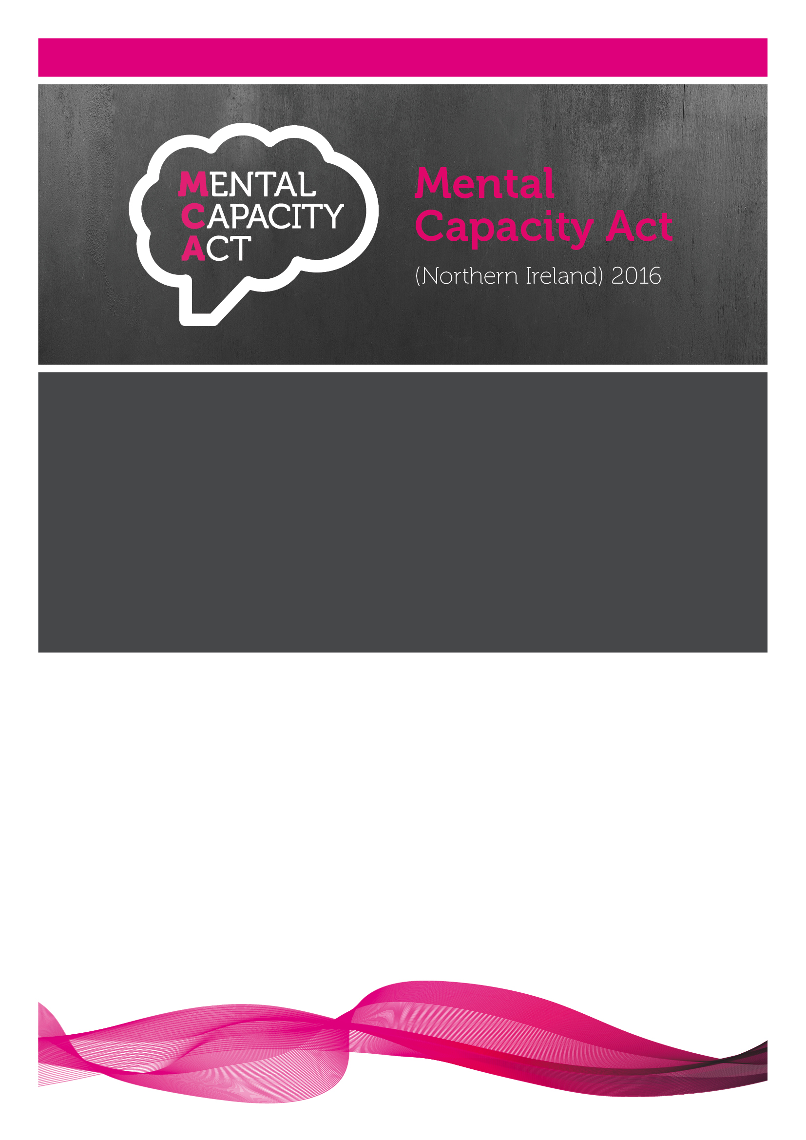



ACTS OF RESTRAINT

CODE OF PRACTICE

Draft as of: 29 July 2026

Contents
Contents 2
Glossary of terms 3
Chapter 1. Introduction 4
Introduction 4
The legal status of the Code 4
Using the Code of Practice 5
Code for Acts of Restraint 5
Who is the Code for? 5
Contents of the Code 5
Chapter 2. Restraint 6
What is Restraint? 6
The restraint condition 7
The act of restraint 7
Restraint, seclusion and deprivation of liberty 8

Glossary of terms
the Act the Mental Capacity Act (Northern Ireland) 2016
an act an act done on behalf of a person who lacks capacity
best interests a holistic consideration of all relevant factors, including special regard for P’s wishes, feelings, beliefs and values – see Chapter 6 of the MCA DoLS Code of Practice for more detail
D usually the person doing an act
the Department the Department of Health (Northern Ireland)
lack capacity unable to make a decision because of an impairment of, or disturbance in the functioning of, mind or brain – see Chapter 5 of the MCA DoLS Code of Practice for more detail
P usually a person who is over the age of 16 and lacks capacity in relation to the matter in question
protection from liability the legal protection under which acts can be done on behalf of a person who lacks capacity – see Chapter 2
restraint condition required for any acts of restraint – see Chapter 2
social worker a person registered with the Health and Care Professions Council as a social worker
special regard strongly than merely having regard or considering, giving top priority to
unable to make a decision the functional test if the person is unable to understand the relevant information, retain that information, appreciate and use and weigh that information and communicate the decision

- Introduction
Introduction
  - The Mental Capacity Act (Northern Ireland) 2016 provides a statutory framework for people who lack capacity to make decision for themselves and for those who now have capacity but wish to make preparations for a time in the future when they lack capacity.
  - The legal framework provided by the Act is supported by this Code of Practice which provides practical information for how the Act works in relation to Acts of Restraint.
  - Section 288 of the Act requires the Department of Health to prepare a Code which must be laid before the Assembly, which can vote to have the Code withdrawn. This Code meets these requirements.
  - Section 289 of the Act provides that the Code has a statutory force, meaning that certain people have a legal obligation to have regard to the Code when working with people who lack, or may lack, capacity to make decisions for himself or herself.
  - This introductory chapter provides a brief overview of the legal status of the Code, how the Code should be used, who it is for and what is in the Code.
The legal status of the Code
  - The Act, and therefore the Code, applies to anyone who is present in Northern Ireland, disregarding where a person may be from or where he or she is habitually resident. Some aspects of the Act, such as transfers, interact with other jurisdictions. In these areas decisions may be made in respect of a person who is not present in Northern Ireland. However, no acts can be done on behalf of such a person using the Act until they have entered Northern Ireland.
  - Section 289 of the Act provides that anyone who acts in a professional capacity for remuneration, as an attorney under an enduring power of attorney, as a deputy appointed by the court, or as a person carrying out research in reliance on any provisions made by or under the Act, must have regard to the Code. This is particularly relevant where the Act requires a person to act reasonably, appropriately or practically, as the Code provides guidance of what this is.
  - The Code is not the only support material for people who work with persons who lack, or may lack, capacity. Consideration must also be given to other relevant material from the Department of Health, the Department of Justice, regulatory bodies and employers.
Using the Code of Practice
  - Throughout this document, the Code of Practice is referred to as “the Code” and the Mental Capacity Act (Northern Ireland) 2016 is referred to as “the Act”. A person who lacks capacity is referred to as “P” and the person who carries out an act as “D”. A glossary of terms used in the Code can be found immediately after the index, before this chapter.
  - The Code provides an overview of the relevant provisions of the Act to help those who need to work with persons who lack, or may lack, capacity in relation to acts of restraint.
Code for Acts of Restraint
  - In addition to this Code, there is a further Code of Practice relating to Deprivation of Liberty Safeguards which provides further guidance on capacity, capacity assessments, best interests and other aspects. This Code should be read in conjunction with relevant chapters in the Deprivation of Liberty Safeguards Code.
Who is the Code for?
  - The Code is not designed to provide help and support for P or P’s relatives or friends, nor to explain or provide the reasoning behind the provisions of the Act.
  - The purpose of the Code is to help those who work with persons who lack, or may lack, capacity in relation to acts of restraint.
Contents of the Code
  - The Code provides detail on the relevant provisions of the Act which relate to acts of restraint. This code provides specific details and must be read with relevant chapters of the deprivation of liberty Code of Practice.
  - Chapter 2 discusses more information on acts of restraint, the restraint condition and also seclusion, restraint and how this relates to deprivation of liberty.

- Restraint
  - The Act recognises that, in some cases, the use of restraint may be necessary to prevent harm to a person (“P”) aged 16 and over who lacks capacity regarding that act of restraint.
  - Section 12 outlines the condition that must be met in order to be protected from liability. This chapter provides an overview of the restraint condition set out in the Act and when it can be used.
What is Restraint?
  - Restraint is defined as an act which:
    - is intended to restrict P’s liberty of movement, whether or not P resists; or
    - is a use of force or a threat to use force and is done with the intention of securing the doing of an act which P resists.
  - Restraint can take many different forms:
    - mechanical, such as a seatbelt;
    - physical, such as holding a person down;
    - medical, such as administering a sedative;
    - restrictive choice, such as not showing a person where the door to leave is; and
    - withholding information, such as not telling a person where he or she is being taken to prevent resistance.
  - Restraint can also be varying in duration and level of intrusiveness. What is appropriate will depend very much on the situation at hand. For example, the act of restraint could be a physical act to prevent P from running on to a busy road. Or it could take the form of a threat to use force to get P to comply with medication.
  - When considering the use of restraint, health and social care staff should, as a matter of good practice, also refer to professional and other guidance on restraint or physical intervention, as issued by the Department of Health.

The restraint condition
  - A person (“D”) restraining P must always have a reasonable belief of lack of capacity and that the restraint is in P’s best interests and ensure any additional relevant safeguards are met to be protected from liability. If the restraint is planned, or is part of a deprivation of liberty, all relevant additional safeguards must be in place (see Deprivation of Liberty CoP for more information).
In addition to the above, the protection from liability will only extend to D doing something that amounts to an act of restraint on P if the restraint condition is met. This is that D must have a reasonable belief, at the time the restraint needs done, that:
    - failure to do the act of restraint would create a risk of harm to P; and
    - the act of restraint is a proportionate response to the likelihood and seriousness of the harm to P.
  - When determining whether an act of restraint is a proportionate response to the likelihood and seriousness of the harm to P, professionals should draw upon the most up to date best practice and guidelines to ensure that the least restrictive form of restraint is used.
  - Harm to P could also include harm to another person where there is resulting harm to P. See Deprivation of Liberty Safeguards CoP for more information on resulting harm to P.
The act of restraint
  - The protection from liability applies both to an act that places restraint or restriction on P, and also to an act that consists of instructing or authorising another person to use restraint. So, for example, a person in charge of P’s care may instruct a carer to do an act of restraint on P in certain circumstances, however, both persons will have to make sure the restraint condition is met to be protected from liability.
  - It is recommended, as best practice, that those carrying out the act of restraint or authorising another person to carry out an act of restraint on P should carry out and document a risk assessment to determine the need and appropriateness of any restraint, and record the details in P’s treatment or care plan, where possible. This should include the type and duration of the restraint, the alternative options considered; the reason for the restraint and setting out the justification for how the restraint condition is met.
  - Staff should also be mindful of other legislation that does require documentation of restraint, for example The Nursing Homes Regulations (Northern Ireland) 2005 and The Residential Care Homes Regulations (Northern Ireland) 2005. It is also important to outline that the Department’s regional policy on the use of Restrictive Practices in Health and Social Care settings should be read in conjunction with sections 9(4)(a) and 12 of the MCA and this Code of Practice.
  - In many situations, restraint may occur in a domestic setting by a non-professional carer. Where this is the case, the carer is still required to meet the restraint condition. Documentation of the restraint as above would be good practice; however it may be useful to speak to a professional such as a social worker or doctor for more guidance on how this should be correctly managed.
Restraint, seclusion and deprivation of liberty
  - Any prolonged, frequently occurring or more intrusive act of restraint runs the risk of becoming more than just restraint. D must be aware of the possibility that extensive or intrusive use of restraint may be a deprivation of P’s liberty. This is dependent on the nature of the restraint, the duration and setting and the level of planning before the restraint was done.
  - Seclusion is the confinement of a person in a room or area from which the person is not free to leave. The term seclusion refers to a specific intervention. It is not intended to be interpretated broadly to cover circumstances where a person is being cared for in an environment (such as care home or supported living service) where they are not free to leave and there may be a deprivation of liberty authorisation in place.
  - If seclusion is required, it must only be used:
• As a last resort intervention in an emergency where there is an unmanageable risk to others and other less restrictive methods are deemed insufficient to manage that immediate risk;
• When a person is, or is liable to be, detained in accordance with an appropriate legal framework;
• In a hospital setting in a room or suite specifically designated for this purpose;
• In accordance with the regional operating procedures.
In every circumstance where a person is confined in a room, or an area, and the person is not free to leave, no matter the name given to the intervention, the person is secluded, which is a deprivation of liberty. Health and social care staff must consider the practice in question in the context of the definition and the circumstances in which it is considered for use.
  - This code should be considered in conjunction with the Department of Health's policy on the use of Restrictive Practices in Health and Social Care Settings and Regional Operational Procedure for the Use of Seclusion, available on the Department website at https://www.health-ni.gov.uk/publications/regional-policy-use-restrictive-practices-health-and-social-care-settings-public-consultation.

