Advance Care Planning Policy For Adults In Northern Ireland
Draft Policy For Public Consultation December 2021

Large Print Version

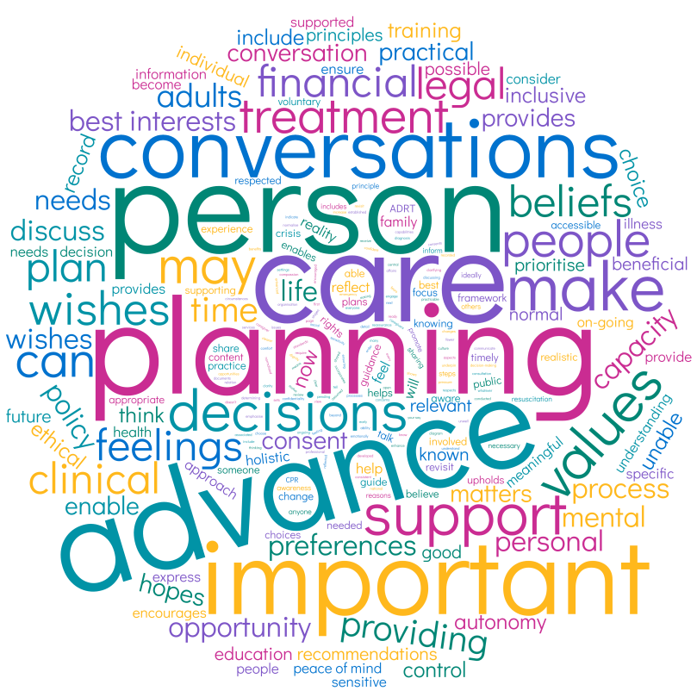

Contents
Introduction 3
Ambition 7
What is Advance Care Planning? 8
Advance Care Planning and Mental Capacity 9
Values and Principles of Advance Care Planning 9
Values 9
Principles of Practice 11
Why is it important to have Advance Care Planning conversations? 12
Benefits of Advance Care Planning 12
When should Advance Care Planning happen? 14
Having Meaningful Advance Care Planning Conversations 18
The ‘Six Ts’ of Good Communication in Advance Care Planning Conversations 19
Sharing Advance Care Planning Conversations, Recommendations and Decisions 22
Reviewing Advance Care Planning Conversations, Recommendations and Decisions 22
How Advance Care Planning Conversations Are Used 23
Components of Advance Care Planning 24
Personal Component of Advance Care Planning 25
“What Matters To Me” - Wishes, Feelings, Beliefs and Values 26
Spirituality 27
Care and Support for Dependents 28
Funeral Wishes 28
Online Accounts 29
Legal Component of Advance Care Planning 29
Mental Capacity Act (NI) 2016 30
Types of Power of Attorney 35
Power of Attorney 36
Enduring Power of Attorney 36
Lasting Power of Attorney 37
Advance Decisions to Refuse Treatment (ADRT) 39
Clinical Component of Advance Care Planning 41
Declining Health & Unexpected Emergencies 41
Clinical Recommendations for Cardiopulmonary Resuscitation (CPR) 42
Best Interests Decisions 43
Recommended Summary Plan for Emergency Care & Treatment (ReSPECT) 45
Organ Donation 47
Body Donation to Medical Science 48
Financial Component of Advance Care Planning 49
Making a Will 49
Conclusion 51
Appendices 53
Appendix 1 Glossary of Terms 53
Abbreviations 57
Appendix 2 Bibliography 58
Journals (a list of 48 Journals follows) 58
Books (a list of 3 follows) 68
Reports (a list of 20 follows) 69
Online References (a list of 18 follows) 71
Online Videos (a list of 4 follows) 75

Introduction

Advance Care Planning is an umbrella term covering personal, legal, clinical, and financial planning. It enables a person to think about what is important to them and plan for their future. It is a voluntary process and helps a person to make known what their wishes, feelings, beliefs and values are, and to make choices that reflect these. Advance Care Planning is an on-going process of conversations between a person, those important to them and those providing care, support or treatment. Advance Care Planning should be an important part of life for all adults.
The Advance Care Planning policy has been written for members of the public, those important to them and those providing care, support or treatment.
This Advance Care Planning policy has been developed to support a person to have greater choice and control over decisions, including plans for their future care and treatment. This is very important if the person becomes unable to make the relevant decisions for themselves at any point.
Advance Care Planning provides the opportunity for adults who wish to do so to:
- Think about what matters to them;
- Then tell people who are important to them;
- Discuss it with those who provide care, support or treatment;
- Write it down and share it;
- Revisit the conversations and decisions, make any changes, and then share again.
Advance Care Planning is important for all adults, at whatever stage of life. “The reality that one day each of us will die, is something few of us consider and fewer still, plan for or discuss” (McKenna et al, 2020). Although Advance Care Planning has traditionally been associated with end of life care, it goes beyond this. As well as supporting decisions in declining health and unexpected emergencies, the opportunity it provides to reflect and consider what is important to the person can enhance their quality of life. It may also provide comfort and reassurance to those important to the person.
This policy provides a framework for Advance Care Planning for adults (aged18 years and over) in Northern Ireland, focusing on the health and social care aspects. The policy provides an overview of Advance Care Planning, and the values and principles that underpin it. It sets out why Advance Care Planning is important and how it can help people make timely, realistic and practical plans for their future. It encourages these plans to be made in conversation with those who are important to them and/or someone providing care, support or treatment.
For those important to the person, Advance Care Planning may provide a clearer understanding of the person’s wishes, feelings, beliefs and values, including any relevant preferences and decisions the person may have made.
For people providing care, support or treatment to someone, the policy provides clarity and support for their role in having these important conversations as part of the holistic care or services they provide. If the person becomes unable to make the relevant decisions for themselves, then these decisions have to be made based on what is in the person’s best interests. In determining what is in the person’s best interests, special regard should be given to the person’s wishes, feelings, beliefs and values. Decisions must not be made on the basis of assumptions based solely on factors such as the person’s age, disability, or on a professional’s subjective view of a person’s quality of life.
Even when a person’s ability to make a specific decision is impaired, all practicable steps should still be taken to support them to make other decisions. When a person is unable to make the specific decision, the person should be supported to be as involved in the decision-making process as possible.
The policy provides an ethical and rights based approach to Advance Care Planning for adults, in line with legislation, best practice and professional guidance and standards. The policy is supported by guidance, training and education and public information to ensure a consistent approach to Advance Care Planning that is inclusive and accessible. (Guidance and information documents pending post Public Consultation).

Ambition
The ambition of this policy and how it is put into practice is that:
- Advance Care Planning conversations become normalised;
- All adults in Northern Ireland (NI) have regular opportunities to express their wishes, feelings, beliefs and values in relation to Advance Care Planning; and that;
- These are reflected in the care, support or treatment they receive.

What is Advance Care Planning?

Advance Care Planning is an umbrella term covering personal, legal, clinical, and financial planning. It enables a person to think about what is important to them and plan for their future. It is a voluntary process and helps a person to make known what their wishes, feelings, beliefs and values are, and to make choices that reflect these. Advance Care Planning is an on-going process of conversations between a person, those important to them and those providing care, support or treatment.
Advance Care Planning should be an important part of life for all adults. It needs to be encouraged by those providing care, support or treatment, to ensure that people have the opportunity to have timely, realistic and practical conversations. These conversations focus on what matters to the person and what would be important for them to prioritise in the future should they become unable to make decisions for themselves.
If the person wants to make a record of these conversations and share them they should be supported to do so. The conversations may include for example, mental health crisis planning, Advance Decisions to Refuse Treatment (ADRT) and the person’s view on cardiopulmonary resuscitation (CPR).

Advance Care Planning and Mental Capacity

Advance Care Planning includes references to a person having mental capacity so it is important to understand what this means. The Mental Capacity Act (Northern Ireland) 2016 is an Act which makes provision relating to persons who lack capacity.
The first principle of the Mental Capacity Act (NI) 2016 is a person is not to be treated as lacking capacity unless it is established that the person lacks capacity in relation to the matter in question. Mental capacity is both decision and time specific. People may be able to make some decisions at one time but not another. Even if the person lacks the mental capacity for a specific decision at that time, their wishes, feelings, beliefs and values are central and the person still needs to be supported to be involved as much as possible. More detail is provided on page 19.

Values and Principles of Advance Care Planning
Values:
Advance Care Planning:
- Respects and upholds the rights, dignity and culture of the person and is inclusive of all adults;
- Provides an ethical approach to discussing these important and sensitive issues;
- Is accessible to the person in a way that enables them to have meaningful conversations;
- Is a person’s individual choice. Some people may not want to think about or engage in Advance Care Planning conversations - their choice should be respected, with the opportunity given to revisit the conversation at another time;
- Is a personal experience. Each person’s wishes, feelings, beliefs and values will be individual to the person and their own circumstances;
- Is a voluntary process. Pressure must not be put on the person having the Advance Care Planning conversation by anyone; those providing care, support or treatment, the family or someone important to the person, or by any organisation.

Principles of Practice:
- Advance Care Planning conversations need to be meaningful, conducted with sensitivity and compassion. They require time and should happen at the person’s pace;
- Consent is more than a form or formality. Consent needs to be addressed at each stage of the Advance Care Planning process i.e. having the conversation, sharing the information with others, making a record, sharing the record;
- Where there is a record of Advance Care Planning conversations, these should be accessible across all settings to ensure a person’s wishes, feelings, beliefs and values, and any recommendations and/or decisions made, are known;
- A person’s confidentiality should be respected;
- Advance Care Planning conversations, any recommendations and/or decisions need to be revisited, reviewed and if needed re-shared to ensure they remain up to date as a person may change their mind about some things;
- Advance Care Planning incorporates the principles of the Mental Capacity Act (NI) 2016.

Why is it important to have Advance Care Planning conversations?

When a person’s wishes, feelings, beliefs and values are known, it can help to promote their autonomy and rights, and reduce any potential distress for the person and for those important to them. It also helps guide and inform those providing care, support or treatment.
Numerous national and international research studies [Appendix 2] on ‘family or caregivers’ experience of Advance Care Planning indicate that meaningful Advance Care Planning conversations are beneficial for a number of reasons:

Benefits of Advance Care Planning
An Enhanced Quality of Life:
When a person has the opportunity to reflect on and talk about “what matters to them” it can help them make choices now that are in keeping with their wishes, feelings, beliefs and values.

Peace of Mind:
When a person has the opportunity to “put their affairs in order” or talk about any hopes or fears they may have, it can help them feel more content.
Clarifying Decisions:
When a person has the information they need to make decisions, and/or has the opportunity to say what matters to them, then those important to the person can know what the person wants or doesn’t want.
Easing Caregiver Concerns:
When those important to the person are clear about what matters to the person, they can feel more confident in making known what the person would want if they became unable to communicate or make decisions for themselves.

Local research studies in Northern Ireland also reinforce the need for a greater awareness and understanding of Advance Care Planning and for more open, timely and meaningful conversations on this [Appendix 2].
Advance Care Planning is relevant for all adults. Ideally, it is a series of conversations, which evolve over time. If the person wants, those important to them should also be involved or be made aware of the conversations.
Advance Care Planning is an important part of providing care, support or treatment, by ensuring people have the opportunity to have realistic and practical conversations about what matters to them, and to consider and record their wishes, feelings, beliefs and values, if they choose to do so.
Anyone providing care support or treatment and who regularly interacts with people has a role to play in understanding the values and principles of Advance Care Planning and the operational processes which enable the appropriate conversations to take place, and if the person consents, to have them recorded and shared. Education and training will be provided to those providing care, support or treatment.

When should Advance Care Planning happen?

Advance Care Planning is important for every adult at any stage of life and is relevant to people who are in good health as well as for those who are very unwell. Ideally Advance Care Planning should happen long before any crisis or serious illness, such as a mental health crisis or the diagnosis of a serious physical illness.
By beginning the conversation early on in their life, the person may feel more emotionally able for it, and can take their time to think and talk about what matters to them. This can involve several stages which may range from not knowing anything about Advance Care Planning, to knowing but not wanting to have the conversation, through to feeling able to think about their personal wishes, feelings, beliefs and values and then having Advance Care Planning conversations.
It can take time for some people to feel ready to have these conversations and/or make a record of it. This is normal, and there can be many reasons for this; for example, some people can be afraid to express their wishes or may believe if they do, people important to them might become upset. People may also be reluctant to consider a time when they may become unable to make the necessary decisions about their care. It is important to increase awareness and understanding of Advance Care Planning conversations, to normalise them. It is important therefore to emphasise the benefits and support people to move from thinking about having an Advance Care Planning conversation to actually having one.
Everyone will approach this differently, and what one person needs may differ from the next person. People’s own experience of how they change their behaviour can be different. It may take time as behaviour change is an ongoing process. The diagram below shows how a person’s behaviour can move from not knowing about, to doing Advance Care Planning.

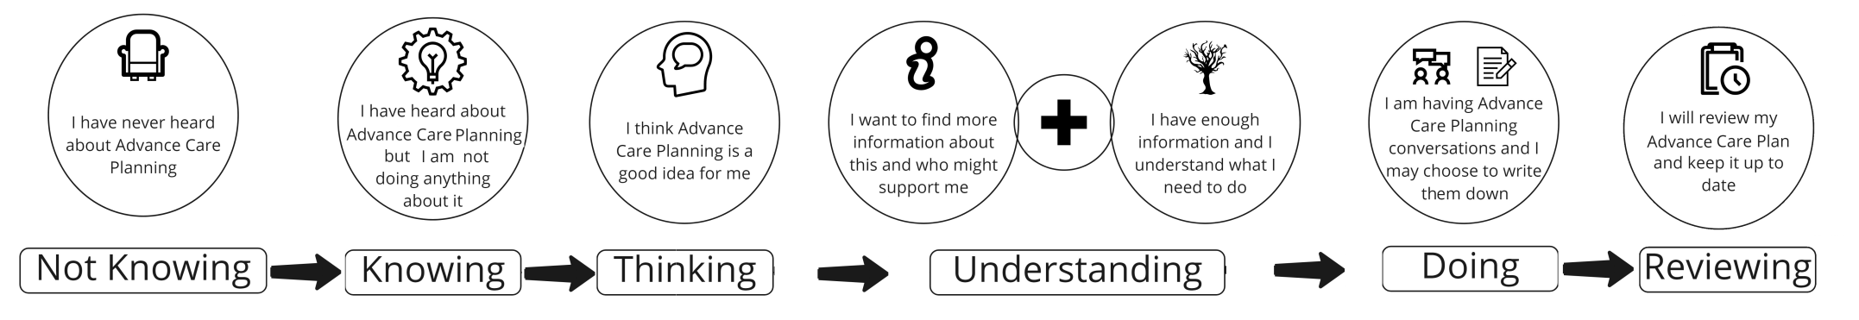
For those people with serious or progressive conditions, and those who may be approaching the end of their life, these conversations should happen as early as possible and when the person is medically stable.
Where these conversations haven’t already happened, they may be prompted when:
- A person indicates they are ready to have these conversations;
- Part of a holistic assessment between the person and those providing care, support or treatment;
- The person has had time to adjust following a diagnosis of a progressive condition and feels ready to have these conversations;
- A person has had a significant deterioration in physical health or a number of unplanned hospital admissions;
- A person may have experienced a mental health crisis during which their ability to make some decisions was impaired;
- The person’s cognitive state is likely to deteriorate;
- The person’s ability to communicate is likely to deteriorate.

People may express their wishes, feelings, beliefs and values over a period of time, to those important to them or to those providing care, support or treatment. Advance Care Planning conversations can take place in any setting but should, where possible, be done when and where the person feels most comfortable. Wherever the conversation takes place, every effort should be made to ensure it is suitable to having meaningful Advance Care Planning conversations.

Having Meaningful Advance Care Planning Conversations

When people are ready to have Advance Care Planning conversations, those providing care, support or treatment have an important role. It is vital that they have the knowledge, confidence and communications skills needed to support this.
The importance of good, effective communication has been consistently highlighted across research studies as well as through reported personal experiences [See Appendix 2]. This reinforces the need to improve capabilities including knowledge, skills and understanding of Advance Care Planning and in particular, communication skills.

The ‘Six Ts’ of Good Communication in Advance Care Planning Conversations

The diagram and table below (including ALT tags) offer a guide on how to communicate during Advance Care Planning conversations whether the conversation is being prompted by the person or by those providing care and support or treatment. It should be remembered that there are two sides to these conversations: either the person who is thinking about and wants to have an Advance Care Planning conversation, or the person who is listening to and/or facilitating the conversation. This may be someone important to the person, and/ or someone who is providing care, support or treatment. Keeping the following in mind supports meaningful Advance Care Planning conversations.

Table explaining the 5 T's
Trust:
Trust is central to these conversations.
A person who is thinking about Advance Care Planning, will want to have a conversation with someone who respects their values and opinions, and is seen as reliable and dependable – someone they trust.

The person who is listening to and/or facilitating these conversations should respect the wishes, feelings, beliefs and values of the person as they plan for their care, and they should support the person throughout the conversation.
Timing:
Should be when the person feels ready to begin the Advance Care Planning conversation and be for as long as the person wishes to continue the conversation(s).

When the person providing care, support or treatment wants to begin the Advance Care Planning conversation, they should check if this is a good time for the person to have the conversation.

Task:
If some of the person’s wishes, feelings, beliefs and values are already known; build on this.

It’s important to be clear on what it is you want to say.
Check that the other person has heard and understands what it was you wanted to say.
Tone:
How we say something is as important as the words we use. These are important conversations and can be emotional therefore be gentle, sensitive and compassionate when having an Advance Care Planning conversation.
Tailored:
Use clear, accessible language, without jargon and make sure that if a person needs help to communicate, e.g. Interpreter, sign language or a device that helps them to communicate, that this is available.

Tuned In:
To how the person might be feeling about and during the conversation.

To the other person’s pace.

To the other person’s understanding.

Sharing Advance Care Planning Conversations, Recommendations and Decisions
During Advance Care Planning conversations, the person’s wishes, feelings, beliefs and values (including ADRT decisions & ReSPECT recommendations) may be recorded and shared, if they consent to do so.

Reviewing Advance Care Planning Conversations, Recommendations and Decisions
Advance Care Planning decisions are not ‘set in stone’. They can be revisited and reviewed at any time to ensure that any wishes, recommendations and/or decisions made are still relevant to the person’s circumstances. Reviewing Advance Care Planning conversations, any recommendations and/or decisions is an integral part of the Advance Care Planning process and any review should be done in line with the values and principles that underpin Advance Care Planning.
A review may be initiated by the person themselves or by someone providing care, support or treatment. The timing or frequency of any review will vary for each person. Reviewing Advance Care Planning conversations, any recommendations and/or decisions is especially important if there are any changes in the person’s circumstances or in their health condition. It is important that any changes to Advance Care Planning conversations, any recommendations and/or decisions are communicated and shared with those important to the person and/or someone providing care, support or treatment.

How Advance Care Planning Conversations Are Used

A person’s Advance Care Planning conversations, any recommendations and/or decisions will be used in the future should a person be unable to make a specific decision for themselves. This may be because they do not have mental capacity or are unable to communicate what their wishes are.
No-one in Northern Ireland has the legal authority to consent to any care or treatment on behalf of another adult. In situations where a person lacks the mental capacity to make a specific decision about their treatment at that time, and does not have a valid and applicable Advance Decision to Refuse Treatment, the clinician who is treating the person will make a ‘best interests’ decision(s). Therefore previous Advance Care Planning conversations, any recommendations and/or decisions will be used to guide and inform the ‘best interests’ decision.

Components of Advance Care Planning
This section covers the four components of Advance Care Planning. They are
Personal, Legal, Clinical and Financial. Each component contains one or more elements and each is described in detail below. Some elements may fit into more than one component. (Public information on these elements will be available following public consultation).
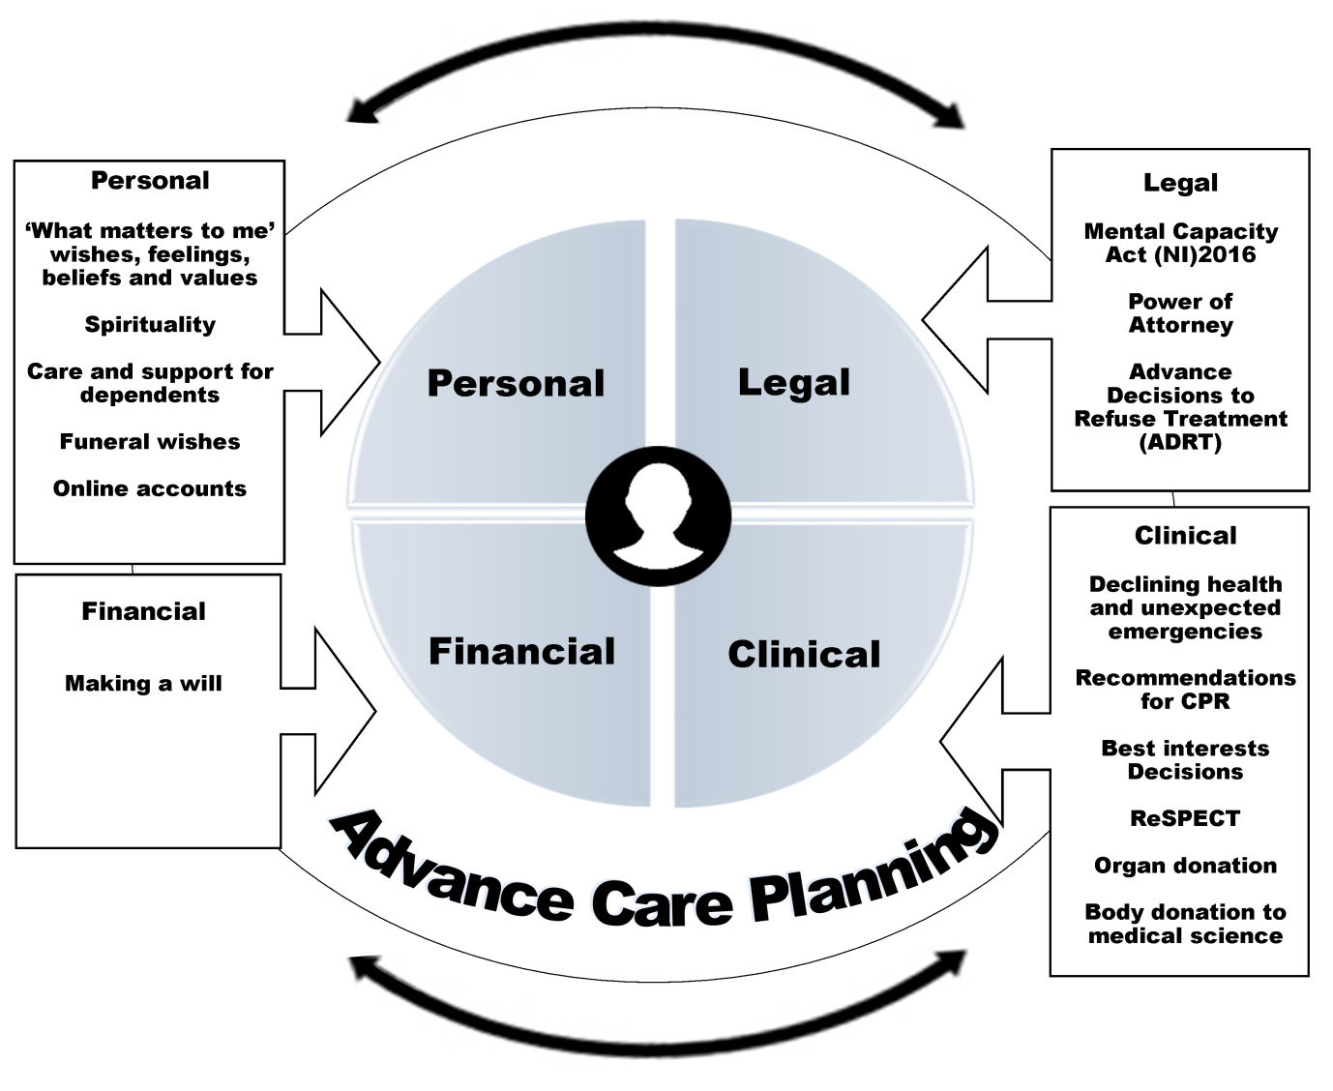
These key components are considered in the following sections.

Personal Component of Advance Care Planning

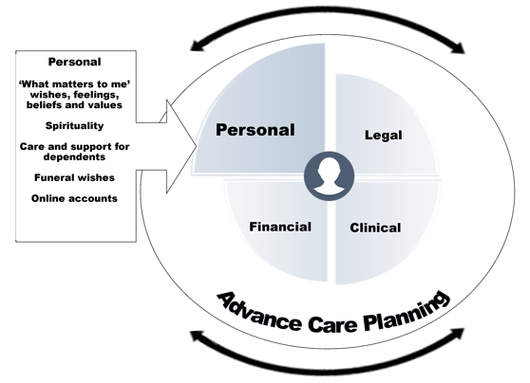

“What Matters To Me” - Wishes, Feelings, Beliefs and Values
This part of Advance Care Planning is about those very personal things that give meaning and purpose to a person’s life. It can include people, places, spirituality or other things that matter to the person.
A person can tell people about what matters to them, or write it down. These can be specific wishes about what is important to them when they are well and what is important to them if they became unable to make the relevant decisions about their lives.
Wishes, feelings, beliefs and values will differ according to each person. For example, for some, managing pain is an absolute priority, while for others, tolerating some pain in order to be with people important to them, is their priority.
It is important for anyone involved in the person’s care, to know what matters to them whether or not it is written down. Knowing what matters to the person helps to guide and inform those providing care, support or treatment to make decisions when the person is unable to make the relevant decisions and/or communicate what their wishes are.

Spirituality
Advance Care Planning conversations focus on what is important to a person and may include the person speaking about the spiritual aspect of their lives. Spirituality is about what gives meaning and purpose to life and it is based on a person’s core beliefs and values. Spirituality can be expressed in many different ways. For some people, they may express their spirituality through their faith and within a formal religion. For others, it may be expressed through music, arts, or nature. Spirituality informs and guides a person in how they behave and in how they relate to others and it can provide comfort, support and strength through a person’s life. Spirituality can become even more important to a person as they grow older or if they are faced with very serious illness.

Care and Support for Dependents
For some, a key priority for their Advance Care Planning will be to have the reassurance that care and support will be in place for their dependents. For many carers for example, having conversations about and making arrangements for the future care and support of those they care for will be an important part of their own Advance Care Planning and may even be a prompt for this.
It is important to recognise the peace of mind that such conversations and plans can bring.
This is not only for those with dependents. For some people, Advance Care Planning will include making arrangements for the care of their pets if they were unable to look after them themselves.

Funeral Wishes
For some, thinking about their own funeral or having conversations about it with those important to them can be emotional. Having these conversations however can ensure that the person’s wishes and preferences are known and reflected. This can also help reduce any concerns that those important to the person may have, as they are involved in the conversations and know what type of funeral the person would want.

Online Accounts
It is important to consider what will happen to any online accounts after a person dies. This may include a person deciding what they would want to happen to photos, videos, emails, banking or other information stored online, sometimes known as a person’s digital legacy.
For some people, they may decide to share their personal wishes regarding social media or online accounts. (e.g. delete or keep open email, or social media accounts).

Legal Component of Advance Care Planning
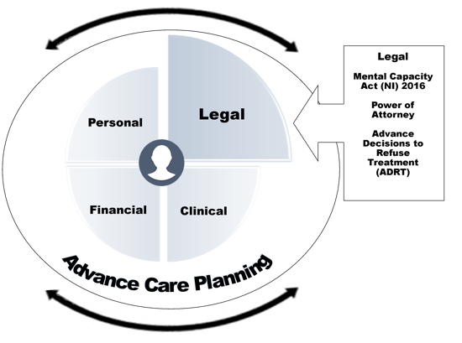

Mental Capacity Act (NI) 2016
Advance Care Planning includes references to a person having mental capacity so it is important to understand what this means. The first principle of the Mental Capacity Act (NI) 2016 is a person is not to be treated as lacking capacity unless it is established that the person lacks capacity in relation to the matter in question. A person may be able to make some decisions at one time but not another. Mental capacity is both decision and time specific, this means:
A person should have the relevant mental capacity for a specific decision at that time;
A person may lack the mental capacity for some specific decisions at that time but retain the mental capacity for many others;
Even if a person lacks the relevant mental capacity for a specific decision at that time, their wishes, feelings, beliefs and values are central and the person still needs to be supported to be involved as much as possible.
Advance Care Planning conversations, any recommendations and/or decisions will be used when the person cannot make decisions for themselves. This may be because even with support, they lack the mental capacity to make the specific decision at that time.
In order to have the capacity to make the specific decision, a person must be able to: understand; retain; appreciate, use and weigh the relevant information; and communicate their decision. When a person lacks capacity for a specific decision, prior Advance Care Planning conversations, any recommendations and/or decisions can help guide those providing care, support or treatment so that, as far as is possible, this is provided in line with the person’s wishes, feelings, beliefs and values for their future care.
The Mental Capacity Act (NI) 2016 is an Act of the Northern Ireland Assembly. The Act received Royal Assent on the 9th May 2016. Section 3 of the Mental Capacity Act (NI) 2016 assigns the following meaning to the term “lack of capacity”;

Section 3 of the Mental Capacity Act (NI) 2016
“(1) For the purposes of this Act, a person who is 16 or over lacks capacity in relation to a matter if, at the material time, the person is unable to make a decision for himself or herself about the matter (within the meaning given by section 4) because of an impairment of, or a disturbance in the functioning of, the mind or brain.
(2) It does not matter;
(a) whether the impairment or disturbance is permanent or temporary;
(b) what the cause of the impairment or disturbance is.
(3) In particular, it does not matter whether the impairment or disturbance is caused by a disorder or disability or otherwise than by a disorder or disability.”

The Act specifies that a ‘lack of capacity’ is about a person not being able to make a decision for themselves on a specific matter.
It also recognises that mental capacity can fluctuate and can be temporary or permanent.
There are a number of very important principles in the Mental Capacity Act (NI) 2016 about capacity which help prevent it being wrongly assumed a person has lack of mental capacity. The statutory principles of the Mental Capacity Act (NI) 2016 are:
Principle 1 – The first principle of the Mental Capacity Act (NI) 2016 is a person is not to be treated as lacking capacity unless it is established that the person lacks capacity in relation to the matter in question.
Principle 2 – The question if a person is able to make a decision for himself or herself can only be determined by considering the requirements of the Act and no assumptions can be made merely on the basis of any condition that the person has or any other characteristics of the person.
Principle 3 – A person is not to be treated as unable to make a decision for himself or herself unless all practicable help and support to enable the person to make the decision has been given without success.
Principle 4 – A person is not to be treated as unable to make a decision merely because the person makes an unwise decision.
Principle 5 – Any act done, or decision made, must be made in the person’s best interests.

Aspects To Consider Regarding Mental Capacity
These are important aspects to consider regarding mental capacity.
Why is a person unable to make the decision?
A person is not able to make a decision if they are not able to:
- Understand the information they need which would help them to make a decision.

- Remember that information for the time needed to make the decision.
- Use that information to weigh up the pros and cons as part of the process of making the decision.

- Communicate their decision (whether by talking, using sign language or by any other means).

Supporting a person to make a decision:
A person must be given all practicable help and support to enable them to make a decision. The steps required are:
- Provide the person with all the relevant information in a way which best suits them and their needs. (e.g., written, spoken, using sign language, etc.).

- Ensure that the conversation with the person is at a time or times which suit the person best (e.g. some people feel more able or alert early in the morning).

- Ensure the setting (environment) to have the conversation suits the person best (e.g. not noisy, no interruptions nor with too many distractions).

- Ensure that those important to the person or those who may support their communication are involved.

Establishing if someone lacks capacity: To establish if a person lacks capacity to make a decision on a specific matter, those assessing the person must:
- Ensure compliance with the principles in the Mental Capacity Act (NI) 2016
- Reasonably believe that the person lacks capacity to make that specific decision.
- Have provided the relevant information in a way that is accessible to the person.
- Have provided the support the person needs to enable them to make the decision.
Who can determine if someone has Mental Capacity?Determining capacity is a core function of any health and social care worker, and it is expected all health and social care professionals should be able to carry out routine mental capacity assessments.
For serious interventions and treatment decisions, a person determining mental capacity must be suitably qualified, as detailed within the Mental Capacity Act (NI) 2016.

Types of Power of Attorney
There are three different types of ‘Power of Attorney’ and each are described here. It is important to note though, that only the first two are currently in place in Northern Ireland. It is advisable to seek legal advice as careful consideration should be given to the range of powers a person wishes to give an attorney.

Power of Attorney
Power of Attorney is a legal document which the person can use to give someone else the authority to take actions or make decisions on their behalf. It enables the person, while they still have mental capacity, to have someone else (called an attorney) to deal with their property and finance. For example if they aren’t physically able to carry out tasks for themselves, such as visiting the bank.
A Power of Attorney ceases when the person loses mental capacity for managing their own affairs.

Enduring Power of Attorney
An Enduring Power of Attorney (EPA) is a legal document which allows a person to appoint others to make decisions on their behalf about their property and financial affairs if they were to lose mental capacity.
Having an EPA allows a person to plan ahead in case they lose the mental capacity to make their own decisions about their finances or property.

Lasting Power of Attorney
Part 5 of the Mental Capacity Act (NI) 2016 makes provision in respect of Lasting Power of Attorney (LPA). This Part of the Act has not yet been commenced, therefore, the provisions of Part 5 of the Act which relate to Lasting Power of Attorney are not yet in force in Northern Ireland.
An LPA is a legal document, which allows a person to appoint others to make decisions on their behalf. It can be made for property and financial affairs, and can also be made for health and social care decisions, including decisions around treatment and end of life care. Section 97 defines Lasting Power of Attorney as follows:

Part 5 of the Mental Capacity Act (NI) 2016: Section 97
97. (1) A lasting power of attorney is a power of attorney by which the donor confers on the attorney (or attorneys) authority to make decisions about (or about specified matters concerning) all or any of the following;
(a) the donor's care, treatment and personal welfare;
(b) the donor's property and affairs;
and which includes authority to make such decisions in circumstances where the donor no longer has capacity.
(2) A lasting power of attorney is created only if;
(a) an instrument conferring authority of the kind mentioned in subsection (1) is made and registered in accordance with Schedule 4;
(b) at the time when the donor executes the instrument, the donor is 16 or over and has capacity to execute it; and;
(c) section 101 (requirements as respects attorneys) is complied with.
(3) An instrument which;
(a) purports to create a lasting power of attorney, but;
(b) does not comply with this section, section 101 or Schedule 4,confers no authority.

An LPA is made when the person has capacity and gives the attorney full decision making power to come into effect only at the time when the person lacks mental capacity. A decision by an LPA attorney is the same as that of the person themselves if they had mental capacity.
An LPA will be a very powerful tool in Advance Care Planning, when the relevant provisions of the Mental Capacity Act (NI) 2016 are brought into force. It will ensure that a person can choose who will make decisions on their behalf should they ever lack mental capacity.
Currently no one can consent to treatment on behalf of another adult in Northern Ireland. In situations where a person has not the mental capacity to make a specific decision for themselves, a ‘best interests’ decision is made.

Advance Decisions to Refuse Treatment (ADRT)

An ADRT is a set of instructions from a person to those providing clinical treatment. It sets out specific circumstances in which the person would not want certain treatments or would want a particular treatment to be stopped.
An ADRT cannot be used to refuse any basic care a person might need to keep them comfortable. This includes warmth, shelter, food and fluids by mouth. An ADRT cannot be used to:
- ask for specific medical treatment;
- request something that is illegal, e.g. assisted suicide;
- nominate someone else to make decisions;
- refuse treatment for a mental health condition if the treatment is in accordance with the Mental Health (NI) Order 1986.

In Northern Ireland, an ADRT is legally binding (governed by common law instead of an Act) if it is valid and applicable to the particular situation. This means those providing care, support or treatment must follow an ADRT provided that they know about it.
An ADRT is recorded while a person is able to make their own decisions and communicate these. It will only be followed when a person loses the mental capacity to make specific decisions or is unable to communicate what their wishes are.
Those providing care, support or treatment should follow the Advance Care Planning Regional Operational Framework (will be developed in line with Policy development).

Clinical Component of Advance Care Planning
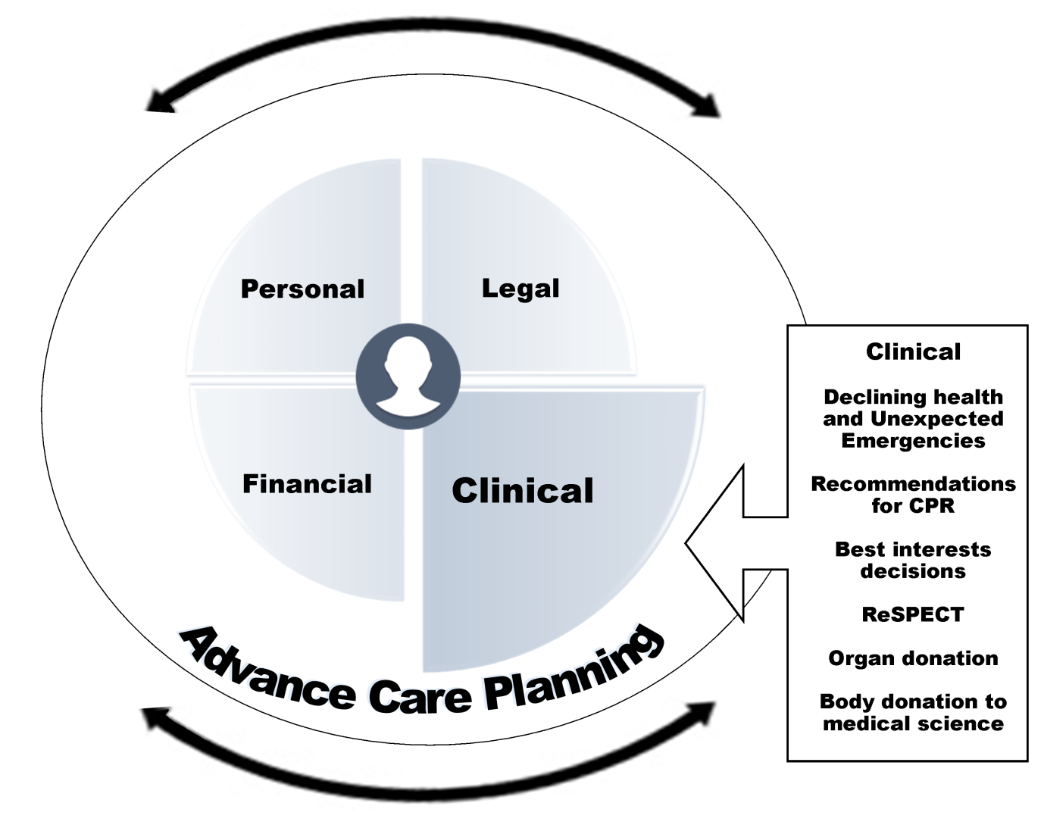

Declining Health & Unexpected Emergencies

Across the course of a person’s life, their health can begin a gradual decline over a period of time. At other times, a person’s health can be suddenly affected by an unexpected emergency situation, such as an accident, a heart attack or a mental health crisis. It is really important therefore, for everyone to think about and plan for the fact that such situations can happen.
Advance Care Planning can include conversations, recommendations and/or decisions regarding a person’s wishes for future care in the event of declining health and/or unexpected emergencies. These conversations help to provide a shared understanding of what matters to the person and inform the clinical recommendations and/or decisions about what is realistic in terms of their future care and treatment as their health declines, and/or specific treatments such as resuscitation, ventilation or artificial nutrition/hydration.

Clinical Recommendations for Cardiopulmonary Resuscitation (CPR)

Advance Care Planning can involve conversations, recommendations and/or decisions about cardiopulmonary resuscitation. This is important, as an unexpected emergency situation may include a cardiac arrest. A cardiac arrest is when the heart has stopped pumping blood around the body and the person becomes unresponsive and stops breathing normally.
An intervention such as cardiopulmonary resuscitation (CPR) seeks to restart the heart. It requires hard pressure to be applied to the person’s chest, which often means those important to the person cannot be present or if they are present, can find this very distressing to watch.
There comes a time for everyone however, when attempting to restart the heart would either not be successful or where the risks of CPR outweigh the benefit. In this instance, there are clear medical indications that the person’s health or condition is, or is expected, to decline to the point where CPR is not an appropriate intervention as it interferes with the normal dying process, whereby the heart is the last organ to stop.
A person or those important to the person cannot insist on any specific treatments to be in provided if deemed inappropriate by the treating clinician, this includes CPR. Knowing what matters to a person helps inform those providing clinical treatment to make and record specific clinical recommendations, including whether CPR would be an appropriate intervention in the event of a cardiac arrest. The key issue is not the decision-maker’s view of the quality of life following CPR, but an objective assessment of what is in the best interests of the patient. This must take account of all relevant factors, particularly the persons wishes, feelings, beliefs and values about what would be an acceptable level of recovery for them.

Best Interests Decisions

When a person lacks the mental capacity to make a specific decision about their treatment at that time, and does not have a valid and applicable ADRT, the clinician who is treating the person will make a ‘best interests’ decision(s). Advance Care Planning ensures that a person can make their wishes, feelings, beliefs and values known and in doing so, this will help guide and inform those making ‘best interests’ decisions.
No one has the legal authority to consent to treatment on behalf of another adult but those important to the person should be included in these ‘best interests’ discussions regarding what the person may have wanted. Even when the person lacks the relevant mental capacity for a specific decision at that time, their wishes, feelings, beliefs and values are central. The person must be placed at the heart of the decision-making process and supported to be involved in the decision-making process as far as possible.
The clinician who is treating the person should base their best interests decision on their experience and understanding of the person’s circumstances and be informed by the person’s prior Advance Care Planning conversations. Decisions must not be made on the basis of assumptions based solely on factors such as the person’s age, disability, or on a professional’s subjective view of a person’s quality of life.
Where there is no evidence of Advance Care Planning, ADRT or clinical recommendations for care and treatment in the event of an unexpected emergency, including cardiac arrest, the clinician who is treating the person will make a ‘best interests’ decision.

Recommended Summary Plan for Emergency Care & Treatment (ReSPECT)

Ideally Advance Care Planning should happen long before any decline in a person’s health or any crisis or emergency. There may however be instances where Advance Care Planning conversations have not taken place and those providing care, support or treatment will have to introduce these conversations in circumstances such as a sudden decline in health or unexpected emergency.
No matter when these conversations happen, they should include talking about and recording what matters to a person and specific clinical recommendations about what is realistic and appropriate treatment and care for the person.
Conversations and recommendations for future care and treatment will be recorded on a ReSPECT form.
ReSPECT stands for “Recommended Summary Plan for Emergency Care and Treatment.” The ReSPECT form sets out information that will help guide and inform those providing care, support or treatment at a time when the person is unable to communicate what their wishes are or does not have mental capacity to make that specific decision, such as in a future unexpected emergency.
The ReSPECT form includes recommendations and/or decisions about specific interventions that may, or may not be wanted or be clinically appropriate.
The ReSPECT form will be signed by the clinician providing clinical recommendations but will be held by the person. The ReSPECT form is not a legally binding document. The ReSPECT form includes:
- What matters to the person regarding their care and treatment e.g. wishes feelings, beliefs and values;
- Existing care planning documents e.g. if the person has made an Advance Decisions to Refuse Treatment (ADRT);
- Clinical recommendations for emergency care and treatment e.g. Resuscitation recommendations;
- Recording mental capacity for involvement in the recommendations made;
As with any other aspect of Advance Care Planning, information recorded on a ReSPECT form should be kept under review and updated as appropriate.
The ReSPECT form will be the regional form for recording all recommendations about emergency care and treatment. The ReSPECT form will be transferable across all care settings. As the ReSPECT form includes CPR recommendations, do not attempt cardiopulmonary resuscitation (DNACPR) forms will no longer be used.
Those providing care, support or treatment should follow the relevant regional operational documents that have been developed to support this policy.

Organ Donation

A person can choose to donate their organs and tissues for transplant. There are two different types of organ donation. One is where the person donates an organ as a ‘live donor’, for example someone may wish to be a kidney donor. The second is where someone has died and their organs and tissues are donated.
A person can record whether they do or do not want to donate their organs and tissues after death on the NHS Organ Donor Register. Many people do not realise that the support of those important to them is necessary for organ donation to go ahead. Knowing a person’s wishes in relation to organ donation helps those important to them at this difficult time.

Body Donation to Medical Science

A person may wish to donate their body to medical science. It is important for the person to discuss this with those important to them, and those providing care, support or treatment. There is a correct process which must be followed; this will include keeping a copy of the fully completed consent form.

Financial Component of Advance Care Planning

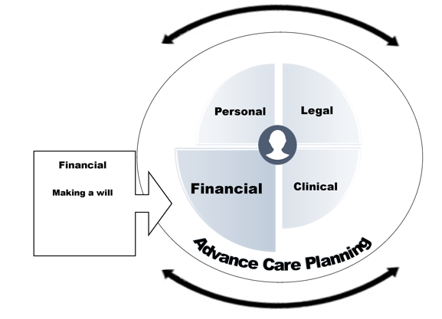

Making a Will

Making a will provides a person with the opportunity to ensure their wishes are followed after they die. It helps to ensure a person can leave any belongings or instructions they wish to those important to them.
A will is a legal document that gives clear instructions which can include:
- Care of children or dependents;
- Financial affairs - money, property and belongings.

Why it's important to make a will

Having a will simplifies the process of managing a person’s affairs after they die:
- A person can decide how their assets are shared.
- An unmarried couple can make sure their partner is provided for.
- If a person is divorced, they can decide whether to leave anything to their former partner.
- A person can get more information on Inheritance tax.

Preparing your will

Although it is possible to write a will by yourself, it is advisable to use a solicitor as there are various legal formalities. If a person doesn’t have a will, the law says who gets what.
An executor is the person who would carry out the wishes in a person’s will. A person can appoint an executor by naming them in their will. The courts can also appoint other people to be responsible for doing this job.
Once a person has made their will, it is important they keep it in a safe place and tell their executor, close friend or relative where it is. If a solicitor makes the will, they will normally keep the original and send the person a copy. A person can ask for the original if they wish to hold it.

Updating your will

A person should review their will, particularly after any major change in their life, such as getting separated, married or divorced, having a child or moving house.
A person can make changes by adding a note to their existing will or by making a new will.

Conclusion

Advance Care Planning contains a number of components, within which there are a number of elements. A person may choose to think about and plan for some of the elements, but not others, and at different times within their life. This reflects the personal and voluntary principles of Advance Care Planning and the need to provide opportunities for a person to have Advance Care Planning conversations and to review these conversations and/or any record that may be documented.
Advance Care Planning enables a person to think about what matters to them. This can enhance their quality of life and enable their wishes, feelings, beliefs and values to inform the care, support or treatment they receive if they become unable to make decisions for themselves.
“Advance Care Planning, probably the most important conversation you will ever have in your life” (Stakeholder quote from engagement, February 2021).

Appendices

Appendix 1 Glossary of Terms

• Advance Care Planning: Advance Care Planning is an umbrella term covering personal, legal, clinical, and financial planning. It enables a person to think about what is important to them and plan for their future. It is a voluntary process and helps a person to make known what their wishes, feelings, beliefs and values are, and to make choices that reflect these. Advance Care Planning is an on-going process of conversations between a person, those important to them and those providing care, support or treatment. Advance Care Planning should be an important part of life for all adults.
• Advance Decisions to Refuse Treatment (ADRT): In Northern Ireland, an ADRT is legally binding (governed by common law instead of an Act) if it is valid and applicable to the particular situation
• Behaviour Change: Behaviour change can refer to any transformation or modification of human behaviour.
• Best interests: When a person lacks the mental capacity to make a specific decision about their treatment at that time, and does not have a valid and applicable Advance Decision to Refuse Treatment, the clinician who is treating the person will make a “best interests’ decision regarding care and treatment.
• Cardiac Arrest: A cardiac arrest is when the heart has stopped pumping blood around the body and the person becomes unresponsive and stops breathing normally.
• Cardiopulmonary resuscitation: a medical procedure involving compression of the chest and artificial respiration, performed to maintain blood circulation and oxygenation in a person who has suffered a cardiac arrest.
• Care, Support or Treatment: Those who provide care, support or treatment, this term is used throughout the policy and includes people working within the community and voluntary sector, independent sector and other health and social care staff working in statutory services.
• Consent: Consent is more than a form or formality. For consent to be valid, it must be voluntary and informed, and the person consenting must have the capacity to make the decision.
• End of Life: A period of time during which a person’s condition is actively deteriorating to the point where death is expected.
• End of Life Care: Is an approach that improves the quality of life of patients and their families living with a life-threatening illness. Care includes assessment and treatment of pain and other needs, physical, psychosocial and spiritual.
• Enduring Power of Attorney: A legal document which allows a person to appoint others to make decisions on their behalf about their property and financial affairs if they were to lose mental capacity.
• Guidance: Evidence-based recommendations on the most effective and cost-effective treatment and care of people with specific diseases and conditions, and recommendations for populations and individuals on interventions that can help prevent disease or improve health. The professional regulators include (General Medical Council (GMC), Nursing Midwifery Council (NMC), Health & Care Professions Council (HSPC) and General Pharmaceutical Council (GPhc), Northern Ireland Social Care Council (NISCC) produce regulatory ‘guidelines’/ ‘guidance’ on how professional standards should be achieved.
• Holistic assessment: Comprehensive assessment that addresses the social, psychological, emotional, physical and spiritual needs of the person.
• Holistic care: Provision of care provided to a person based on an understanding of their social, psychological, emotional, physical and spiritual needs.
• Lasting Power of Attorney (LPA): see section 97 of the Mental Capacity Act (NI) 2016, Is a legal document, which allows a person to appoint others to make decisions on their behalf .
• Mental Capacity Act (Northern Ireland) 2016: Legislation that when fully commenced, will fuse together mental capacity and mental health law.
• National Institute for Health and Care Excellence (NICE): An organisation that provides a robust and independent appraisal of the best available evidence to make recommendations for the health and social care system.
• Organ Donation: Organ donation is the entire practice of retrieving a human organ from a living or deceased person.
• Palliative Care: The active, holistic care of people with advanced progressive illness. Management of pain and other symptoms and provision of psychological, social and spiritual support is paramount. The goal of palliative care is to achieve the best quality of life for people and those important to the person. Many aspects of palliative care are also applicable earlier in the course of the illness in conjunction with other treatments.
• Progressive condition: A disease or health condition that gets worse over time, resulting in a general decline in health or function.
• Power of Attorney: Is a legal document which the person can use to give someone else the authority to take actions or make decisions on their behalf.
• ReSPECT: Is an element of the clinical component of Advance Care Planning enabling personalised recommendations for emergency care and treatment to be documented.
• Serious Illness: A health condition that carries a high risk of mortality and impacts a person's daily function or quality of life.
• Spirituality: Spirituality is about what gives meaning and purpose to life and is based on a person’s core beliefs and values.
• Those important to the person: This may be family, carers or someone who knows, cares and has affection for the person. They may be connected through their personal, legal, cultural or emotional relationship.

Abbreviations
- ADRT - Advance Decision to Refuse Treatment
- CPR - Cardiopulmonary resuscitation
- DNACPR - Do not attempt cardiopulmonary resuscitation
- EPA - Enduring Power of Attorney
- LPA - Lasting Power of Attorney
- MCA - Mental Capacity Act (Northern Ireland) 2016
- NI - Northern Ireland
- NICE - National Institute for Health and Care Excellence
- ReSPECT - Recommended Summary Plan for Emergency Care and Treatment

Appendix 2 Bibliography

Journals (a list of 48 Journals follows)
- Abba, K., Llyod-Williams, M. & Horton, S. (2019). Discussing end of life wishes – the impact of community interventions? BMC Palliative Care. 18 pp18-26 DOI:
- Abel J., Kellehear, A., Millington Sanders, C., Taubert, M., & Kingston, H. (2020). Advance Care Planning re-imagined: a needed shift from COVID times and beyond. Palliative Care and Social Practice. 14
- Beck E-R, McIlfatrick S, Hasson F, Leavey G. (2017) Health care professionals’ perspectives of advance care planning for people with dementia living in long-term care settings: A narrative review of the literature. Dementia. 2017;16(4):486-512. doi:10.1177/1471301215604997
- Beck ER, McIlfatrick S, Hasson F, Leavey G. (2017) Nursing home manager's knowledge, attitudes and beliefs about advance care planning for people with dementia in long-term care settings: a cross-sectional survey. J Clin Nurs. 2017 Sep;26(17-18):2633-2645. doi: 10.1111/jocn.13690. Epub 2017 Feb 9. PMID: 27995678.
- Biondo, P.D., King, S., Minhas, B. et al. (2019). How to increase public participation in advance care planning: findings from a World Café to elicit community group perspectives. BMC Public Health. 19 679 DOI:
- Brazil K, Carter G, Cardwell C, et al. (2017) Effectiveness of advance care planning with family carers in dementia nursing homes: A paired cluster randomized controlled trial. Palliative Medicine. 2018;32(3):603-612. doi:10.1177/0269216317722413
- Brazil, K., Carter, G., Galway, K. et al. (2015). General practitioners’ perceptions on advance care planning for patients living with dementia. BMC Palliat Care 14, 14 (2015).
- Canacott, L. & Moghaddam, N. (2019). Is the Wellness Recovery Action Plan (WRAP) efficacious for improving personal and clinical recovery outcomes? A systematic review and meta-analysis. Psychiatric Rehabilitation Journa.l 42(4) pp372-381 DOI: https://psycnet.apa.org/doiLanding?doi=10.1037%2Fprj0000368
- Carr K, Hasson F, McIlfatrick S, Downing J. Factors associated with health professionals decision to initiate paediatric advance care planning: A systematic integrative review. Palliat Med. 2021 Mar;35(3):503-528. doi: 10.1177/0269216320983197. Epub 2020 Dec 29. PMID: 33372582; PMCID: PMC7975890.
- Demirkapu, H., Van den Block, L., De Maesschalck, S., De Vleminck, A., Colak, Z. & Devroey, D. (2021). Advance Care Planning Among Older Adults of Turkish Origin in Belgium: Exploratory Interview Study. Journal of Pain and Symptom Management. 62(2) pp252 – 259 doi:
- Detering, K. M., Buck, K., Ruseckaite, R., et al. (2019). Prevalence and correlates of advance care directives among older Australians accessing health and residential aged care services: multicentre audit study BMJ Open. 9 pp1-9 DOI:
- Somal, K., & Foley, T. (2021). A Literature Review of Possible Barriers and Knowledge Gaps of General Practitioners in Implementing Advance Care Planning in Ireland: Experience from Other Countries. International Journal of Medical Students, 9(2), 145–156.
- Dixon, J. and Knapp, M. (2019). Delivering advance care planning support at scale: a qualitative interview study in twelve international healthcare organisations. Journal of Long-term Care., pp127-142.
- Dunphy, E., Conlon, S. C., O’Brien, S. A., Loughrey, E., & O’Shea, B. J. (2016). End-of-life planning with frail patients attending general practice: an exploratory prospective cross-sectional study. British Journal of General Practice. 66(650): pp661-666. DOI:
- Ernecoff, N.C., Keane, C.R. & Albert, S. M. (2016). Health behavior change in advance care planning: an agent-based model. BMC Public Health. 16 193 DOI:
- Gilissen, J., Hunt, L., Van den Block, L., Van Der Steen, J., Tahir, P. and Ritchie, C. (2021). Earlier initiation of palliative care in the disease trajectory of people living with dementia: a scoping review protocol. BMJ Open. 11(6)
- Graham-Wisener, L., Nelson, A., Byrne, A., Islam, I., Harrison, C., Geddis, J., & Berry, E. (2021). Upstreaming advance care planning: application of health behavior change theory to understand barriers and facilitators to talking about death and dying in the community.
- Harding, A., Preston, N., Doherty, J. et al. (2021). Developing and evaluating online COVID-centric advance care planning training and information resources for nursing staff and family members in nursing homes: the necessary discussions study protocol. BMC Geriatr 21, 456.
- Hill LM, McIlfatrick S, Taylor B, Dixon L, Fitzsimons D. (2019) Implantable cardioverter defibrillator (ICD) functionality: patient and family information for advanced decision-making. BMJ Support Palliat Care. 2019 Nov 26:bmjspcare-2019-001835. doi: 10.1136/bmjspcare-2019-001835. Epub ahead of print. PMID: 31771959.
- J Stevens, P Pype, K Eecloo, L Deliens, K Pardon, A D Vleminck. (2021). Facilitating advance care planning in the general practice setting for patients with a chronic, life-limiting illness: protocol for a phase-III cluster-randomized controlled trial and process evaluation of the ACP-GP intervention. BMC Palliative Care. 20(19)
- Kelly, B. D. (2014). An end to psychiatric detention? Implications of the United Nations Convention on the Rights of Persons with Disabilities. The British Journal of Psychiatry. 204 (3) pp174–175
- Kelly, B. D. (2015). Best Interests, mental Capacity legislation and the UN convention on the Rights of Persons with Disabilities. BJPsych Advances. 21 pp188-195 DOI:
- Litzelman, D. K., Cottingham A. H., Griffin, W. Inui, T. S. & Ivy, S. S. (2016). Enhancing the prospects for palliative care at the end of life: A statewide educational demonstration project to improve advance care planning. Palliative & Supportive Care. 14(6) pp641 – 651 DOI:
- Mallon, A., Hasson, F., Casson, K. et al. (2021). Young adults understanding and readiness to engage with palliative care: extending the reach of palliative care through a public health approach: a qualitative study. BMC Palliative Care. 20(1), pp.1-13. DOI:
- Marshall, H. & Sprung, S. (2017). The Mental Capacity Act: ‘Best interests’—a review of the literature. British Journal of Community Nursing., 22(8), pp384-390 DOI:
- McIlfatrick S, Slater P, Bamidele O, Muldrew D, Beck E, Hasson F. (2021) ‘It’s almost superstition: If I don’t think about it, it won’t happen’. Public knowledge and attitudes towards advance care planning: A sequential mixed methods study. Palliative Medicine. 2021;35(7):1356-1365. doi:10.1177/02692163211015838
- McIlfatrick, S., Slater, P., Beck, E., Bamidele, O., McCloskey, S., Carr, K., Muldrew, D., Hanna-Trainor, L. & Hasson, F. (2021). Examining public knowledge, attitudes and perceptions towards palliative care: a mixed method sequential study. BMC Palliative Care. 20 (44)
- McKenna, D., O’Shea, J. and Tanner, L., 2020. The Heart of Living and Dying: Upstreaming Advance Care Planning into Community Conversations in the Public Domain in Northern Ireland. Journal of social work in end-of-life & palliative care, 16(4), pp.346-363.
- Meehan, E., Foley, T., Kelly, M.C., Kelleher, A.B., Sweeney, C., Hally, R.M., Detering, K. and Cornally, N., (2019). Advance care planning for individuals with chronic obstructive pulmonary disease: a scoping review of the literature. Journal of Pain and Symptom Management.
- Meehan, E., Sweeney, C., Foley, T., Lehane, E., Kelleher, A.B., Hally, R.M., Shanagher, D., Korn, B., Rabbitte, M., Detering, K.M. and Cornally, N., (2019). Advance care planning in COPD: guidance development for healthcare professionals. BMJ supportive & palliative care.
- Molyneaux, E., Turner, A., Candy, B., Landau, S., Johnson, S & Llyod-Evans B. (2019). Crisis-planning interventions for people with psychotic illness or bipolar disorder: systematic review and meta-analyse. BJPsych Open. 5 pp1-9 DOI:
- O'Connell, J., Gardner, G. & Coyer, F. (2014) Beyond competencies: using a capability framework in developing practice standards for advanced practice nursing. Journal of Advanced Nursing 70(12), 2728– 2735.
- O’Halloran P, Noble H, Norwood K, Maxwell P, Murtagh F, Shields J, Mullan R, Matthews M, Cardwell C, Clarke M, Morton R, Shah K, Forbes T, Brazil K.(2020) Nurse-led advance care planning with older people who have end-stage kidney disease: feasibility of a deferred entry randomised controlled trial incorporating an economic evaluation and mixed methods process evaluation (ACReDiT). BMC Nephrol. 2020 Nov 13;21(1):478. doi: 10.1186/s12882-020-02129-5. PMID: 33187506; PMCID: PMC7663906.
- O'Halloran P, Noble H, Norwood K, Maxwell P, Shields J, Fogarty D, Murtagh F, Morton R, Brazil K. (2018) Advance Care Planning With Patients Who Have End-Stage Kidney Disease: A Systematic Realist Review. J Pain Symptom Manage. 2018 Nov;56(5):795-807.e18. doi: 10.1016/j.jpainsymman.2018.07.008. Epub 2018 Jul 17. PMID: 30025939; PMCID: PMC6203056
- Oliver, D. (2021). Improving DNACPR discussions, decisions, and documentation. BMJ. 372:n722 DOI
- O'Riordan J, Noble H, Kane PM, et al. (2019) Advance care plan barriers in older patients with end-stage renal disease: a qualitative nephrologist interview study. BMJ Supportive & Palliative Care 2020;10:e39.
- Owen, G. S., Gergel, T., Stephenson, L. A., Hussain, O., Rifkin, L., & RuckKeene, A. (2019). Advance decision-making in mental health – Suggestions for legal reform in England and Wales. International Journal of Law and Psychiatry. 64 pp162-177
- Piers, R., Braeckel, E. V., Benoit, D & Van Den Norrtgate, N. (2021). Early resuscitation orders in hospitalized oldest-old with COVID-19: A multicentre cohort study. Palliative Medicine. 35(7) pp1288-1294
- Prince-Paul M, DiFranco E. (2017).Upstreaming and Normalizing Advance Care Planning Conversations—A Public Health Approach. Behavioral Sciences. 7(2):18.
- Rawlings D, Miller-Lewis L, Collien D, Tieman J, Parker D, Sanderson C. (2017). Lessons Learned from the Dying2Learn MOOC: Pedagogy, Platforms and Partnerships. Education Sciences. 7(3) 67
- Ryan, T., McKeown, J. (2020). Couples affected by dementia and their experiences of advance care planning: a grounded theory study. Ageing & Society. 40 pp439-460
- Somal, K., & Foley, T. (2021). A Literature Review of Possible Barriers and Knowledge Gaps of General Practitioners in Implementing Advance Care Planning in Ireland: Experience from Other Countries. International Journal of Medical Students. 9(2) pp145-156
- Stein, G. L., Cagle, J. G. & Christ, G. H. (2017). Social Work Involvement in Advance Care Planning: Findings from a Large Survey of Social Workers in Hospice and Palliative Care Settings. Journal of Palliative Medicine. 20(3) pp253-259
- Szmukler, G. (2019). “Capacity”, “best interests”, “will and preferences” and the UN Convention on the Rights of Persons with Disabilities. World Psychiatry. 18 pp34-41
- Tieman, J., Miller-Lewis, L., Rawlings, D. et al. (2018). The contribution of a MOOC to community discussions around death and dying. BMC Palliative Care. 17(31)
- Webb, P., Davidson, G., Davidson et al. (2020). Key components of supporting and assessing decision making ability. International Journal of Law and Psychiatry. 72 pp1-9
- Webb, P, Davidson, G, Edge, R, et al. (2020). Service users' experiences and views of support for decision making. Health Soc Care Community. 28 pp1282– 1291
- Wendrich-van Dael, A., Gilissen, J., Van Humbeeck, L., Deliens, L., Vander Stichele, R., Gastmans, C., Pivodic, L. and Van Den Block, L. (2021). Advance care planning in nursing homes: new conversation and documentation tools. BMJ Supportive & Palliative Care. 1 pp312-317.

Books (a list of 3 follows)
- Gregson P, Nolte L, Todd J, Detering KM. 2020. Advance care planning education capability framework: implementation guide. Advance Care Planning Australia, Austin Health, Melbourne.
- Leonard, R,. Noonan, K., Horfall, D., Psychogios, H., Kelly, M., Rosenberg, J., Rumbold, B., Grindrod A., Read, N. & Rahn, A. (2020). Death Literacy Index: A Report on its Development and Implementation. Sydney: Western Sydney University.
- Macmillan Cancer Support & The Public Health Agency Northern Ireland (2016) Your Life, Your Choices: Plan Ahead. Northern Ireland.

Reports (a list of 20 follows)
- Byrne, O & Baker, S. Ireach & All Ireland Institute of Hospice and Palliative Care (2020) Palliative Care Research Study All Island (ROI & NI Combined).
- Byrne, O & Baker, S. Ireach & All Ireland Institute of Hospice and Palliative Care (2020) Palliative Care Research Study NI.
- Canadian Hospice Palliative Care Association (2020) Advance Care Planning in Canada: A Pan-Canadian Framework.
- Compassion in Dying (2018) Starting the conversation: Planning ahead for your treatment and care.
- Department of Health (2020) Advance Care Planning Policy for Northern Ireland (for adults): Thematic Review of DNACPR Issues.
- Department of Health (2016) A Strategy for Children’s Palliative and End-of-Life Care 2016-26.
- Department of Health COVID-19 HSC Clinical Ethics Forum (2020) COVDI-19 Guidance: Ethical Advice and Support Framework.
- Department of Health (2019) Mental Capacity Act (NI) 2016: Deprivation of Liberty Safeguard Code of Practice. [accessed December 2020]
- Department of Health (2019) Review of the law relating to Advance Decisions to Refuse Treatment: Mental Capacity Act (NI) 2016 section 284.
- Genentech. (2020). A guide for initiating advance care planning conversations with your patients.
- Healthwatch Norfolk (2016) ‘Thinking ahead’ Advance Care Planning.
- Healthwatch Staffordshire (2017) Think Different, Think end of Life Care.
- Marie Curie (2021) Terminal Illness and bereavement during the Covid-19 pandemic in Northern Ireland: Perspectives of those left behind and lessons for the future.
- McIlfatrick, S., Slater, P., Beck, E., Muldrew, D., Hanna-Trainor, L. & Hasson, F. (2021). Where Are We Now? - Examining public knowledge and attitudes towards palliative care and advance care planning in Northern Ireland. Ulster University
- National Institute for Health and Care Excellence. (2019) Advance Care Planning: A quick guide for registered managers of care homes and home care services.
- National Institute for Health and Care Excellence. (2007) Behaviour Change: general approaches.
- National Institute for Health and Care Excellence. (2016) Community engagement: improving health and wellbeing and reducing health inequalities.
- NHS Benchmarking Network. National Audit of Care at the End of Life: Second round of audit report. Northern Ireland (2020).
- Patient Client Council (2020) Exploring the experiences and perspectives of clinically extremely vulnerable people during COVID-19 shielding. Final Report.
- Patient Client Council (2021) Towards an action plan for health literacy in Northern Ireland.

Online References (a list of 18 follows)
- Acts of the Northern Ireland Assembly, Mental Capacity Act (Northern Ireland) 2016 [accessed December 2020].
- All Ireland Institute of Hospice and Palliative Care: Palliative Care Research Study NI (July 2020) Version 1.2. [accessed December 2020].
- An evidence-based blog article by Dr Nicola Cornally, University College Cork, PCRN member: Advance Care Planning as a Medium for Providing Care Aligned to Peoples Wishes [accessed November 2021]
- Arkless, C., Goodwin, J. & Muir, S. (2016). Advance Care Planning Training Manual: Understanding Advance Care Planning [accessed December 2020].
- Booth, R. ‘Do not resuscitate’ orders caused potentially avoidable deaths, regulator finds. The Guardian. 3 December 2020. [accessed December 2020].
- Decision making and mental capacity. National Institute for Health and Care Excellence. 11 August 2020. [accessed December 2020].
- Enduring Power of Attorney – an explanatory note. Northern Ireland Courts and Tribunals Service July 2018. epa-notes-for-guidance-Aug-2018-updated-Nov-2019.pdf (justice-ni.gov.uk) [accessed December 2020].
- Gregson P, Nolte L, Todd J, Detering KM. 2020. Education Capability Framework: 2020 Implementation Guide. Advance Care Planning Australia. Austin Health, Melbourne. [accessed December 2020].
- Health Quality & Safety Commission New Zealand Advance Care Planning Competencies. [accessed December 2020].
- Health Quality & Safety Commission New Zealand (2019) The Five Year Advance Care Planning Strategy [accessed December 2020].
- Health Quality & Safety Commission New Zealand. (2020) Serious illness conversations: Reference guide for health care professionals [accessed December 2020].
- Managing your affairs and enduring power of attorney. NI Direct Government Services (2021). [accessed January 2021].
- Ministry of Health. (2011). Advance Care Planning: A guide for the New Zealand health care workforce. Wellington: Ministry of Health [accessed December 2020].
- National Ethics Advisory Committee. (2014). Ethical Challenges in Advance Care Planning. Wellington: Ministry of Health New Zealand. [accessed December 2020].
- Northern Ireland Life & Times Survey. (2021). Economic and Social research Council. [accessed March 2021].
- Rao. J. K. Engaging Public Health in End-of-Life Issues: It Is Time to Step Up to the Plate. Ann Intern Med 2015 162 pp230-231. [Epub ahead of print 7 March 2020]. [accessed December 2020].
- United Nations Convention on the Rights of People with Disabilities (2008) [accessed December 2020].
- United Nations General Assembly, Universal Declaration of Human Rights, 10 December 1948, 217 A (III), accessed December 2020].

Online Videos (a list of 4 follows)
- June 2020, “Advance Care Planning – Issues Raised by the Covid19 Pandemic”, webinar by John Lombard, University of Limerick, PCRN member

- Sept 2020, “Advance care planning. An awareness raising session for district nursing”, webinar by Niall Gallagher, Specialist Social Work:

- April 2020 – Project ECHO AIIHPC: Intellectual Disability Services, “Advance Care Planning & Anticipatory Prescribing during a Crisis”, webinar: [speakers include: Professor Mary McCarron, Dr. Regina McQuillan, Dr. Jean Lane, Dr. John O Brien, Professor Sean Kennelly, Dr. Cathy Payne].
- July 2016, “Advance Care Planning in Dementia”, webinar by Dr Karen Harrison Dening, Dementia UK:

Those important to the person: This may be family, carers or someone who knows, cares and has affection for the person. They may be connected through their personal, legal, cultural or emotional relationship.
⁻ Those who provide care, support or treatment, this term is used throughout the policy and includes people working within the community and voluntary sector, independent sector and other health and social care staff working in statutory services.
Heslop P, Blair P, Fleming P, Hoghton M, Marriott A, Russ L. Confidential Inquiry into premature deaths of people with learning disabilities (CIPOLD). Bristol: Norah Fry Research Centre; 2013.
Decisions Relating to CPR - 2016.pdf (resus.org.uk)
Ethical and Human Rights based approach references for example United Nations Convention on the Rights of People with Disabilities Articles 9, 12, 16, 17 & 25 COVID-19 Guidance Ethical Advice and Support Framework COVID-19 HSC Clinical Ethics Forum
Extract from the Mental Capacity Act (NI) 2016
Further information on safeguarding adults to make informed choices free from duress, pressure or undue influence please refer to the Adult Safeguarding Policy
“Family or caregivers” is the phrase used within research studies. This policy uses the term “those important to the person”
Such as having adequate time, using a quiet place that allows for confidentiality and lessens possibility of inappropriate interruptions or distractions; provision of appropriate and accessible material, appropriate people involved, and specific communication preferences or needs the person may have.
Refer to Advance Care Planning Capabilities Framework (Pending)
If levels of health literacy are under-developed, this can lead to a communication gap between the person and those providing care support or treatment when having advance care planning conversation.[Towards an action plan for health literacy in Northern Ireland: A Patient and Client Council scoping paper January 2021. Further information on Health Literacy - PCC Health Literacy Scoping Paper FINAL Jan 21 v2 - Patient and Client Council Northern Ireland (hscni.net)]
See section “Advance Decisions to Refuse Treatment” page 25.
See section “Recommended Summary Plan for Emergency Care & Treatment (ReSPECT)” page 28.
See “Best Interests” section page 27.
Mental Capacity Act (Northern Ireland) 2016 (legislation.gov.uk)
The Mental Capacity Act (NI) 2016 refers to anyone over the age of 16 but the scope of this policy is for those aged 18 and over.
Mental Capacity Act (NI) 2016 – Deprivation of Liberty Safeguards - Code of Practice - November 2019.
Mental Capacity Act (Northern Ireland) 2016 (legislation.gov.uk)
Information on NI Direct about Managing your affairs and enduring powers of attorney Department for Justice Guidance notes on Enduring powers of Attorney
The Mental Capacity Act (NI) 2016 introduces the role of a Lasting Power of Attorney (LPA) to Northern Ireland. The Mental Capacity Act (NI) 2016 has come into effect here in phases of implementation. LPA was not included in phase 1. Implementation is ongoing, but there is currently no timeline for the start of that phase which will include LPA coming into use.
See ‘Best Interests’ section page 27.
When the Mental Capacity Act (Northern Ireland) 2016 is fully commenced it will provide a statutory foundation for an ADRT. It will note that if there is a valid ADRT it cannot be overruled by a decision under the Act. This will include mental health treatment.
Quality statement 4: Best interests decision making | Decision making and mental capacity | Quality standards | NICE
When fully implemented Section 7 of the Mental Capacity Act (NI) 2016
Heslop P, Blair P, Fleming P, Hoghton M, Marriott A, Russ L. Confidential Inquiry into premature deaths of people with learning disabilities (CIPOLD). Bristol: Norah Fry Research Centre; 2013
Decisions relating to cardiopulmonary resuscitation 2016
Organ Donor Register
Information booklets including Consent Form are available from the Queens University Anatomy Office. If you would like to receive an Information Booklet including a Consent Form, please email the Anatomy Office at anatomy@qub.ac.uk or telephone 028 90 972131. Staff will be very happy to discuss any queries that you may have.
NI Direct Information on Making a Will
The Mental Capacity Act (NI) 2016 introduces the role of a Lasting Power of Attorney (LPA) to Northern Ireland. The Mental capacity Act (NI) 2016 has come into effect here in phases of implementation. LPA was not included in phase 1. Implementation is ongoing, but there is currently no timeline for the start of that phase which will include LPA coming into use.

