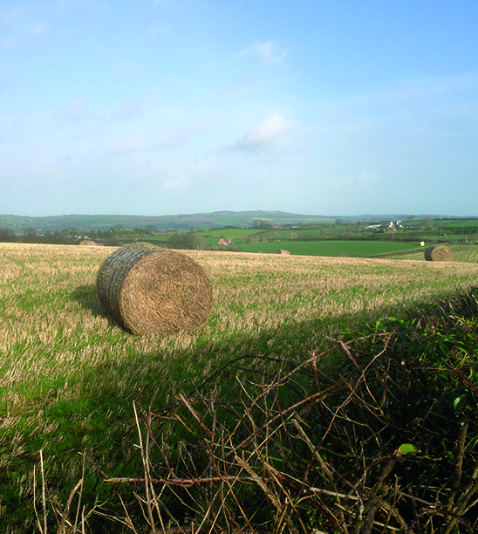
Review of the List of Bodies and Persons set out in the Schedule to the Rural Needs Act (NI) 2016

Public Consultation Document

Draft Public Consultation Document

Contents

- Introduction
- The Rural Needs Act (Northern Ireland) 2016
- Background to the Review
- Responding to the Public Consultation
- Freedom of Information Act 2000 - Confidentiality of Consultations
- Closing date
- ANNEX A – List of Questions used in Online Public Consultation on Citizen Space

Introduction

- The Department of Agriculture, Environment and Rural Affairs is undertaking a public consultation to inform a review of the list of bodies and persons set out in the Schedule to the Rural Needs Act (Northern Ireland) 2016 (the Act) which the Department is required to carry out under Section 1(3) of the Act.

- The public consultation is being carried out by means of an online survey using Citizen Space (the Northern Ireland Civil Service online consultation tool) which will commence on Monday 22 July 2024. The consultation will run for eight weeks closing at 23.59 on Friday 13 September 2024. The online survey can be accessed at the following link: [INSERT LINK].

- This document sets out the background to the review of the list of bodies and persons set out in the Schedule to the Act and includes the questions which stakeholders are invited to respond to in the online survey on Citizen Space.

- The current list of bodies and persons set out in the Schedule to the Act can be accessed at the link below:
https://www.legislation.gov.uk/nia/2016/19/schedule

The Rural Needs Act (Northern Ireland) 2016

- The Rural Needs Act (NI) 2016 (the Act) came into operation for Northern Ireland departments and district councils in June 2017 and for the other public authorities listed in the Schedule to the Act in June 2018. The aims of the Act are to help improve the quality of life of people in rural areas by ensuring that the social and economic needs of people in rural areas are fully considered by government in their decision making processes and to increase transparency on how public authorities consider rural needs.

- Section 1(1) of the Act places a statutory duty on Northern Ireland departments, district councils and the other public authorities listed in the Schedule to the Act to have due regard to the social and economic needs of people in rural areas when developing, adopting, implementing or revising policies, strategies and plans and when designing and delivering public services.

- Section 1(3) of the Act requires the Department to review the list of bodies and persons set out in the Schedule to the Act at least every three years and, if it thinks it appropriate, DAERA has the power to amend the Schedule to the Act by order to:

  - add a body or person to the Schedule;
  - remove a body or person from the Schedule; or
  - modify any entry in the Schedule.

- An order under Section 1(3) must not be made unless a draft of the order has been laid before, and approved by a resolution of, the Assembly.

- Section 3(1) of the Act requires public authorities to compile information on the exercise of its functions under Section 1 and to publish that information in its annual report and send that information to DAERA. Section 3(2) of the Act requires DAERA to publish that information in an Annual Report and to lay a copy of the report before the Northern Ireland Assembly. Section 3(3) of the Act requires the Minister of Agriculture, Environment and Rural Affairs to make a statement to the Assembly about the content of the report after the report is laid.

- Section 4 of the Act requires DAERA to make arrangements with public authorities for the purposes of securing cooperation and the exchange of information between public authorities and to review the list of bodies and persons set out in the Schedule to the Act at least every three years.

Background to the Review

- Section 1(3) of the Rural Needs Act (NI) 2016 requires DAERA to review the list of bodies and persons set out in the Schedule to the Act at least every three years from the coming into operation of the Act. A list of the bodies and persons set out in the Schedule to the Act can be accessed at the link below:
https://www.legislation.gov.uk/nia/2016/19/schedule

- Following the review, if it thinks it appropriate, DAERA has the power to amend the Schedule by order to:

- add a body or person to the Schedule;
- remove a body or person from the Schedule; or
- modify any entry in the Schedule.

- An order under subsection (3) must not be made unless a draft of the order has been laid before, and approved by a resolution of, the Assembly.

- Section 1(5) of the Act provides that DAERA must not exercise the power conferred by Section 1(3) so that a body or person becomes a public authority for the purposes of the Act unless the body or person is a body or person appearing to the Department to exercise functions of a public nature.

- A review of the list of bodies and persons set out in the Schedule to the Act was undertaken in the period 2020/21.

- DAERA is now commencing a review of the list of bodies and persons set out in the Schedule to the Act and is seeking the views of stakeholders to inform the review.
Responding to the Consultation

- The Department would encourage stakeholders to respond to the public consultation using the online survey on Citizen Space which is accessible via the following link: [INSERT LINK]

- A list of the questions used in the online survey is provided at Annex A.

- If you are unable to respond using the online survey on Citizen Space, written responses to the consultation will also be accepted. If you wish to respond in writing you can request a copy of the written response template by emailing rural.needs@daera-ni.gov.uk or by telephoning 028 90576013.

- Written responses to the consultation should be sent to:
Henry McDonald
Strategic Policy and Legislation Branch
Rural Affairs Division
Department of Agriculture, Environment and Rural Affairs
Clare House
303 Airport Road West
Belfast
BT3 9ED

Or e-mailed to rural.needs@daera-ni.gov.uk.

- All responses should be received by Friday 13 September 2024. If you have any queries regarding making a response you can email rural.needs@daera-ni.gov.uk or telephone 028 90576013 for assistance.

Freedom of Information Act 2000 – Confidentiality of Consultations

- The Department will publish a summary of responses following completion of the consultation process. Your response, and all other responses to the consultation, may be disclosed on request. The Department can refuse to disclose information only in exceptional circumstances. Before you submit your response, please read the paragraphs below on the confidentiality of consultation and they will give you guidance on the legal position about any information given by you in response to this consultation.

- The Freedom of Information Act 2000 gives the public a right of access to any information held by a public authority (the Department in this case). This right of access to information includes information provided in response to a consultation. The Department cannot automatically consider as confidential information supplied to it in response to a consultation. However, it does have the responsibility to decide whether any information provided by you in response to this consultation, including information about your identity, should be made public or treated as confidential.

- This means that information provided by you in response to the consultation is unlikely to be treated as confidential, except in very particular circumstances.

- The Lord Chancellor’s Code of Practice on the Freedom of Information Act provides that:

  - the Department should only accept information from third parties in confidence if it is necessary to obtain that information in connection with the exercise of any of the Department’s functions and it would not otherwise be provided;
  - the Department should not agree to hold information received from third parties ‘in confidence’ which is not confidential in nature;
  - acceptance by the Department of confidentiality provisions must be for good reasons, capable of being justified to the Information Commissioner.

- For further information about confidentiality of responses, please contact the Information Commissioner’s Office:
Tel: (028) 9027 8757
Email: ni@ico.org.uk
Website: https://ico.org.uk/

Closing Date

- The public consultation commences on Monday 22 July 2024 and will be open for a period of 8 weeks.

- The public consultation will close at 23.59 on Friday 13 September 2024.

ANNEX A

List of Questions contained in online survey on Citizen Space

- What is your name?
- What is your email address?
- What is the name of your organisation? (if appropriate)
- Please indicate the category of the person or organisation responding.
- Do you wish to propose adding any body or person to the Schedule, removing any body or person from the Schedule or modifying any entry in the Schedule? (Please note that only bodies or persons which exercise functions of a public nature can be added to the Schedule.)
- Do you think any body or person should be added to the Schedule? (Please note that only bodies or persons which exercise functions of a public nature can be added to the Schedule.)
- Please provide the name of body or person which you think should be added to the Schedule.
- Please provide the reasons why you think they should be added to the Schedule.
- How do you think rural communities would benefit from adding this body or person to the Schedule?
- Do you think any additional body or person should be added to the Schedule?
- Do you think any body or person should be removed from the Schedule?
- Please provide the name of body or person which you think should be removed from the Schedule.
- Please provide the reasons why you think they should be removed from the Schedule.
- Do you think any other body or person should be removed from the Schedule?
- Do you think any entry in the Schedule should be modified?
- Please provide the name of the body or person listed in the Schedule whose entry you think should be modified and the reasons why you think it should be modified.
- Please detail the modification to that entry that you think should be made.
- Do you think any other body or person should be modified in the Schedule?
- Do you have any other comments in relation to the Review of the list of bodies and persons set out in the Schedule to the Rural Needs Act (NI) 2016?
- Please provide any further comments in relation to the Review of the list of bodies and persons set out in the Schedule to the Rural Needs Act (NI) 2016?

For further information contact:

Strategic Policy & Legislation Branch
Rural Affairs Division
Department of Agriculture, Environment and Rural Affairs
Clare House
303 Airport Road West
Belfast
BT3 9ED
Email: rural.needs@daera-ni.gov.uk
www.daera-ni.gov.uk

