**Consultation on Timetable and Work Programme for Development of Fourth Cycle River Basin Management Plan**

**2028 – 2033**

**Tell us what you think and help us to manage, protect and improve NI’s water environment**

This document initiates and outlines the consultation process under which the fourth River Basin Management Plan for Northern Ireland will be produced. DAERA (Department of Agriculture, Environment and Rural Affairs), including its agency, NIEA (Northern Ireland Environment Agency) is undertaking this consultation to enable and encourage participation in the river basin management planning process. This consultation offers the opportunity to provide comments on the river basin planning programme directly to DAERA.

**3 July 2025 to 3 January 2026**

**Introduction**

Water is fundamentally important to daily life and the natural environment. Halting the decline in our water environment and delivering water quality improvements are paramount.

It is critical that we manage it properly to ensure that water can continue to meet the needs of society, the economy and wildlife over the long-term and help to reduce the costs associated with water pollution and drought.

River basin planning takes an integrated approach to the protection, improvement and sustainable use of the water environment. A River Basin Management Plan (RBMP) includes the objectives and actions required to protect and improve the water environment and also identifies synergies and opportunities for integrating with other strategies.

**River Basin Management**

The Water Environment (Water Framework Directive) Regulations (Northern Ireland) 2017 require the production and implementation of a RBMP in six yearly cycles. The third cycle plan obtained Executive approval and was published on 13 June 2025, covering the period 2021 to 2027. The fourth cycle plan is required to be published by December 2027.

The Department of Agriculture, Environment and Rural Affairs (DAERA) acknowledges that this consultation process for the fourth cycle RBMP has been delayed from its original start date of December 2024. The delay in finalising the third cycle RBMP has impacted the commencement of the subsequent cycle. However, the Department is committed to expediting the timeline and ensuring that the final fourth cycle RBMP is published by December 2027, in line with statutory requirements. We appreciate your understanding and continued engagement in this important process.

**River Basin Districts**

Republic of Ireland River Basin Management Plan (Grey Areas)

In Northern Ireland, one River Basin Management Plan covering the three river basin districts (RBDs) is produced:

North Eastern RBD which lies solely within Northern Ireland

Neagh Bann international RBD shared with Ireland

North Western international RBD shared with Ireland

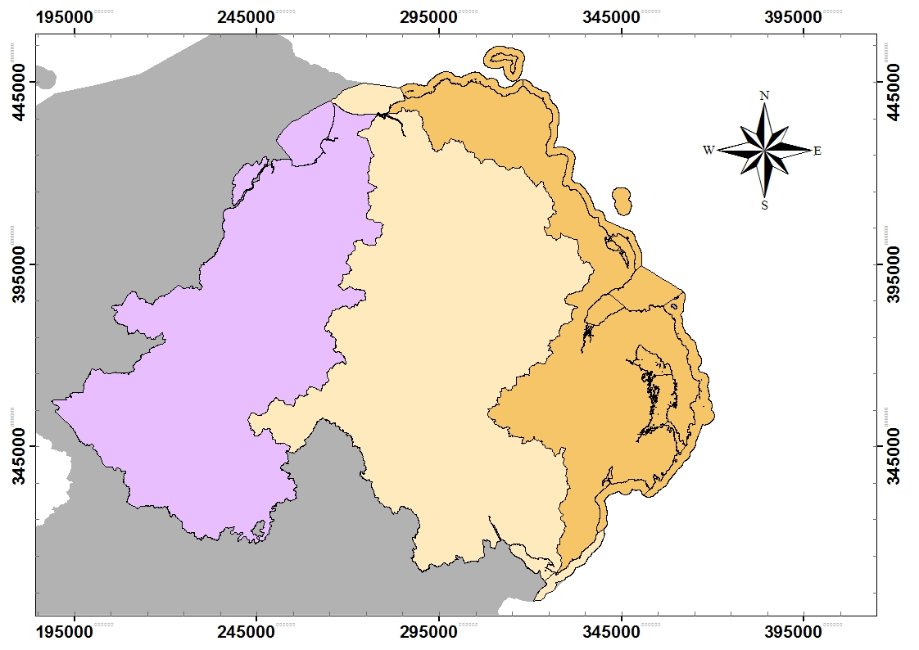

For accessibility, the map shows the three River Basin Districts (RBDs):

• North Western international RBD (shared with Ireland) is shown in purple.

• Neagh Bann international RBD (shared with Ireland) is shown in beige/tan.

• North Eastern RBD (lies solely within Northern Ireland) is shown in orange.

The Neagh Bann IRBD includes Lough Neagh and its contributing catchments as well as its outflow and marine waters at the north coast. The small area of the River Shannon within Northern Ireland is covered by Republic of Ireland’s river basin management plan.

The plans are developed in coordination with the relevant authorities in Republic of Ireland. Coordination occurs in terms of the implementation of the plans, specifically with respect to setting objectives and identifying measures. It is expected that coordination will continue during the development and implementation of the fourth cycle plan.

**Online Map Viewer**

To find your river basin district and obtain details on the condition of your local water bodies visit the interactive river basin map viewer [NIEA catchment data map viewer](https://gis.daera-ni.gov.uk/arcgis/apps/webappviewer/index.html?id=16fddc459bd04d64b9e8f084f3a8e14a).

**Links to key plans and strategies**

To further safeguard and improve our water environment during the next RBMP period, it is essential to identify synergies with Northern Ireland's [Programme for Government](https://www.executiveoffice-ni.gov.uk/news/executive-publishes-programme-government#:~:text=The%20NI%20Executive%20has%20today%20launched%20its%20Programme,which%20will%20be%20delivered%20by%20working%20in%20partnership.), key plans, and strategies. This will enable us to achieve multiple benefits for the residents of Northern Ireland.

These plans and policies* include, but are not limited to:

* [Ammonia Strategy](https://www.daera-ni.gov.uk/consultations/consultation-sea-environmental-report-proposed-ammonia-strategy-and-revised-operational-protocol)
* [Climate Action Plan](https://www.daera-ni.gov.uk/consultations/public-consultation-northern-irelands-draft-climate-action-plan-2023-2027)
* [Environmental Improvement Plan](https://www.daera-ni.gov.uk/sites/default/files/publications/daera/Environmental%20Improvement%20Plan%20for%20Northern%20Ireland.PDF)
* [Flood Risk Management Plans](https://www.infrastructure-ni.gov.uk/articles/timetable-and-works-programme-preparation-northern-ireland-flood-risk-management-plan-frmp-2021-2027)
* [Green Growth](https://eu-west-1.protection.sophos.com?d=daera-ni.gov.uk&u=aHR0cHM6Ly93d3cuZGFlcmEtbmkuZ292LnVrL2FydGljbGVzL2dyZWVuLWdyb3d0aC1zdHJhdGVneS1ub3J0aGVybi1pcmVsYW5kLWJhbGFuY2luZy1vdXItY2xpbWF0ZS1lbnZpcm9ubWVudC1hbmQtZWNvbm9teQ==&i=NjU1NTQ1ZDA2MjBmMmMyMzA0ZGU4Yzlh&t=aDR3SW9wNDJhbmRnYUY4TTJKWDdCNWVEdzZRQ1NLTG9ZNXE4d090Q2gvND0=&h=7103e2218837491a8681fbef492914fb&s=AVNPUEhUT0NFTkNSWVBUSVZ7jNfssHGhWkLgIElvWNtQOoAkbBQF6qqD9YIVTox8Ew)
* [Lough Neagh Report and Action Plan](https://www.daera-ni.gov.uk/publications/lough-neagh-report-and-action-plan)
* [Nutrients Action Programme](https://www.daera-ni.gov.uk/articles/nutrients-action-programme)
* [Sustainable Agriculture Programme](https://www.daera-ni.gov.uk/ga/topics/sustainable-agriculture-programme)

* [The Northern Ireland Climate Change Adaptation Programmes](https://www.daera-ni.gov.uk/articles/northern-ireland-climate-change-adaptation-programme)

*\*Some of these strategies are established and published, while others are ongoing programmes or are currently under development or review. The fourth cycle RBMP will consider the most current iteration of these plans and strategies to ensure effective integration.*

The development of the fourth cycle RBMP provides an opportunity to learn from experience and to build on what has been learnt through the previous cycles. Understanding the information garnered from the previous cycles will be important when designing the fourth cycle plan.

The importance of science in providing the underpinning evidence to inform the environmental objectives is critical and robust science will therefore inform the fourth cycle. It is clear that the challenges associated with Lough Neagh will also form a significant driver for the fourth cycle plan.

**Timetable and consultation arrangements for the development of the fourth cycle plan 2028 – 2033**

The review and update of the river basin management plan involves three public consultation steps.

To accommodate time constraints, an 8-week Call for Evidence was also conducted (which closed on 8 June 2025). The purpose of the Call for Evidence was to collect relevant information and opinions from the public and stakeholders to support the preparation of the Significant Water Management Issues (SWMI) Report and subsequently inform the draft 4th cycle RBMP.

As required by The Water Environment (Water Framework Directive) Regulations (Northern Ireland) 2017, DAERA will undertake an assessment of the significant water management issues in Northern Ireland including a driver-pressure-state-impact-response analysis as recommended by the Office for Environmental Protection. This will provide the evidence base for reviewing and updating the water quality objectives and the programme of measures for the fourth cycle plan. DAERA will also undertake the relevant screening exercises and impact assessments in respect of the fourth cycle RBMP.

The following graphic details the consultations which will enable wider involvement in the development of the fourth cycle plans.

**Consultation on timetable and work programme**

**for development of the 4th cycle RBMPs**

This timeline consultation outlines the 4th cycle work programme timeframe and

identifies the key consultation stages you can engage in developing fourth cycle plan

**July 2025 to January 2026**

**Consultation on significant water management issues (SWMI) for 4th cycle RBMP**

The SWMI consultation will ask for your views on our approach to dealing with the most

significant issues affecting water quality for each of the three river basin districts

within Northern Ireland.

**December 2025 to June 2026**

**Consultation on the draft 4th cycle river basin management plan**

The draft fourth cycle RBMP will be published for consultation asking you to consider

the proposed identified issues, measures and delivery plan

**December 2026 to June 2027**

We aim to have the final fourth cycle RBMP approved and published by December 2027. This RBMP will set the direction for how we will manage, protect and improve our water environment in Northern Ireland to 2033.

**Next Steps**

The river basin planning process aims to engage all stakeholders who have an interest in or may be impacted by the water environment and its management. The well-being of our water environment is a collective responsibility, and your contributions are essential in determining the future of water management in Northern Ireland.

**If you are concerned about the water environment and its sustainable use for future generations then we would welcome your input into the development of the fourth cycle RBMP for 2028 to 2033.**

During the development of the fourth cycle plan we are committed to actively engaging with all key stakeholders and the public. This includes outreach and collaboration with sectors such as agriculture, industry, NI water and non-governmental organisations (NGOs). We will utilise sector specific working groups, online events and other collaborative platforms to ensure diverse perspectives are incorporated into the planning process. This stakeholder and public engagement will help DAERA to identify and meet the challenges facing the water environment.

**Here's how you can get involved:**

• **Respond to the Consultation Questions (page 8):** Carefully review the consultation questions and provide thoughtful and evidence based responses based on your knowledge and experience.

**• Share Your Expertise:** If you have specific expertise in areas related to water management, please consider sharing relevant information or research findings to support the development of the plan.

**• Spread the Word:** Encourage your networks, colleagues, and community members to participate in the consultation and contribute their perspectives.

The evaluation of all responses received will be undertaken after each consultation. This will enable DAERA to utilise the responses in the development of the fourth cycle RBMP.

Your involvement will help us develop a robust and effective River Basin Management Plan that protects and enhances our precious water resources for generations to come. Together, we can ensure a sustainable water future for Northern Ireland.

**Consultation Questions:**

* **Do you have any feedback on** [**DAERA third cycle RBMP**](https://www.daera-ni.gov.uk/news/third-cycle-river-basin-management-plan-2021-2027-published)**, published on 13 June 2025;**
* **Does the programme of consultations on page 6 adequately meet the consultation requirements for developing the fourth cycle river basin management plan?**
* **What additional information or considerations would you like added to the consultation programme?**
* **How can we improve partnership working at the catchment-scale to develop a more efficient and effective process in creating the fourth cycle plan?**
* **Do you wish for your details to be retained by the Department to contact you regarding future River Basin Management Plan consultations? Y/N**

**You can respond by:**

* Online via Citizen Space
* Sending a response by email to [rbmpcycle4consultation@daera-ni.gov.uk](mailto:rbmpcycle4consultation@daera-ni.gov.uk) or
* Send a written response, including your name and organisation, to:

RBMP Fourth Cycle Consultation

Water Policy Branch

DAERA

Clare House

303 Airport Road West

Sydenham Intake

Belfast

BT3 9ED

**Accessibility**

You can get a copy of this document in other formats, including Large Print, Braille, and other languages. To request an alternative format, please contact us using the details above.

**How We Will Handle Your Response (Freedom of Information and Data Protection)**

DAERA will publish a summary of responses following the completion of this consultation. Please note that we are unable to acknowledge or reply individually to the points you may raise as part of your reply unless you specifically request it.

Freedom of Information (FoI) provided in response to this consultation may be disclosed on request under the Freedom of Information Act (FOI Act). The Department can only refuse to disclose information in exceptional circumstances. We cannot automatically treat information supplied as confidential. The Department has the responsibility to decide whether any information provided, including information about your identity, should be made public or treated as confidential. If you do not wish information about your identity to be made public, please include an explanation in your response, including any harm you believe such a disclosure might cause. Please be aware that information you provide is unlikely to be treated as confidential, except in very particular circumstances.

Data Protection Section 8(e) of the Data Protection Act 2018 permits the processing of personal data when it is necessary for an activity that supports or promotes democratic engagement. All information provided by respondents will be held and used for the purposes of this consultation and will be disposed of in accordance with the provisions of the Data Protection Act 2018 and the General Data Protection Regulation (GDPR).

For more information and to view the DAERA Privacy Statement, please go to: <https://www.daera-ni.gov.uk/publications/daera-privacy-statement-document>

For further information about confidentiality of responses please contact the Information Commissioner's Office.

**This consultation closes at midnight on 03 January 2026 so your consultation response must be returned before that deadline.**

**Thank you for your involvement and assistance in this consultation exercise.**